

**RECRUITING ASSISTANCE FOR**

THE HR MANAGERS

**NAAN MUDHALVAN**

**PROJECT REPORT**

***Submitted by***

**JAGADESH S (611220104059)**

**JAGAN S (611220104060)**

**MADHESWARAN V L (611220104080)**

**NAVAJEEVAN S R (611220104093)**

**GOPAL S (611220104306)**

***in partial fulfilment for the award of the degree of***

# **BACHELOR OF TECHNOLOGY**

# ***in***

# **INFORMATION TECHNOLOGY**

**KNOWLEDGE INSTITUTE OF TECHNOLOGY,**

**SALEM – 637504.**

**ANNA UNIVERSITY::CHENNAI 600025**

**BONAFIDE CERTIFICATE**

Certified that this the project report titled **“Recruiting assistance for the HR Managers”** is the bonafide work of **“JAGADESH S (611220104059), JAGAN S (611220104060), MADHESWARAN VL (611220104080) , NAVAJEEVAN S R (611220104093), GOPAL S (611220104306)”** who carried out the project work under my supervision.

## SIGNATURE

**Mr. R. SIVAGURU. ME(Phd)., ASSISTANT PROFESSOR FACULTY MENTOR**

Department of Computer Science and Engineering

Knowledge Institute of Technology, Kakapalayam,

Salem – 637504.

**SIGNATURE**

**Mr. T. KARTHIKEYAN B. TECH, M.S(IT)., Ph.D., ASSISTANT PROFESSOR**

## SPOC FACULTY

Department of Computer Science and Engineering,

Knowledge Institute of Technology, Kakapalayam,

Salem – 637504.

## SPOC HEAD OF THE DEPARTMENT

**ACKNOWLEDGEMENT**

At the outset, we express our heartfelt gratitude to god, who has been our strength to bring this project to light.

At this pleasing moment of having successfully completed our project, we wish to convey our sincere thanks and gratitude to our beloved president **Mr.C.BALAKRISHNAN,** who has provided all the facilities to us.

We would like to convey our sincere thanks to our beloved principal,**Dr.PSS.SRINIVASAN**, who forward us to do our project and offers adequate duration to complete our project.

We express our sincere thanks to **Dr.V.KUMAR,** Head of the Department of Computer Scie, for fostering the excellent academic climate in the department.

We express our pronounced sense of thanks with deepest respect and gratitude to our Faculty Mentor **Mr.R.SIVAGURU,** Assistant Professor, Department of Information Technology, for his valuable and precious guidance and for having amicable relation.

With deep sense of gratitude, we extend our earnest and sincere thanks to our SPOC **Mr.T.KARTHIKEYAN,** Assistant Professor, Department of Computer science and Engineering **,** for his guidance and encouragement during this project.

We would also like to express our thanks to all the faculty members of our department friends and students who helped us directly and indirecty.

**TABLE OF CONTENTS**

|  |  |  |
| --- | --- | --- |
| **Chapter No** | **Title** | **Page No** |
|  | **LIST OF FIGURES** | **6** |
|  | **LIST OF ABBREVIATION** | **7** |
| **1.** | **PROJECT SPECIFICATION** | **8** |
|  | 1.1 Project Abstract | 8 |
|  | 1.2 Project Objectives | 8 |
|  | 1.3 Key Deliverables | 9 |
|  | 1.4 Scope of Work | 9 |
|  | 1.5 Requirements | 10 |
|  | 1.6 Empathy Map | 10 |
|  | 1.7 Ideation & Brainstorming |  |
| **2** | **PREPARATION DATA MODELING** | **23** |
|  | 2.1 Data Modelling | 15 |
|  | 2.2 Salesforce Developer Org | 15 |
|  | 2.3 Define Data Requirements | 17 |
|  | 2.4 Design Custom Objects and Relationships | 19 |
|  | 2.5 Custom Object and Relationship Creation | 21 |
|  | 2.6 Create Relationships For Job Posting  2.7 Create a Tab  2.8 Create a Lightning App | 30  37  42 |
| **3.** | **Users & Data Security** | **43** |
|  | 3.1 User and Data Security  3.2 Creation on Profile  3.3 Creating a User  3.4 Creating a Permission Set | 43  43  47  51 |
| **4.** | **Automation** | **56** |
|  | 4.1 Automation | 56 |
|  | 4.2 Apex Code | 60 |
| **5.** | **Reports & Dashboard** | **63** |
|  | 5.1 Reports & Dashboard | 63 |
| **6.** | **Conclusion** | **73** |
|  | 6.1 Conclusion | 73 |
| **7.** | **Project Demonstration** | **74** |
|  | 7.1 Project Demonstration | 74 |

# **LIST OF FIGURES**

|  |  |  |
| --- | --- | --- |
| **Figure No** | **Name Of Figure** | **Page No** |
| 1.6 | Empathy Map | 10 |
| 1.7  2.3  2.4  2.7  2.8 | Ideation & Brainstorming  Define Data Requirements  Design Custom Objects and Relationships  Create a Tab  Create a Lightning App | 12  17  19  37  42 |

**LIST OF ABBREVIATION**

|  |  |
| --- | --- |
| CRM | Customer Relationship Management |
| ESP | Email Service Provider |
| UI | User Interface |
| UX | User Experience |
| OWD | Org - Wide Default |
| CTA | Call To Action |
| CSV | Comma - Separated Values |
| SLA | Service Level Agreement |
| API | Application Programming Interface |
| SaaS | Software as a Service |
| PaaS | Platform as a Service |

**CHAPTER – 1**

**PROJECT SPECIFICATION**

**1.1 Project Abstract:**

The project aims to implement Salesforce as a tool to streamline and enhance the recruiting assistance processes for our HR Manager. This includes automating tasks, improving candidate tracking, and centralizing data to ensure efficient and data-driven hiring decisions**.**

**1.2 Project Objectives:**

1.Streamline the recruitment process for the HR Manager, reducing manual tasks and improving efficiency.

2.Enhance candidate tracking and communication, ensuring a positive candidate experience.

3.Centralize candidate data in Salesforce for better reporting and analysis.

4.Integrate with other HR and organizational systems to maintain data consistency.

5.Provide training and support for HR staff to effectively use the Salesforce system.

**1.3 Key Deliverables:**

1.Customized Salesforce platform configured to meet HR Manager's recruiting needs.

2.Automated workflows for candidate tracking, interview scheduling, and communication.

3.Centralized database for candidate information and recruitment metrics.

4.Integration with existing HR systems (if applicable).

5.Training materials and sessions for HR staff.

6.User documentation for system maintenance and troubleshooting.

**1.4 Scope of Work:**

1.Requirement gathering: Collaborate with HR Manager to understand their specific needs and processes.

2.Configuration and customization: Customize Salesforce to match the HR Manager's requirements.

3.Automated workflows: Develop automated workflows for candidate tracking, communication, and interview scheduling.

4.Data migration: Migrate existing candidate data to Salesforce.

5.Integration (if required): Ensure Salesforce integrates seamlessly with other HR and organizational systems.

6.Training and support: Provide training sessions for HR staff and ongoing support.

**1.5 Requirements:**

1.Salesforce expertise: The project team should have experience with Salesforce configuration and customization.

2.Collaboration with HR: Regular communication and collaboration with the HR Manager and their team.

3.Data security: Ensure data security and privacy compliance throughout the implementation.

4.Integration knowledge: If integrating with other systems, the team should have integration expertise.

5.Training resources: Provide training materials and conduct training sessions for HR staff.

6.Documentation: Develop comprehensive user documentation for system maintenance.

**1.6 Empathy Map**

An empathy map is a simple, easy-to-digest visual that captures knowledge about a user’s behavior and attitudes.

It is a useful tool to help teams better understand their users. Creating an effective solution requires understanding the true problem and the person who is experiencing it. The exercise of creating the map helps participants consider things from the user’s perspective along with his or her goals and challenges.

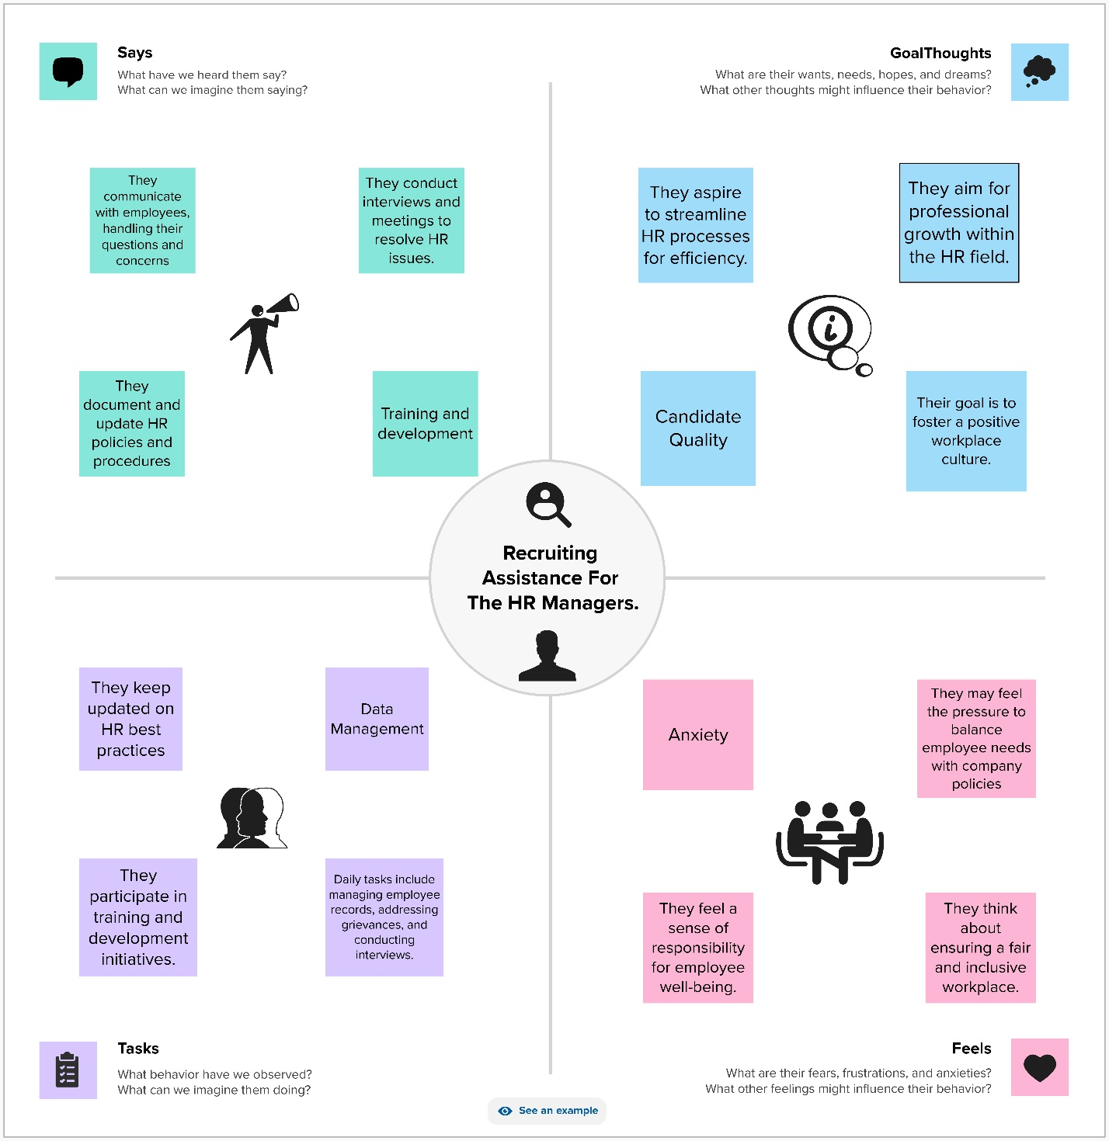

**1.7 Ideation & Brainstorming**

Brainstorming provides a free and open environment that encourages everyone within a team to participate in the creative thinking process that leads to problem solving.

Prioritizing volume over value, out-of-the-box ideas are welcome and built upon, and all participants are encouraged to collaborate, helping each other develop a rich number of creative solutions.

## Step-1: Team Gathering, Collaboration and Select the Problem Statement:

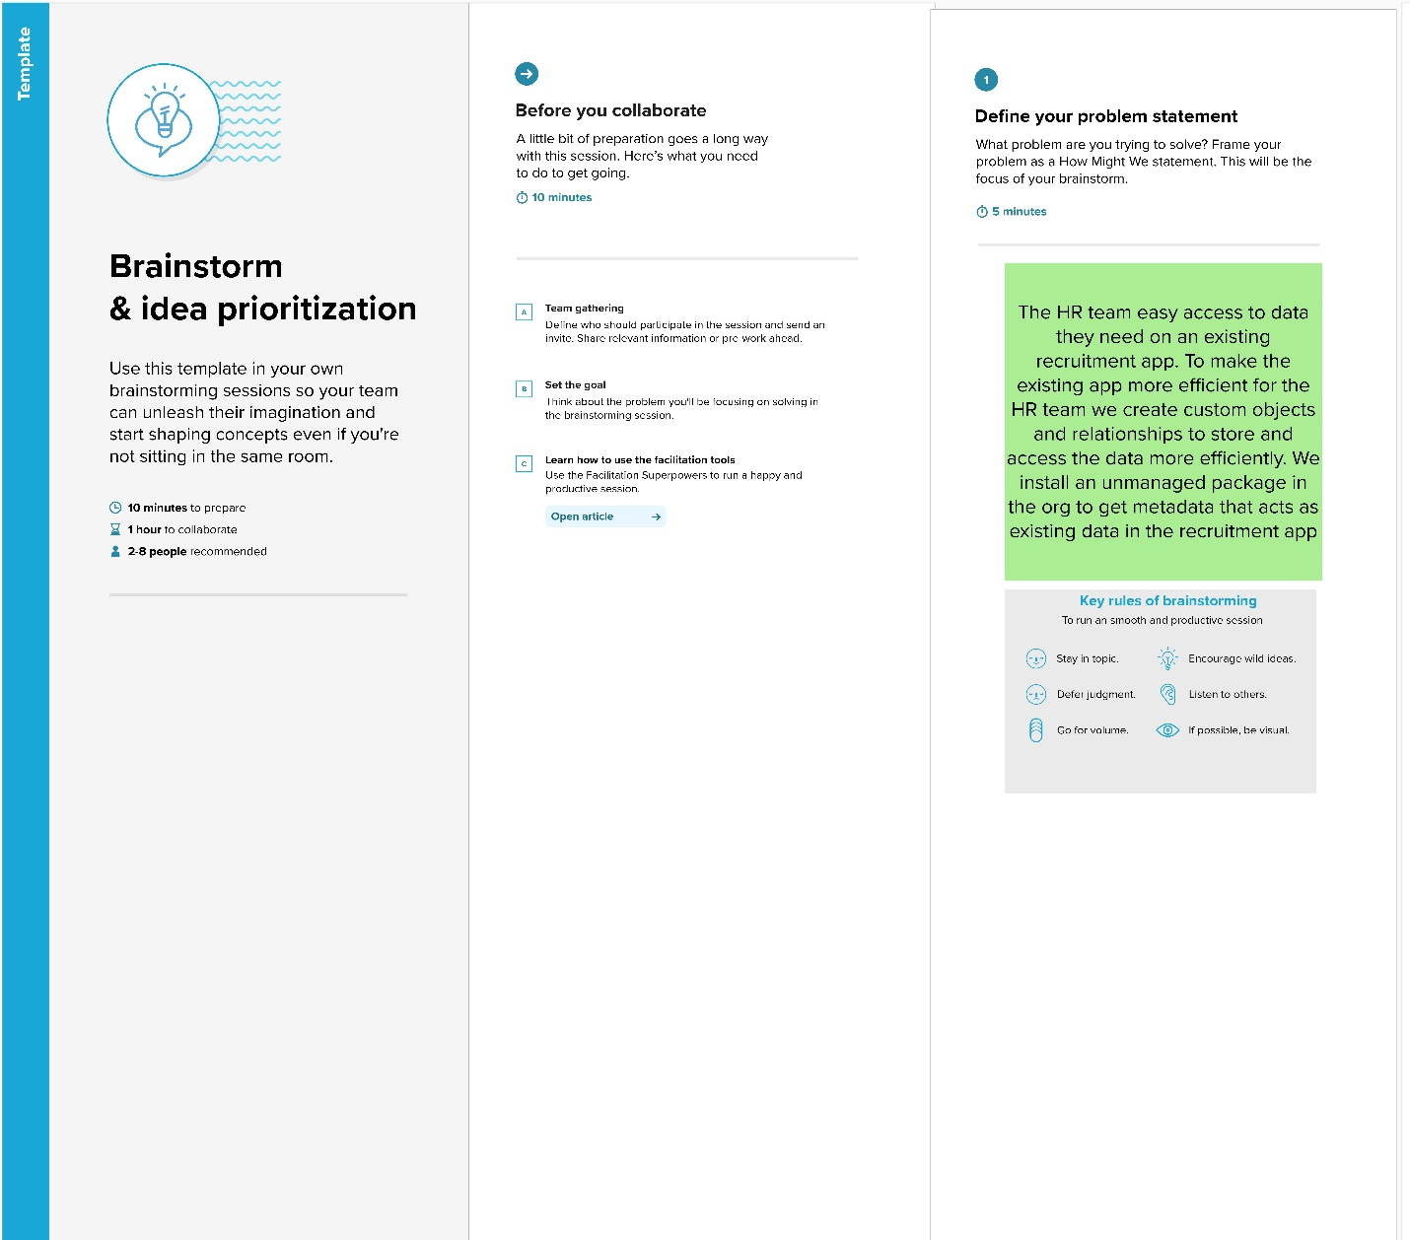**Step-2: Brainstorm, Idea Listing and Grouping:**

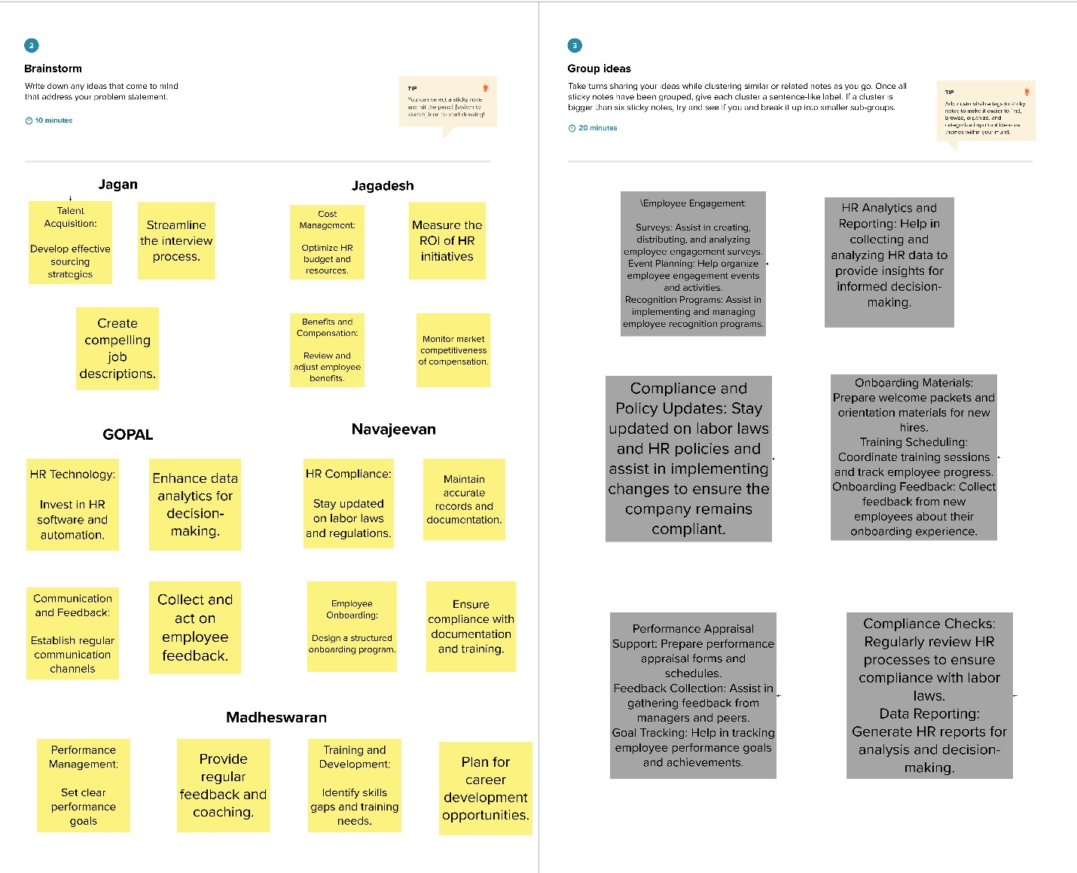

**Step-3: Idea Prioritization:**

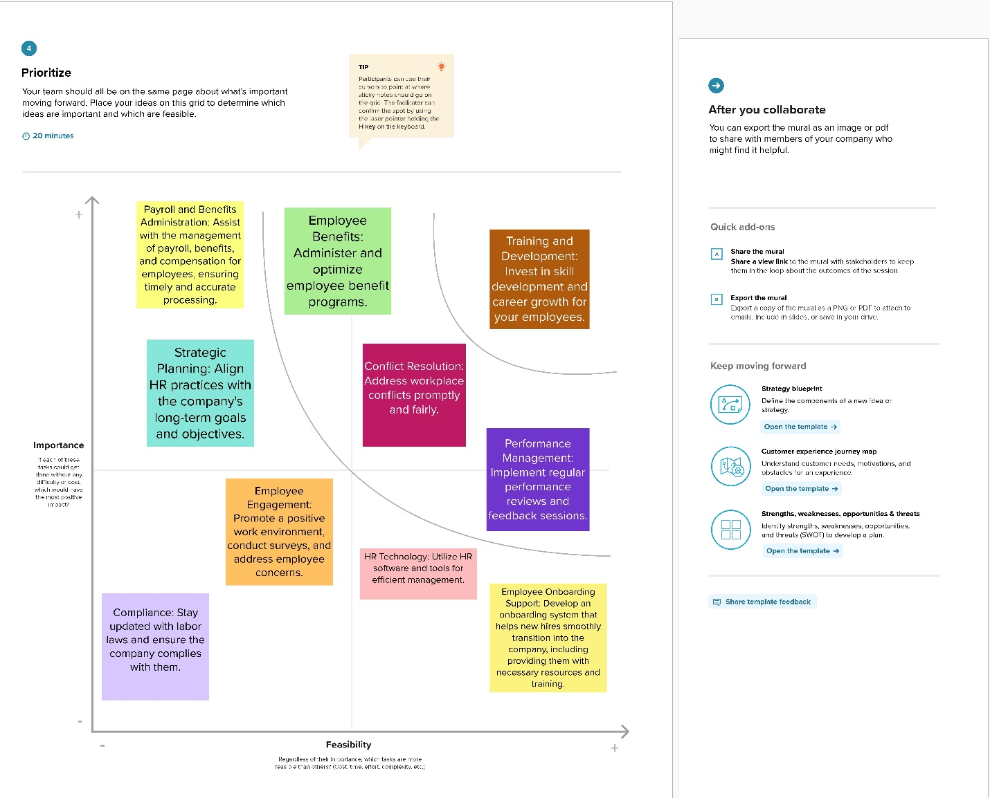

**CHAPTER - 2**

**PREPARATION DATA MODELING**

**2.1 Data Modelling**

For the recruitment app enhancement project aimed at assisting HR managers, the data preparation and modeling process should be meticulously planned to ensure the effective management and utilization of the custom objects and relationships. Here is a step-by-step guide for preparing data modeling in this context:

* 1. **Salesforce Developer Org**

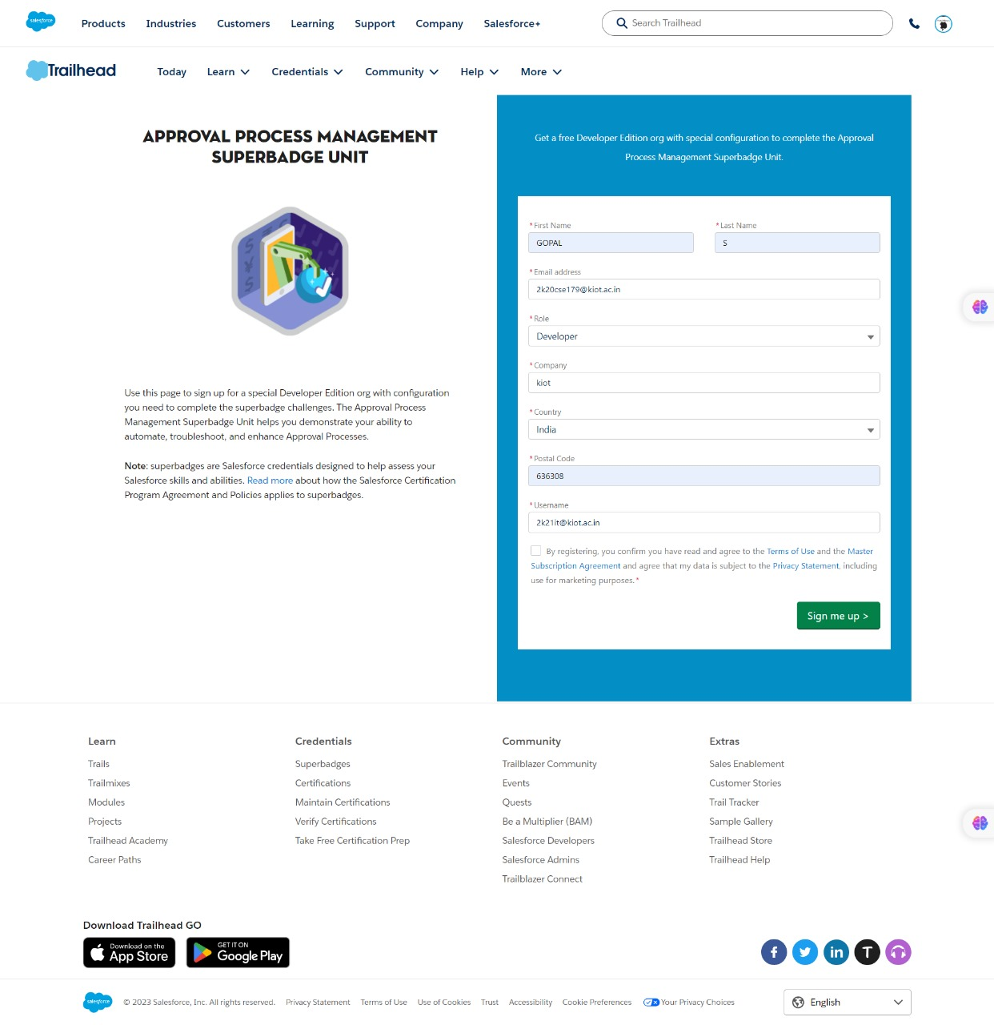In Salesforce, a Developer Sign Up or Developer Edition is a special type of Salesforce environment that is primarily used for development, testing, and learning purposes.

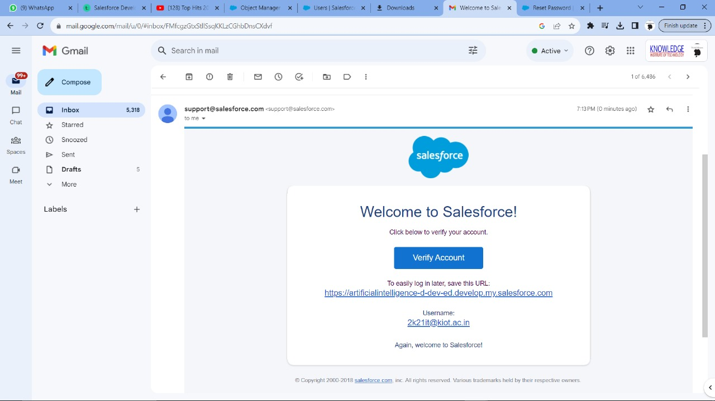 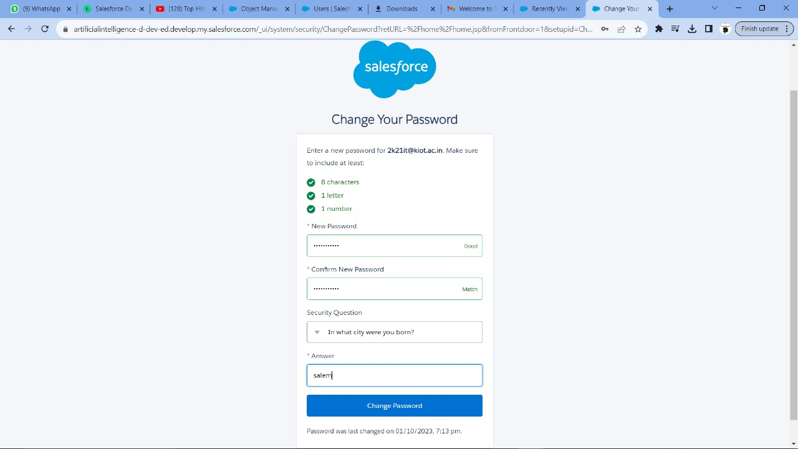

**2.3 Define Data Requirements:**

Collaborate with the HR team to identify the specific data points required for effective recruitment management, such as candidate information, job openings, interview details, and onboarding purpose

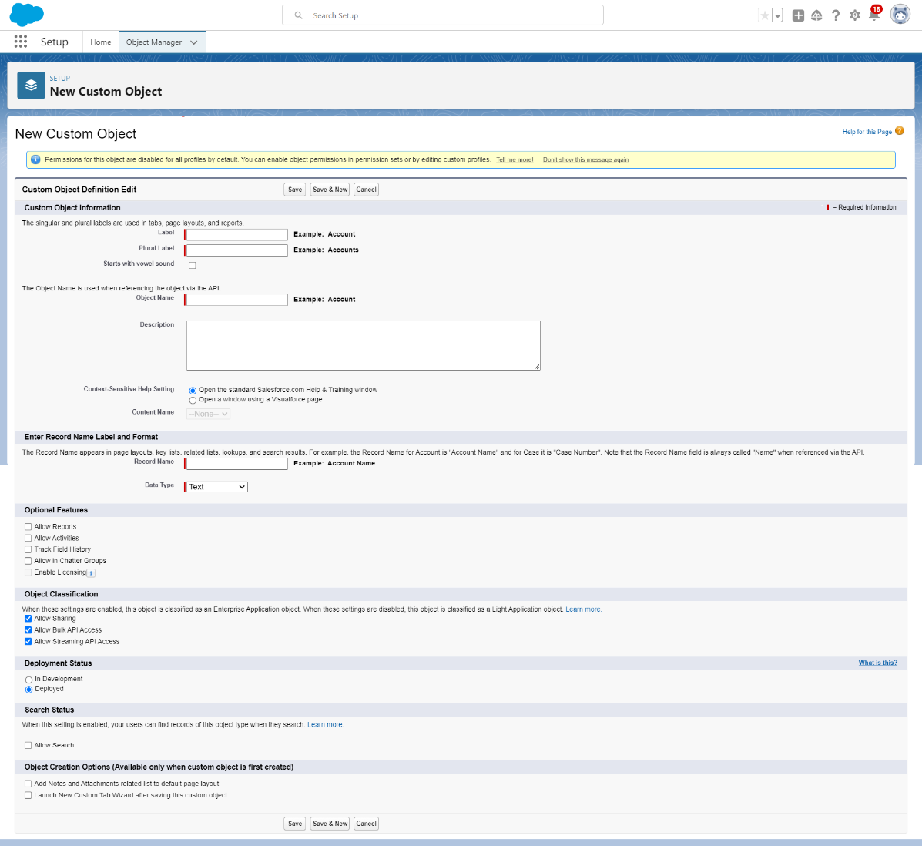

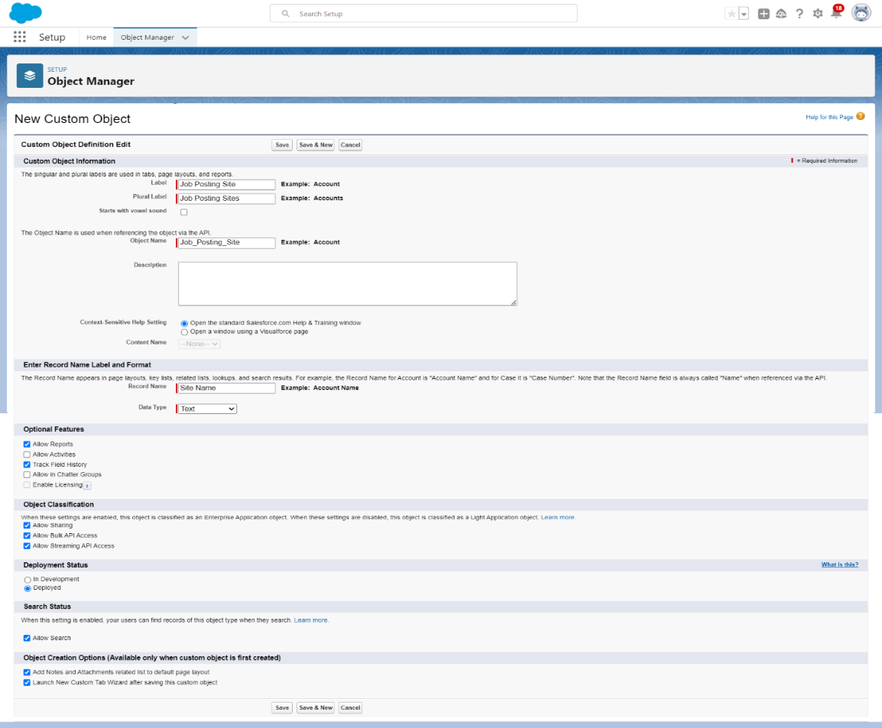

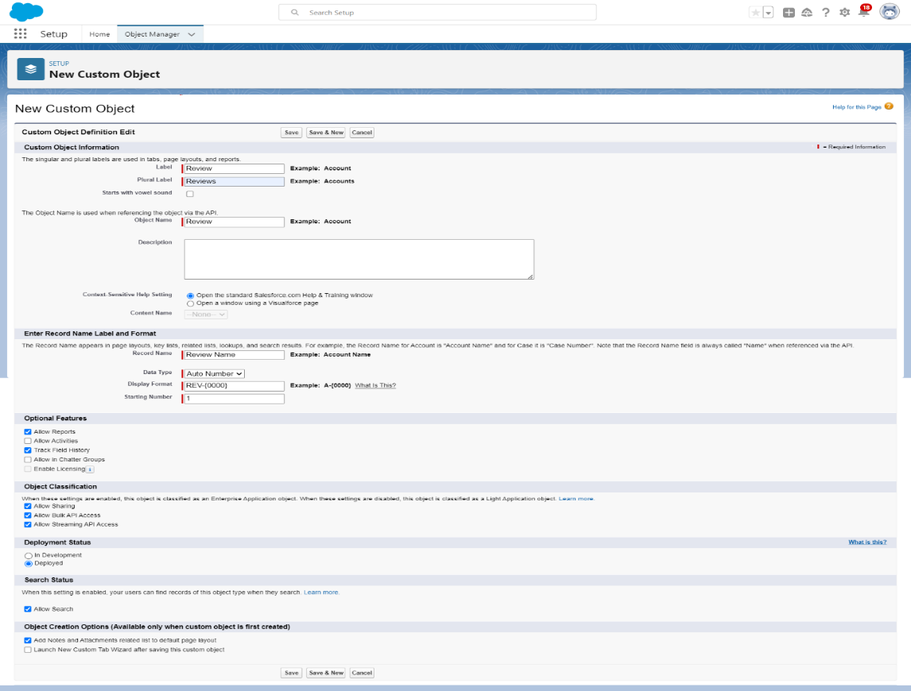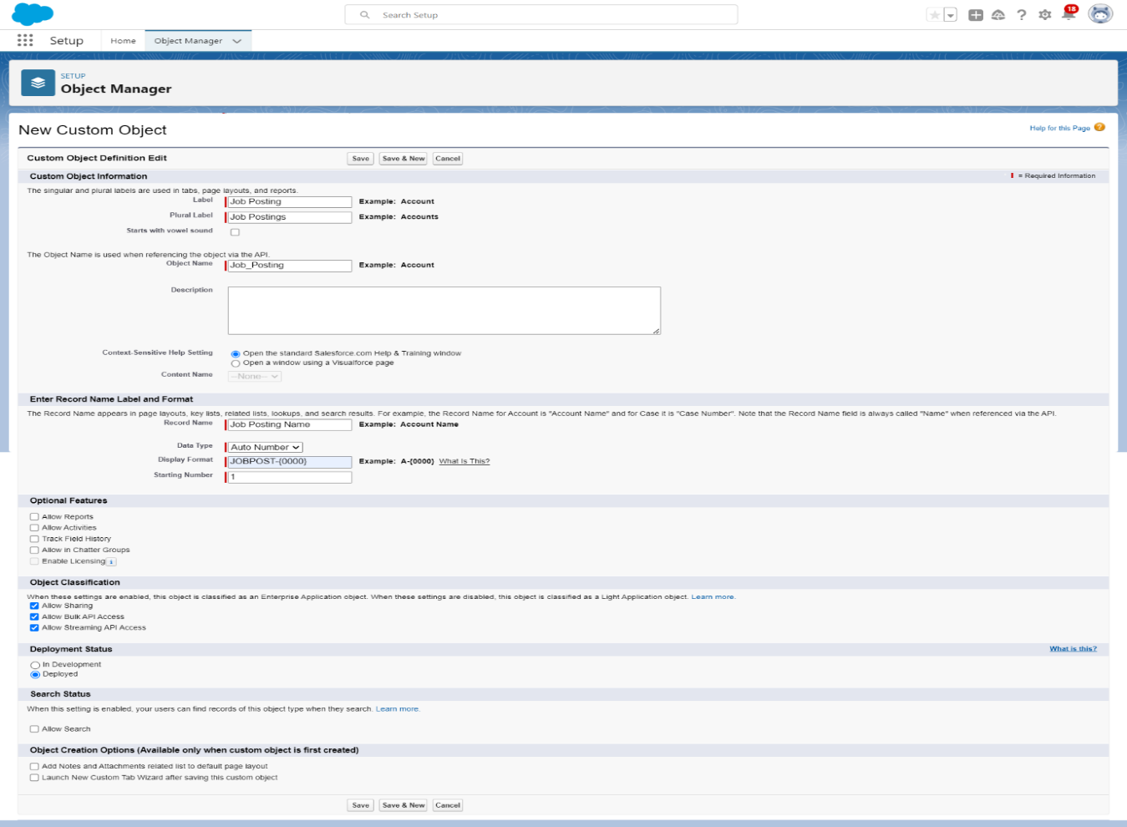

**2.4 Design Custom Objects and Relationships**

Create custom objects, such as "Candidates," "Job Openings," and "Interviews," with relevant fields to capture essential data points for each category.

Establish appropriate relationships, such as master-detail or lookup relationships, between the custom objects to enable efficient data access and navigation for the HR team.

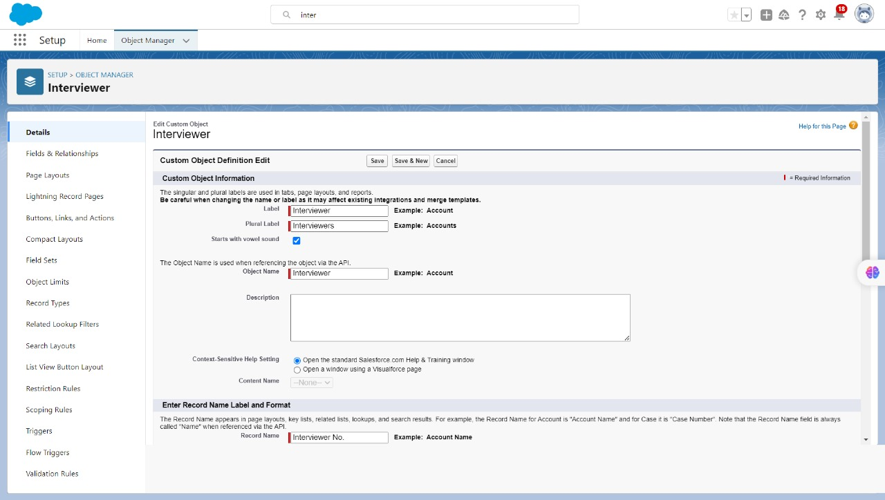

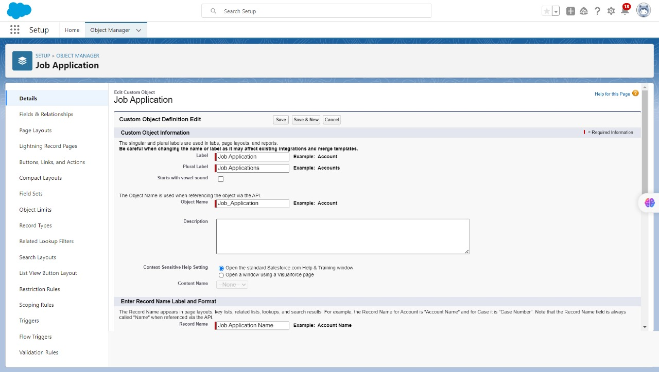



**2.5 Custom Object and Relationship Creation:**

From the object manager, click on the job posting site, then click on Fields & Relationships.

1. Click the gear icon and select Setup. This launches Setup in a new tab.

2. Click the Object Manager tab next to Home.

3. Select the job posting sites.

4. Click field and relationship than click new.

5. Select the data type as URL.

6. Click next.

7.For Field Label, enter the Job Posting Site URL.

8.Click Next, Next, and click Save & New.

Now let's create the other fields and we must choose the data types of the fields carefully

1. Status(Picklist)(Active Inactive)It should be in separate line

2. Select the Checkbox as the Data Type, then click Next

3. For Field Label, enter Technical Site.

4.Select the Text Area as the Data Type, then click Next.

For Field Label, enter Description.

Click Next, Next, then Save & New

Create pick list field for Job Posting Site object  
Click on the gear icon and then select Setup

* After the above steps, Select Job Posting Site Object
* Now Select Fields and relationships from setup menu of the Attendee object.
* Click new and select Pick list fields ?next and enter label name(Status) and select enter values option(Active, Inactive),next, next and Save

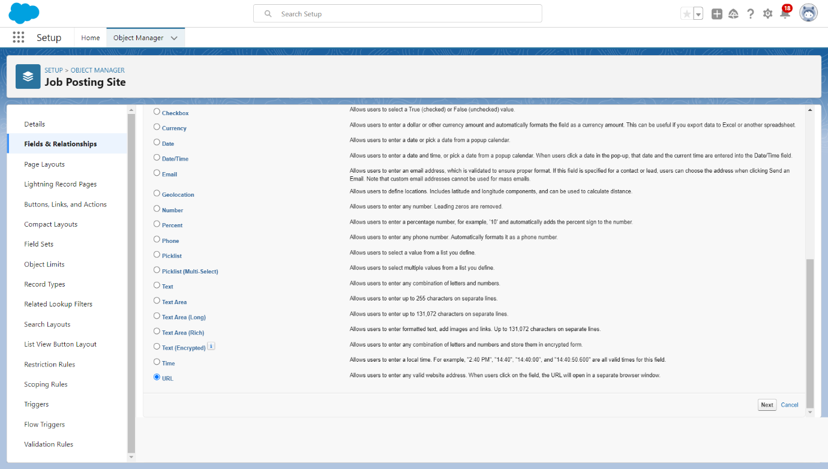

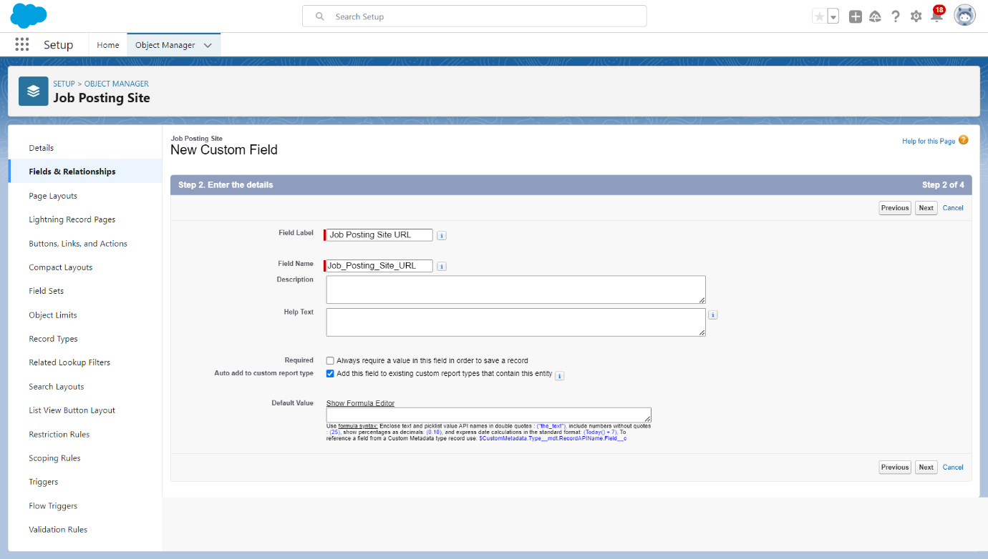

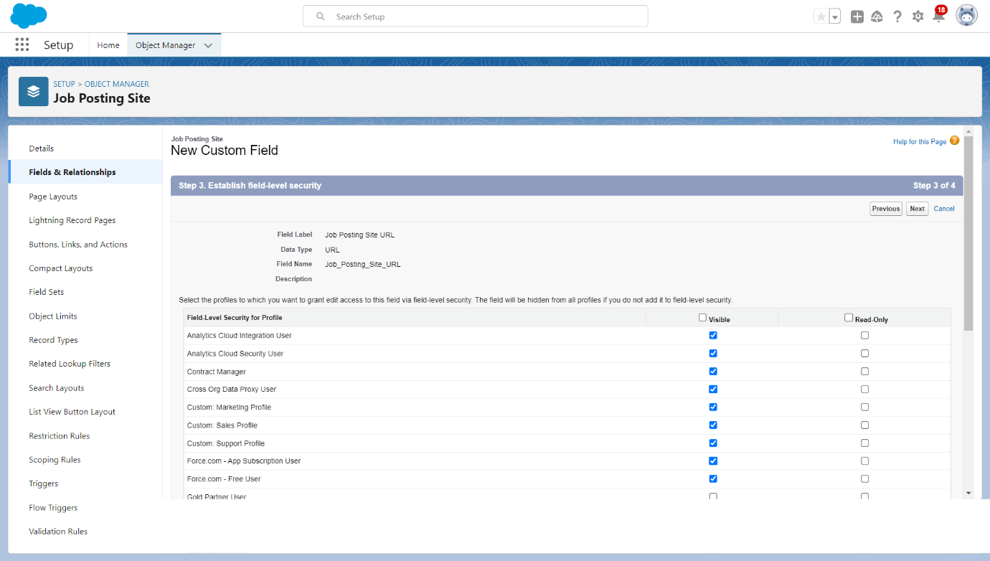

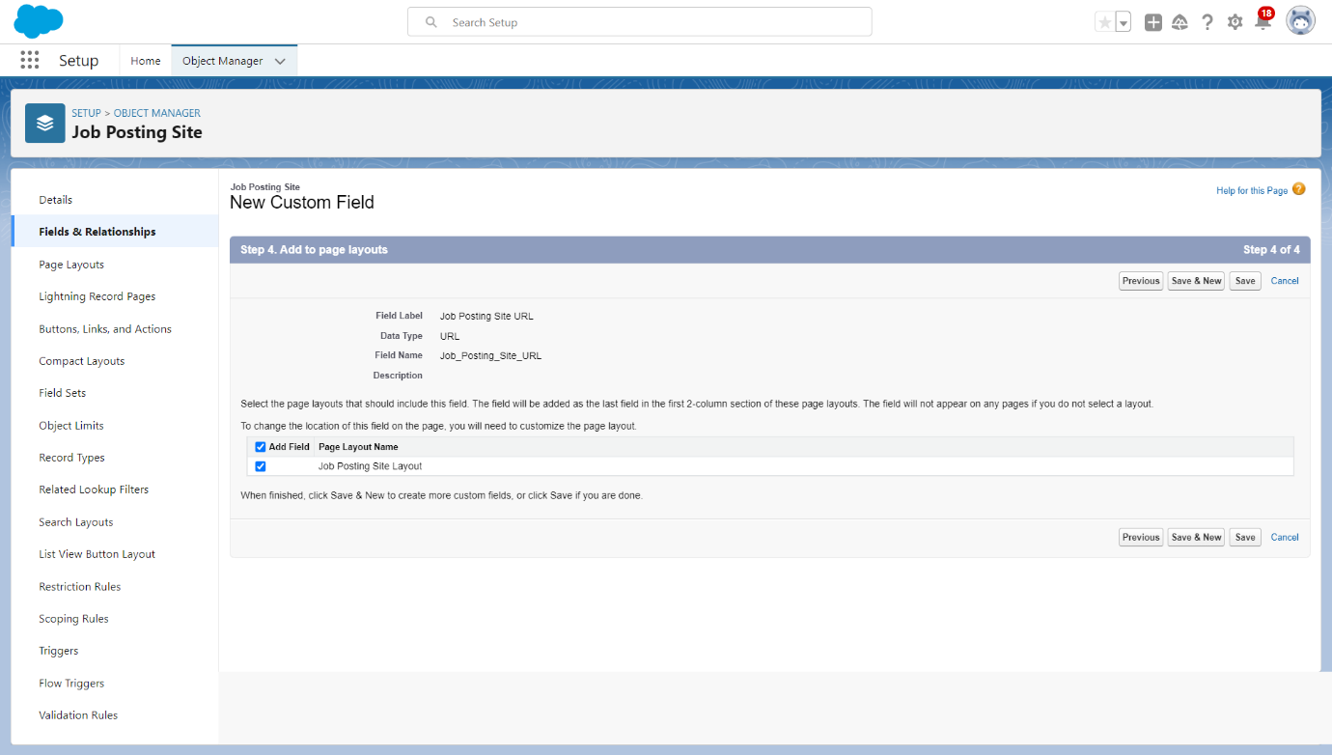

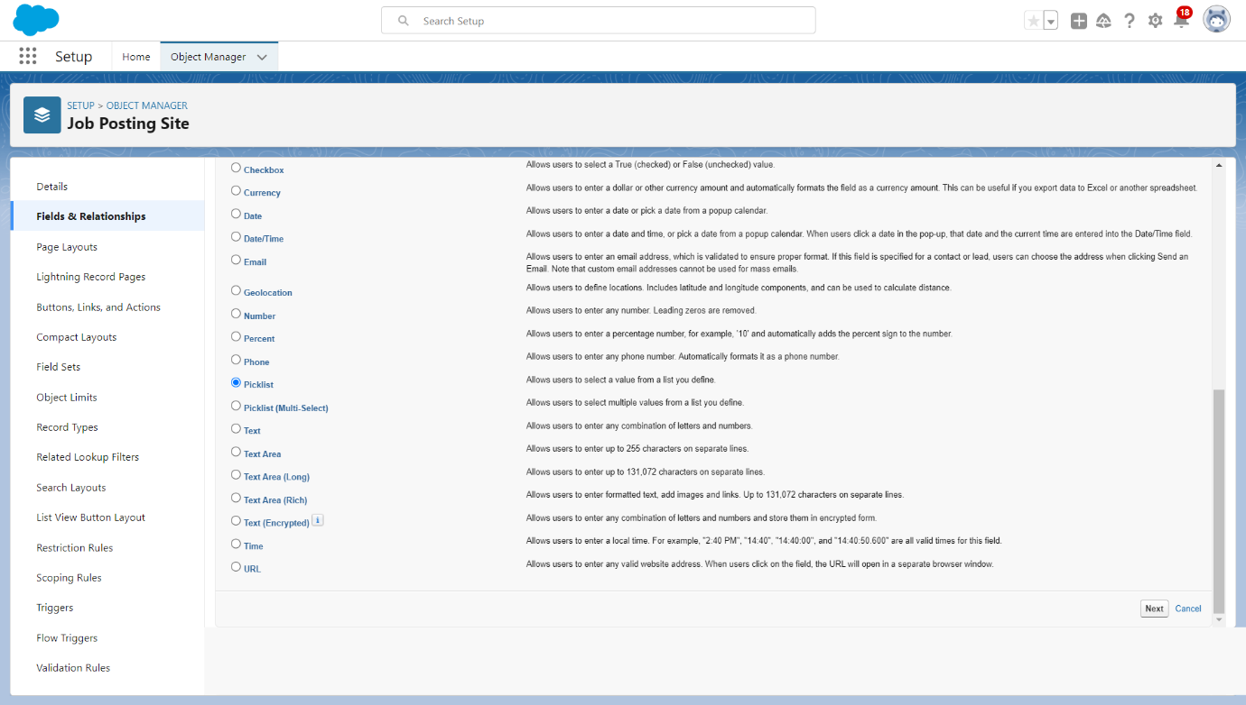

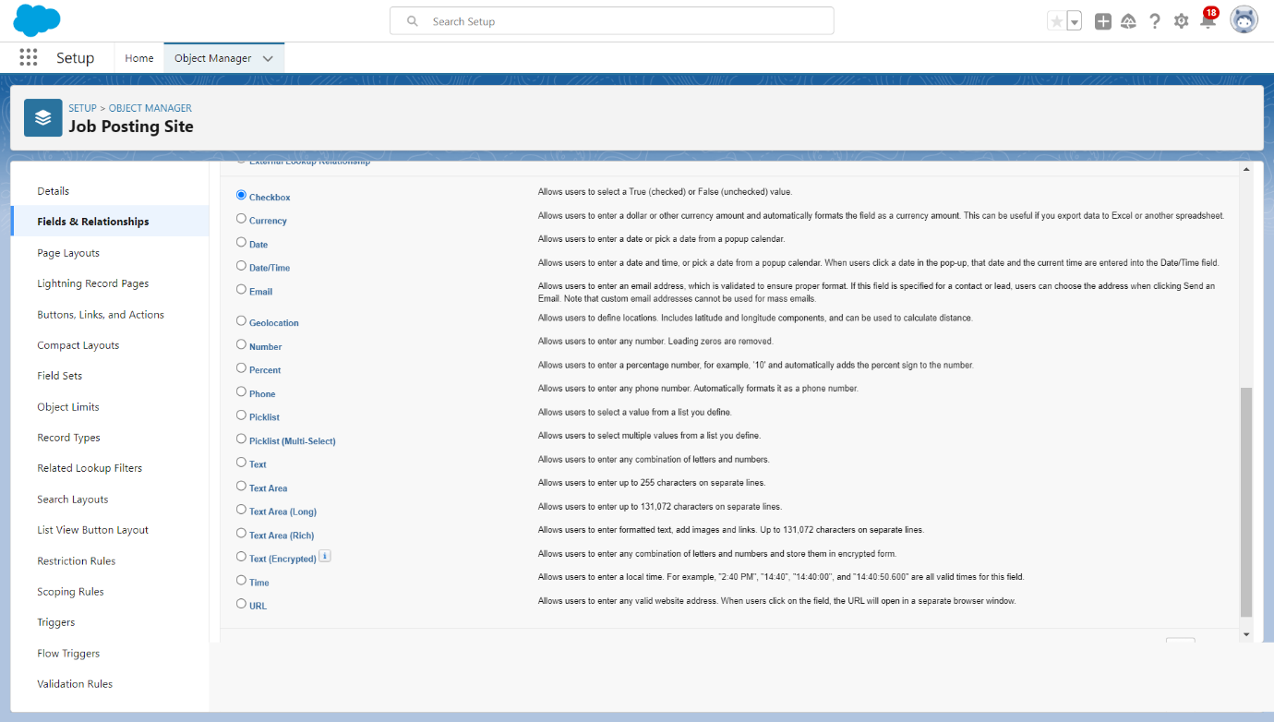

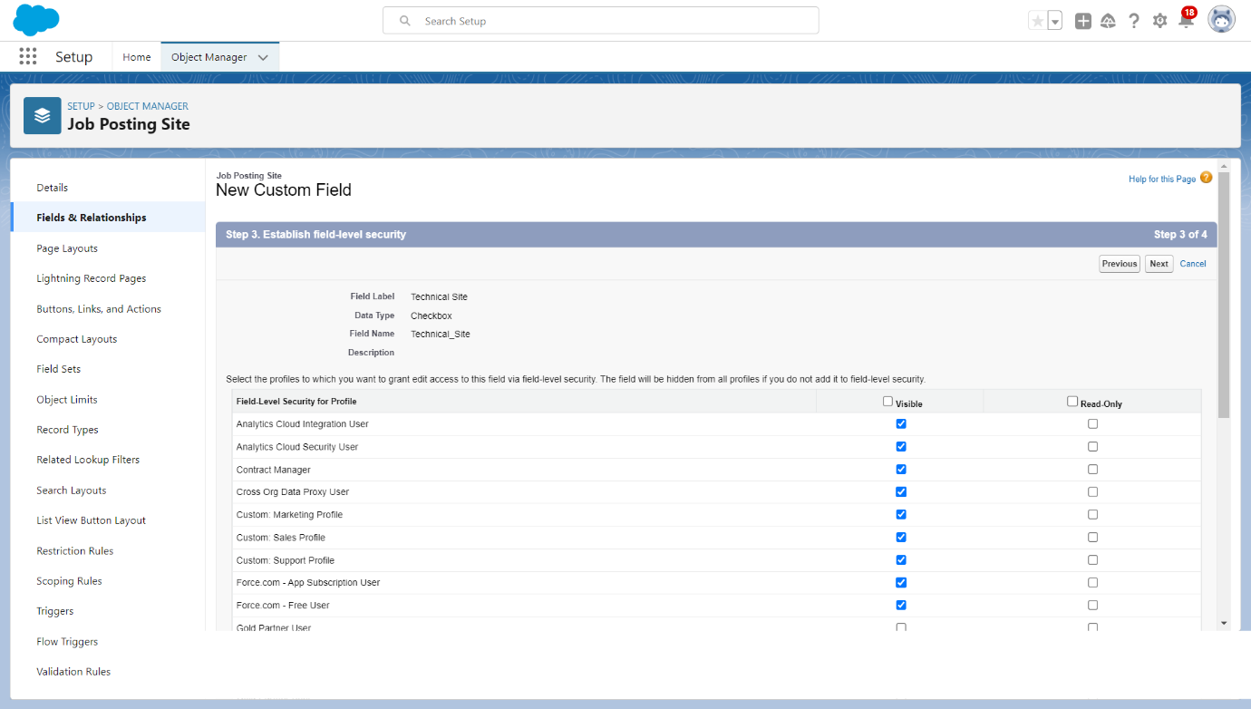

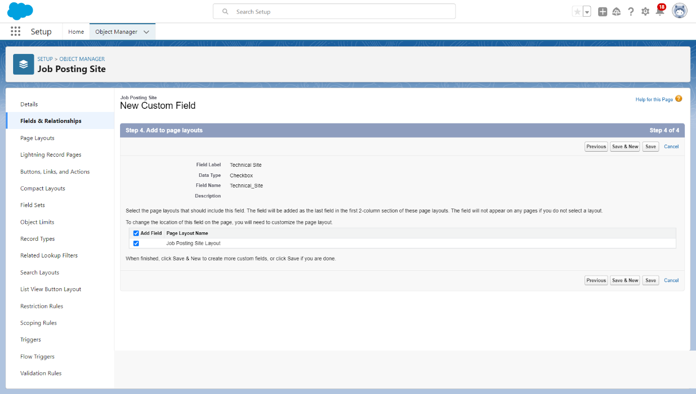

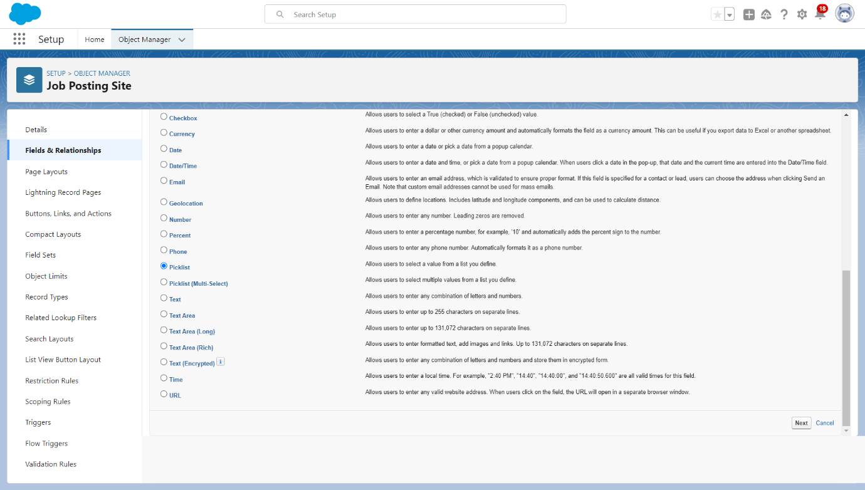

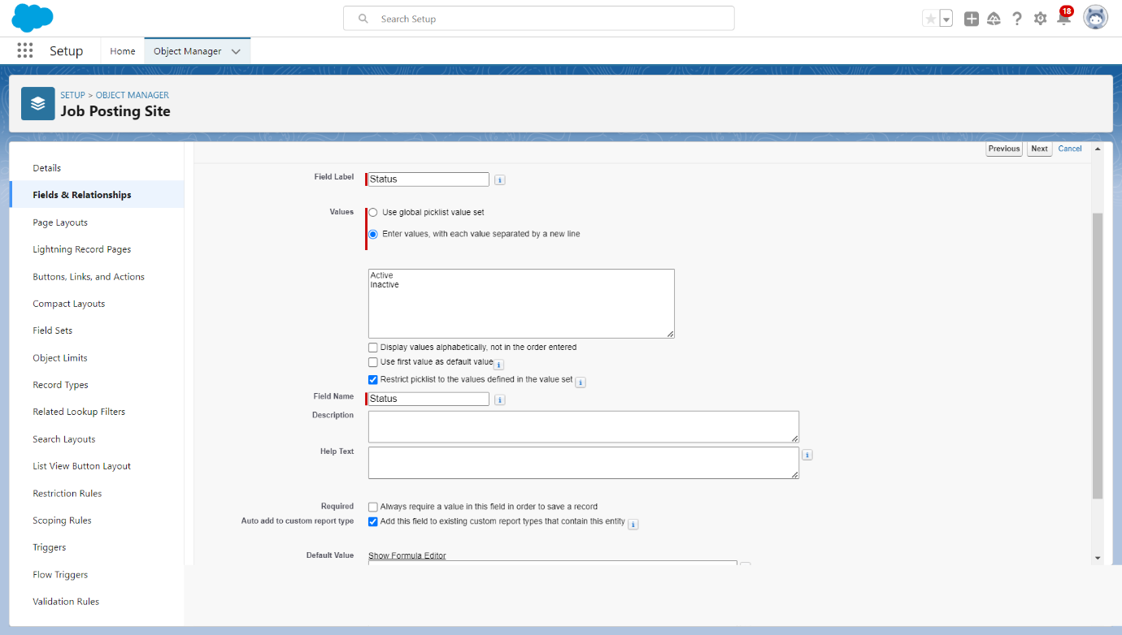

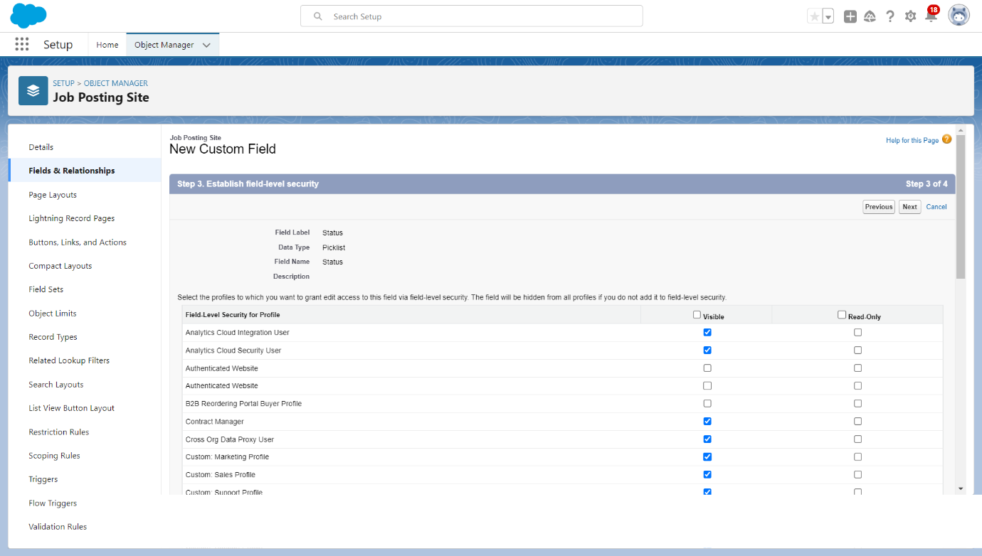

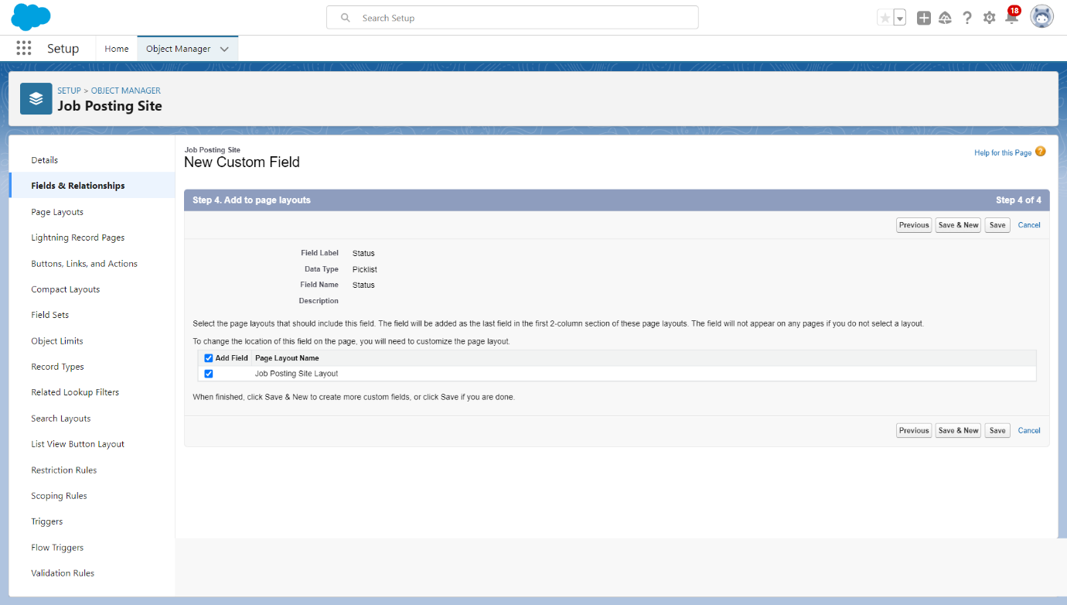

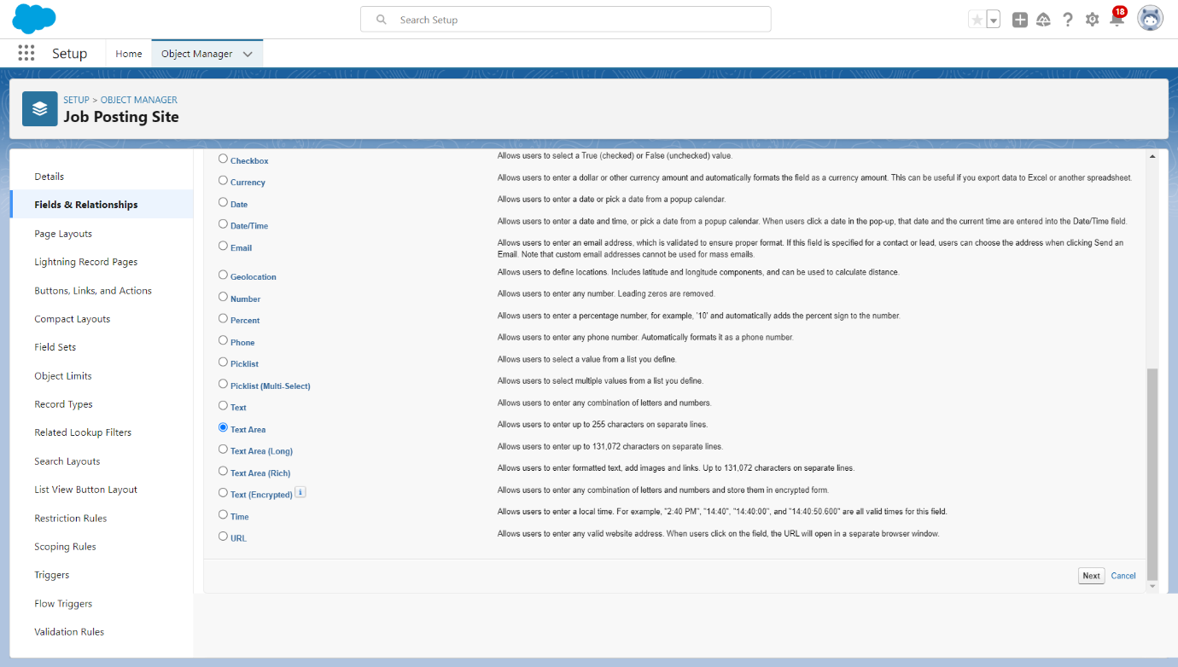

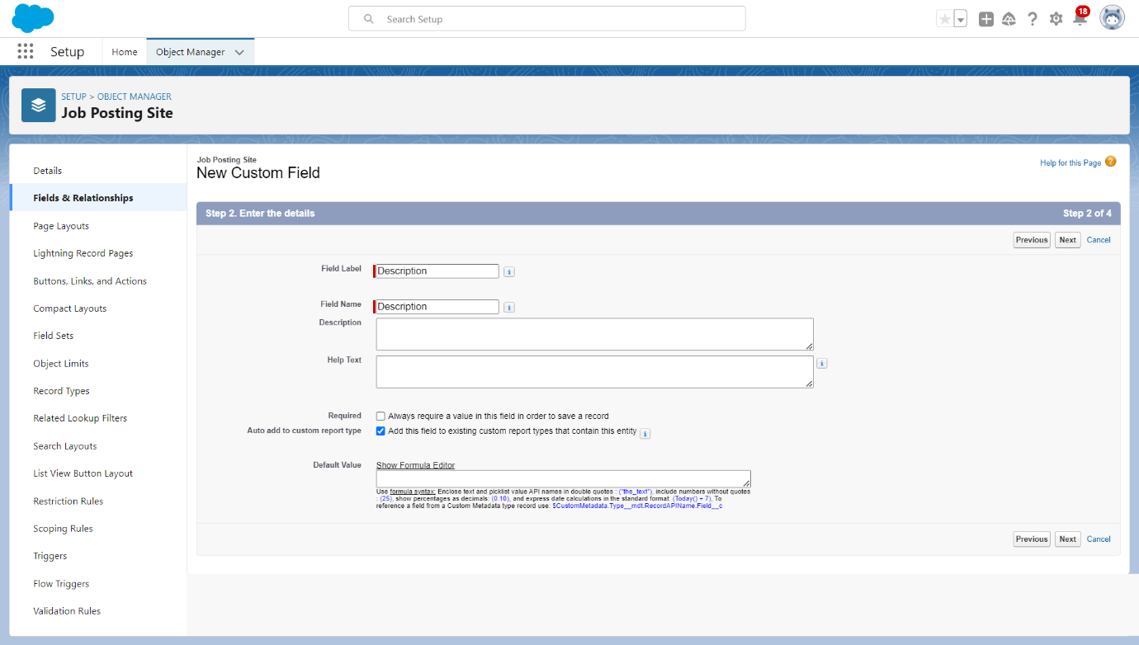

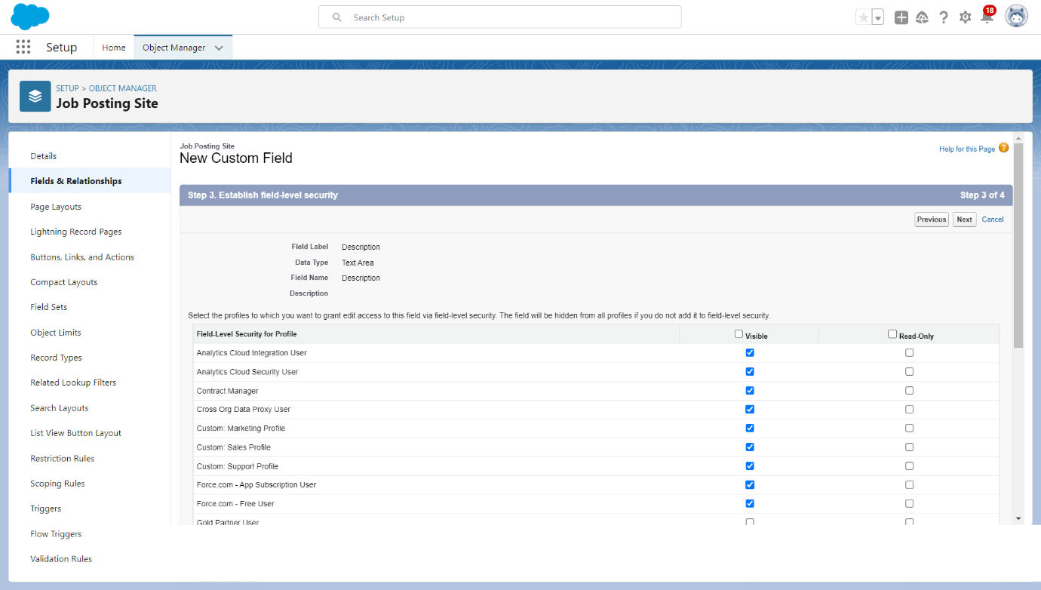

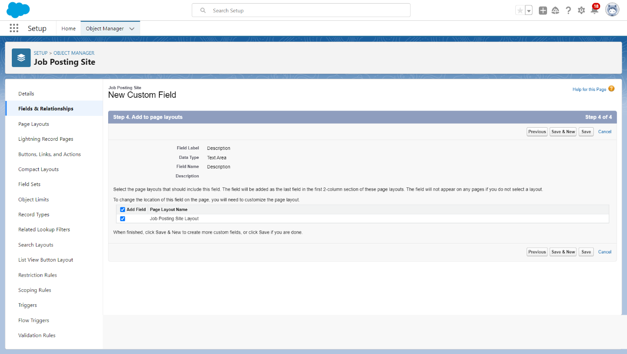

**2.6 Create Relationships For Job Posting**

Creating a master-detail relationship between Job posting and job posting site.

1. From Setup, go to Object Manager

2.Select job posting and click Fields & Relationships.

3. Click New

4. Choose Master-detail Relationship and click Next  
5. Choose the related Object (Job posting site) and select that object.

6. Enter the label name(Job Posting Site) for the lookup field

7. Click Next, Next, and Save

Creating a master-detail relationship between job posting and position for job posting object.

1. From setup, click object manager.

2. Select Job posting object, click on field and relationships, click new.

3. Select the data type as Master-detail relationship.

4.Click Next, relate to position.

5.Enter the label Position.

6. Click next, next, next and save.

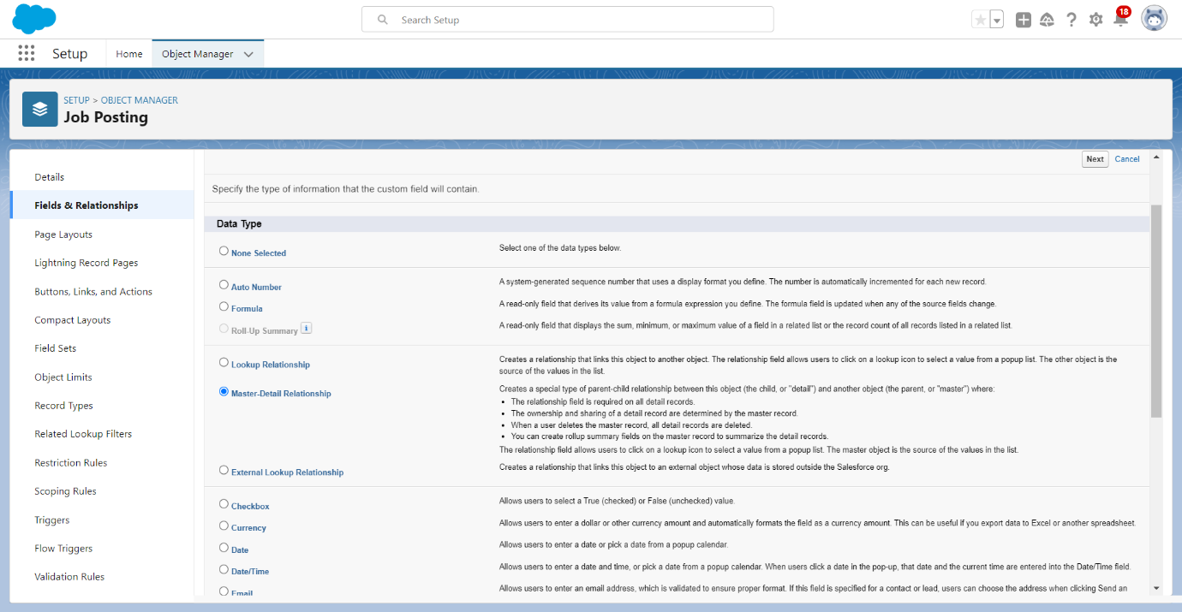

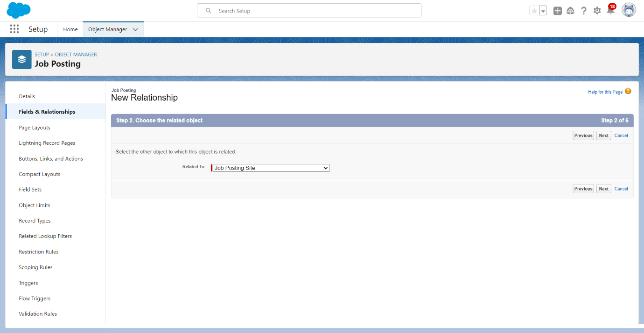

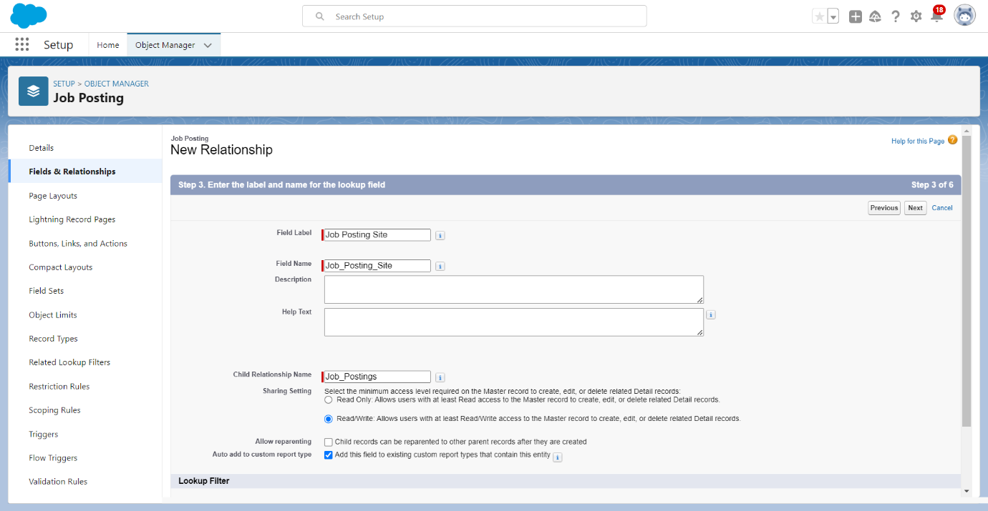

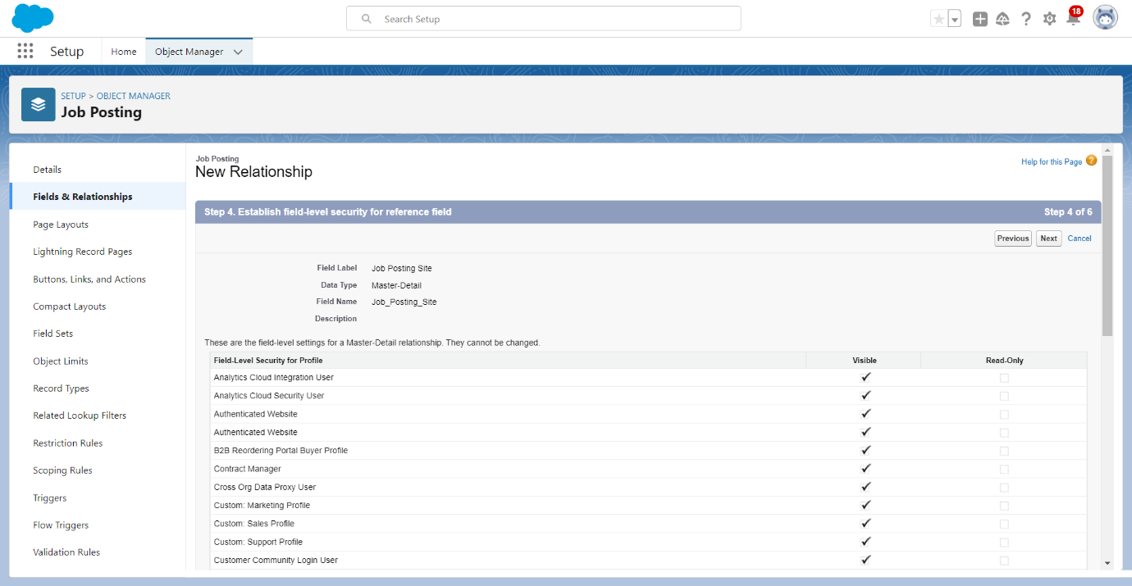

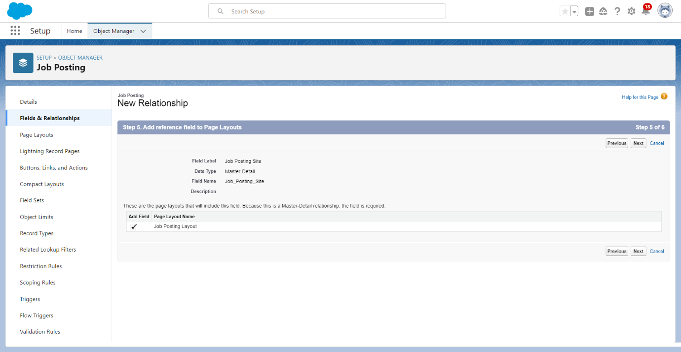

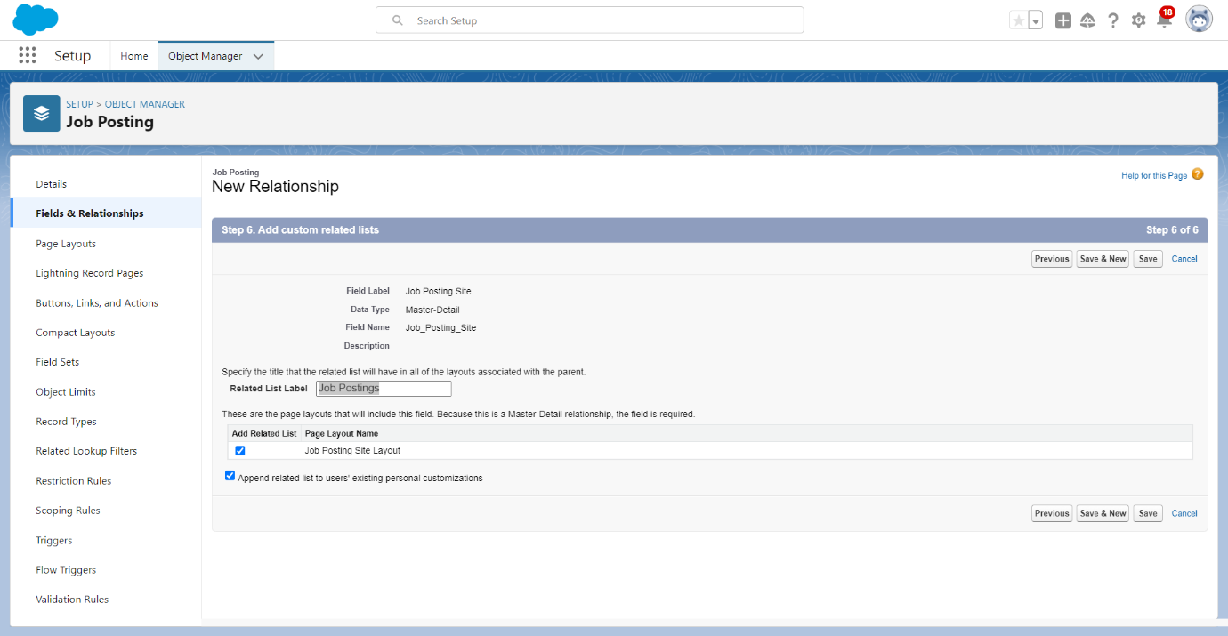

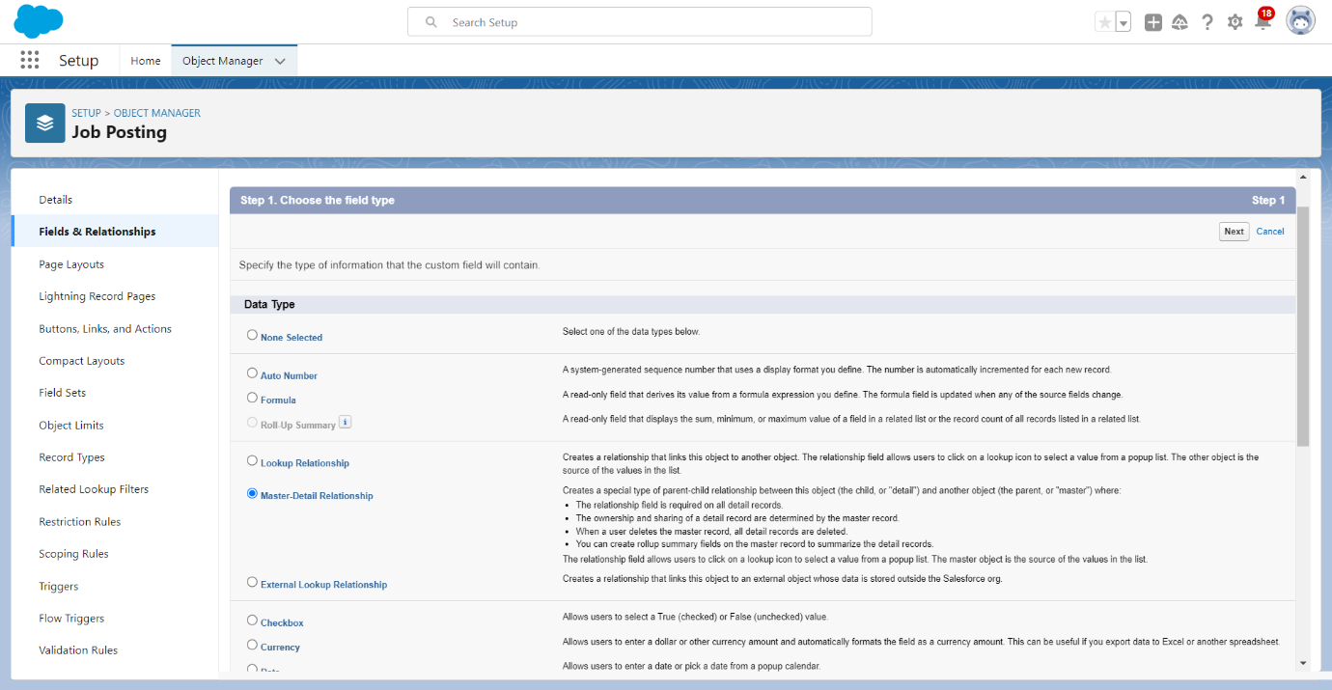

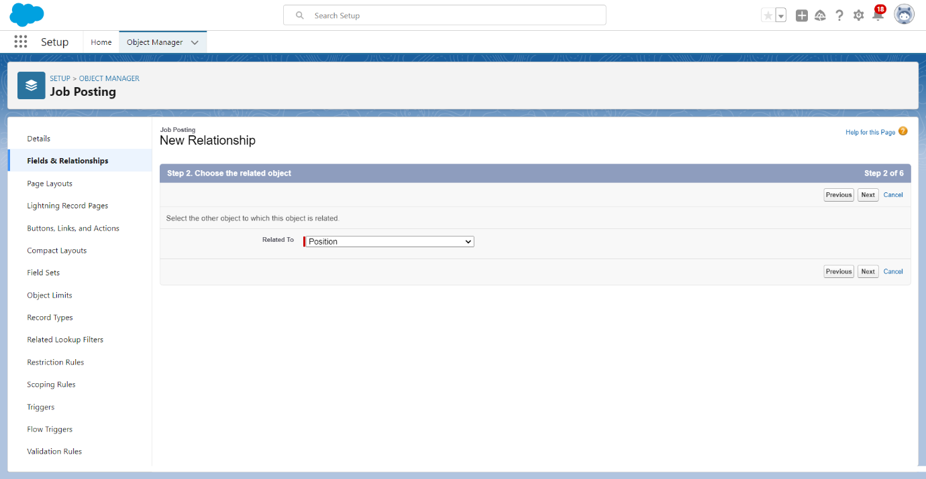

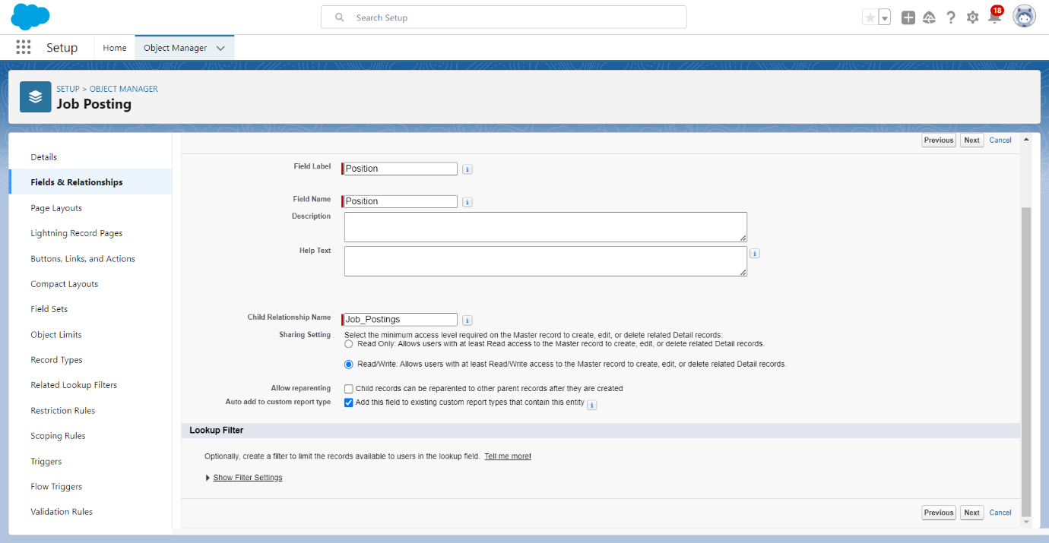

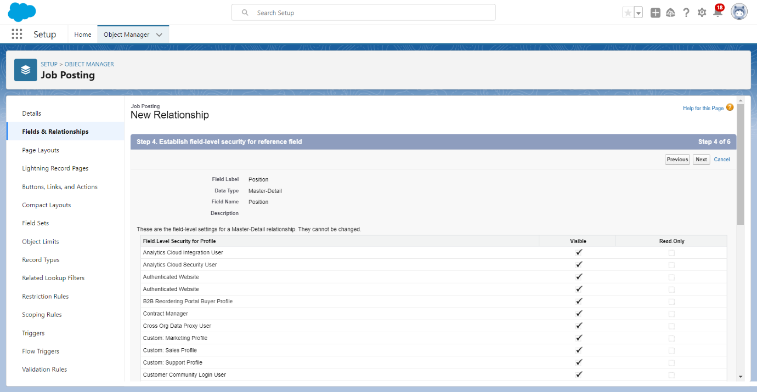

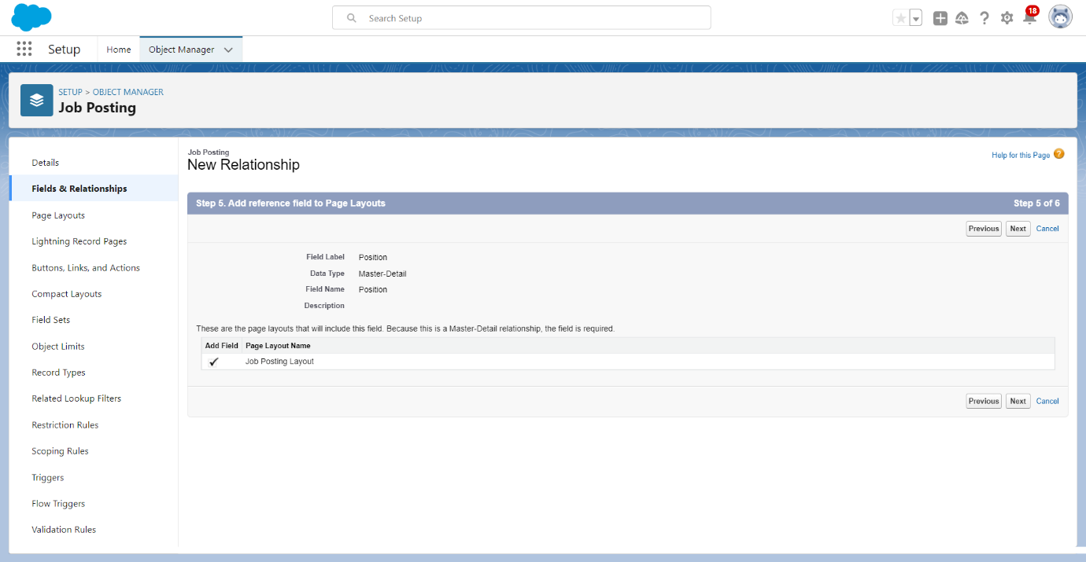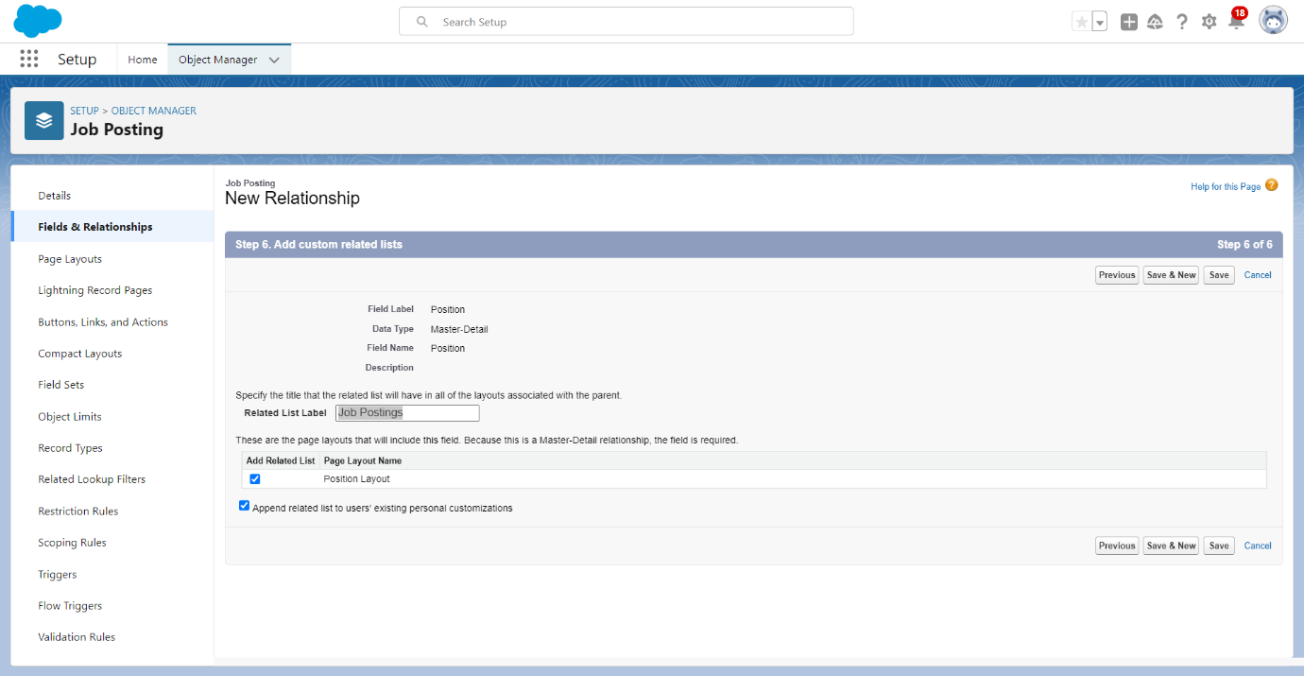

### **2.7 Create A Tab**

Salesforce Tabs are like the menu options in a software application. They allow you to access specific functions, objects, or data.

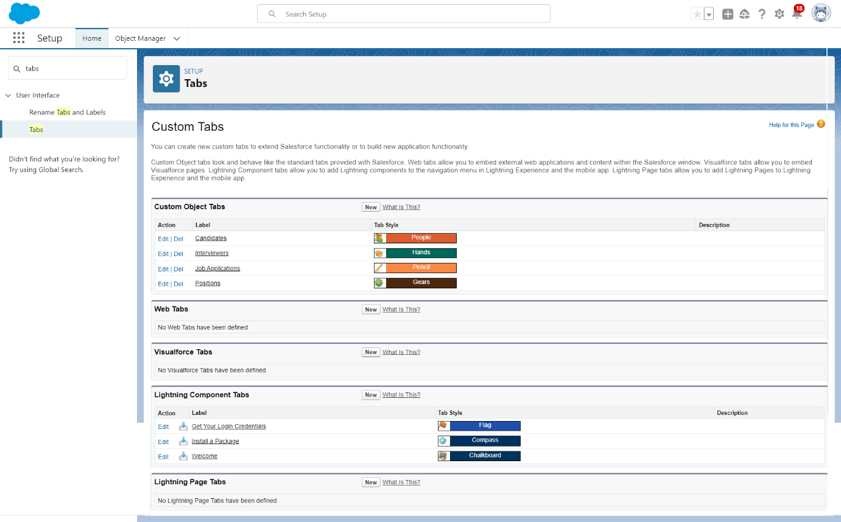

### **Creation Of Reviews Tab**

Now create a custom tab.

1. Click on Home tab, enter Tabs in Quick Find and select Tabs.
2. Under custom object tabs, click New.
3. For Object, select Reviews.
4. For Tab Style, select any icon.
5. Leave all defaults as is. Click Next, Next, and Save.

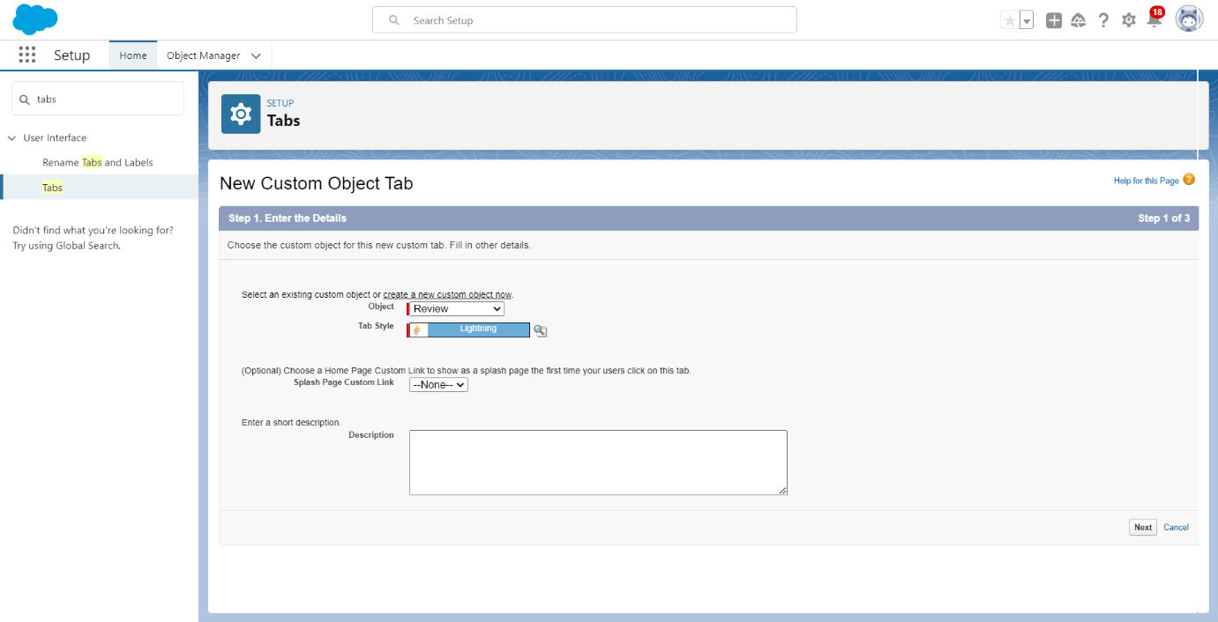

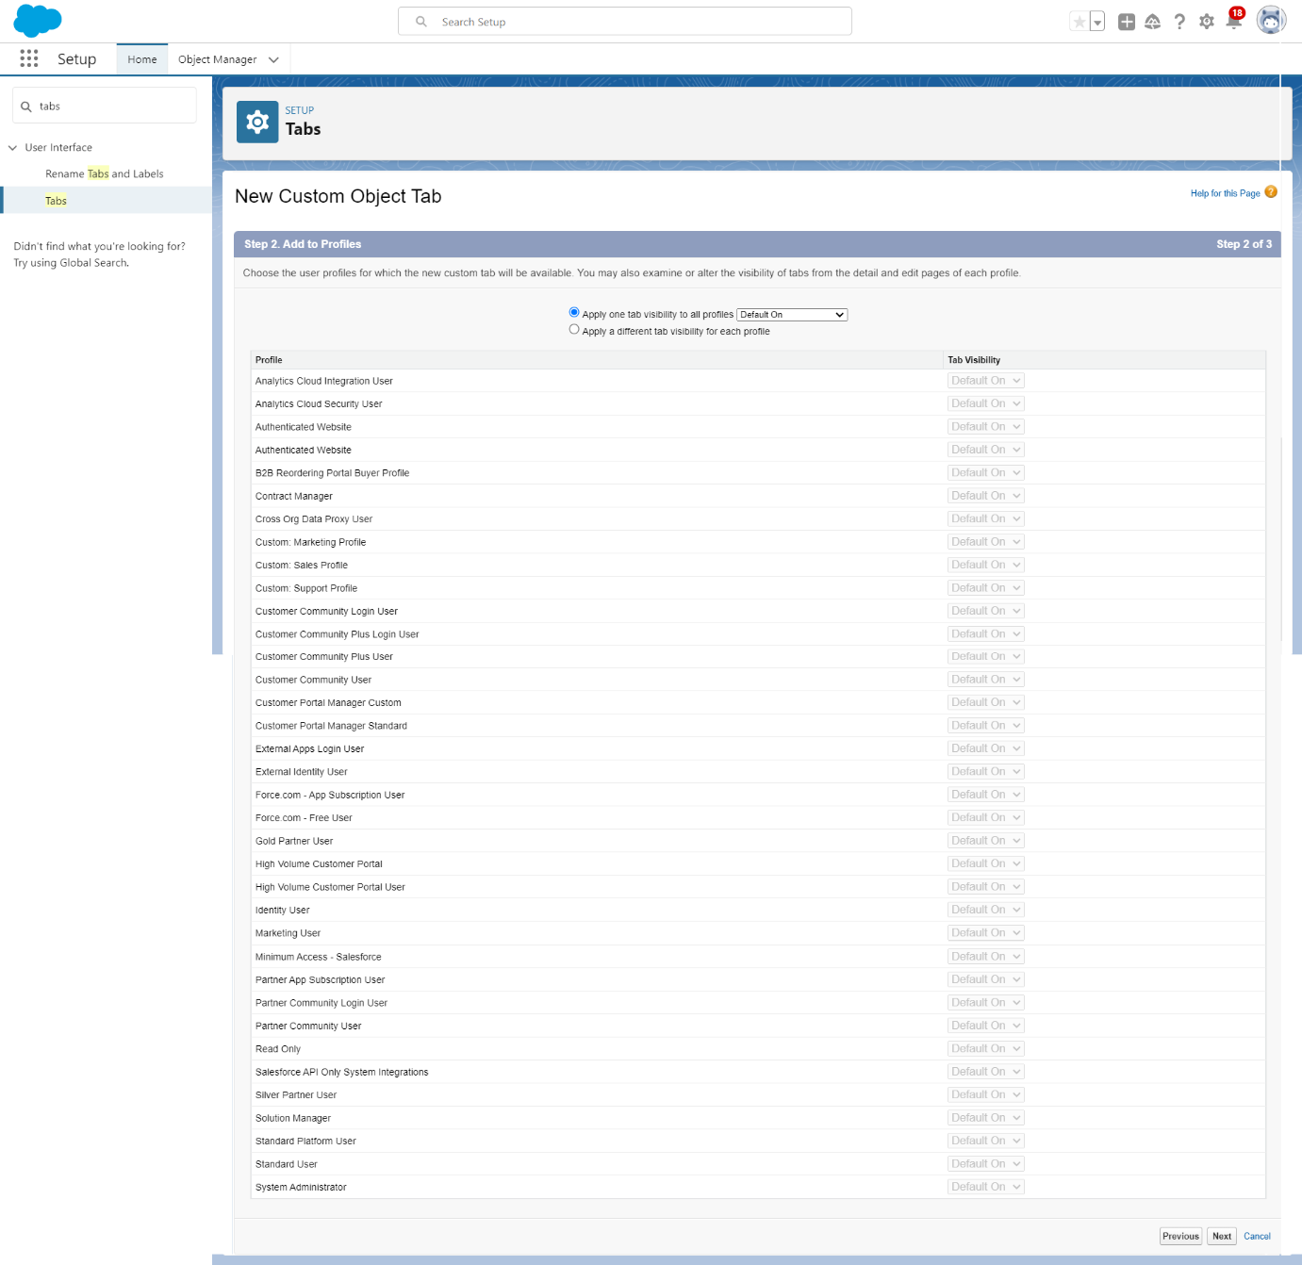

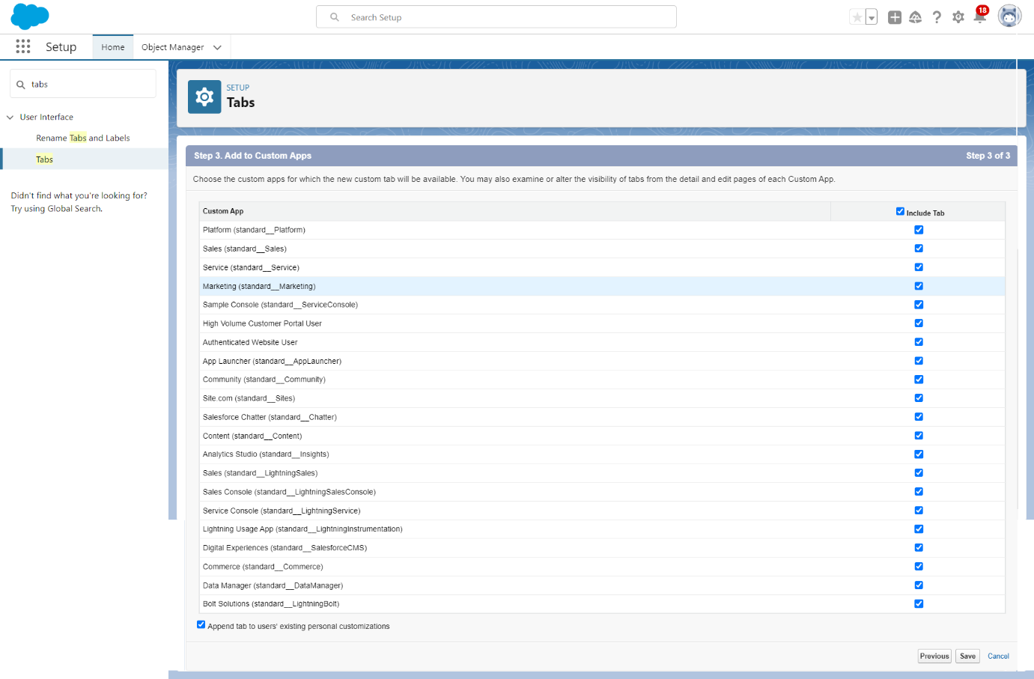

### **Creation Of Job Postings Tab**

Now create a custom tab.

1. Click on Home tab, enter Tabs in Quick Find and select Tabs.
2. Under custom object tabs, click New.
3. For Object, select Job Postings.
4. For Tab Style, select any icon.
5. Leave all defaults as is. Click Next, Next, and Save.

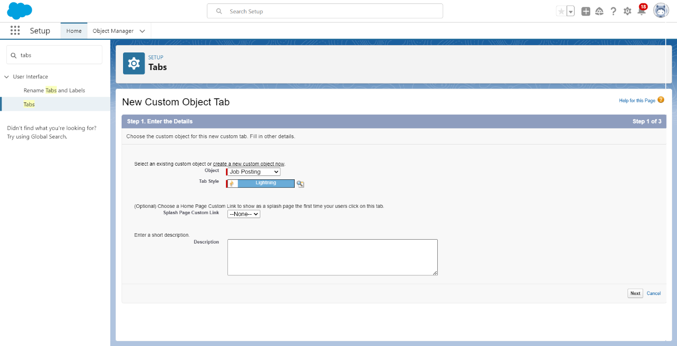



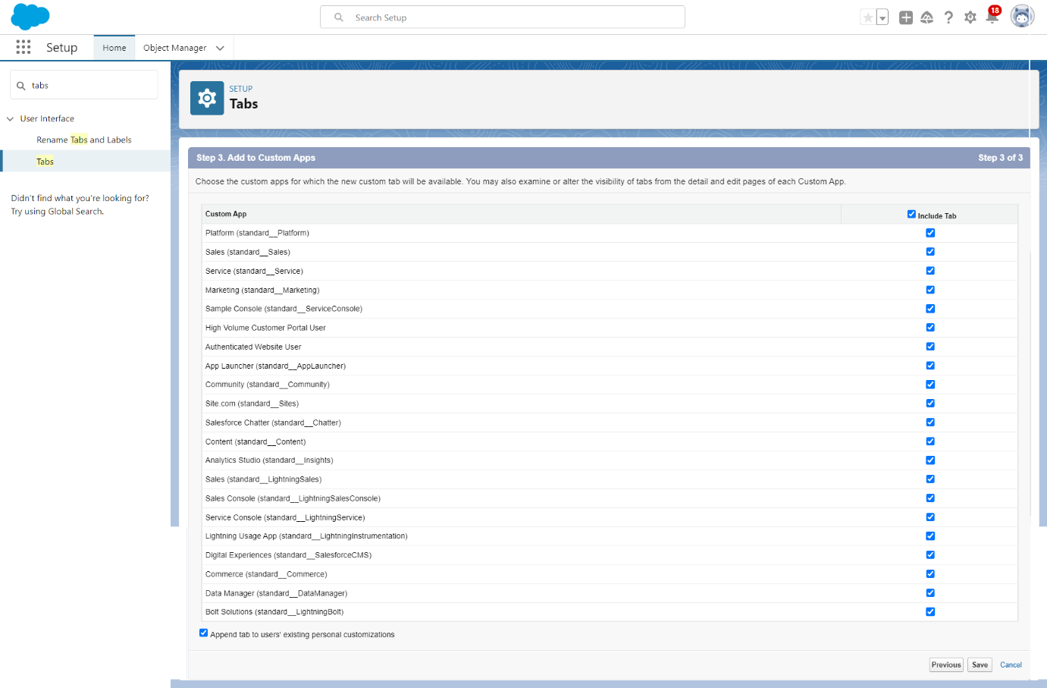

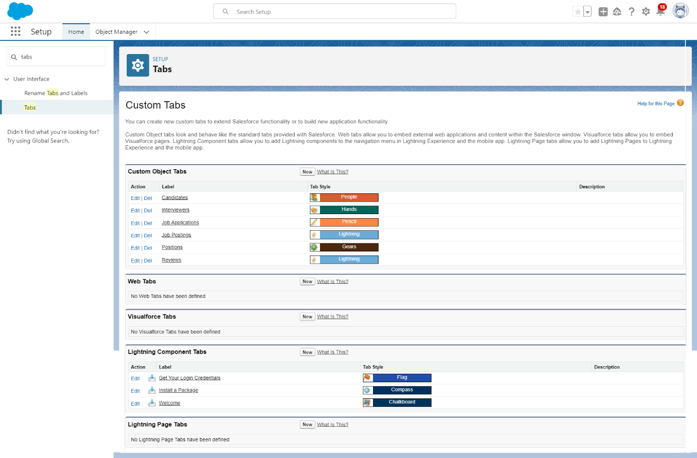

**2.8 Create a Lightning App**

The Lightning App Builder is a point-and-click tool that makes it easy to create custom pages for the Salesforce mobile app and Lightning Experience, giving your users what they need all in one place.

Create a Travel Approval Lightning App

* + - Build a Lightning app, add tabs, and customize page layouts.
    - Create custom objects and fields for the app.
    - Define relationships between objects.
    - Import data and test the app.

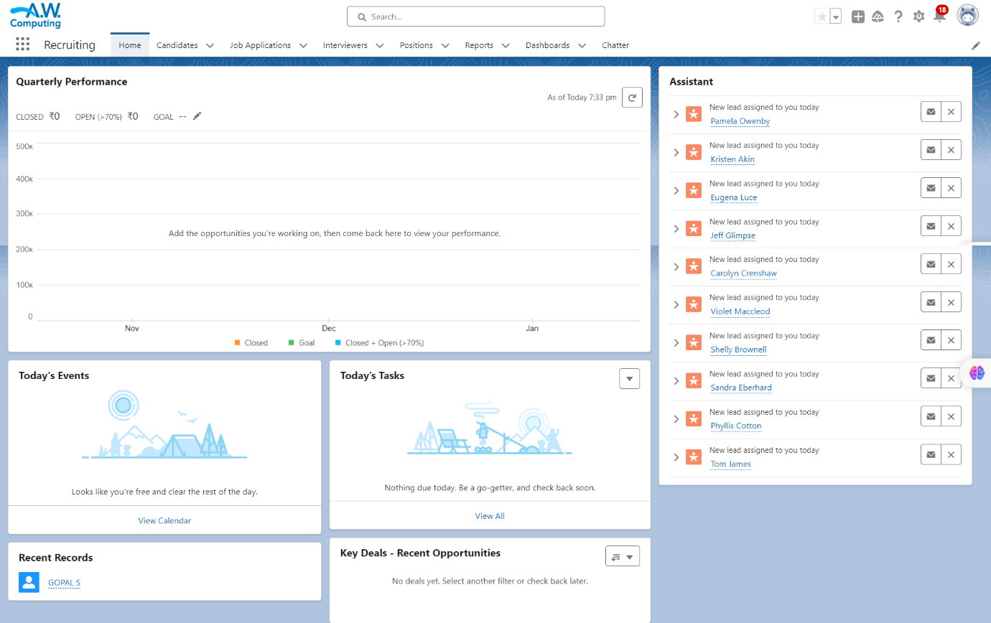

**CHAPTER – 3**

**USER & DATA SECURITY**

**3.1 Users & Data Security**

Salesforce provides robust user and data security features to help organizations protect their data and control who can access and manipulate it.

**3.2 Creation On Profile**

From Setup enter Profiles in the Quick Find box, and select Profiles.

1. From the list of profiles, find Standard User.
2. Click Clone.
3. For profile name, enter Event user profile.
4. Click save.
5. While still on the Event profile page, then click edit.
6. Scroll down Custom Object Permissions and Give view all access permissions to the Order details, supplier, product, customer, category, payment.

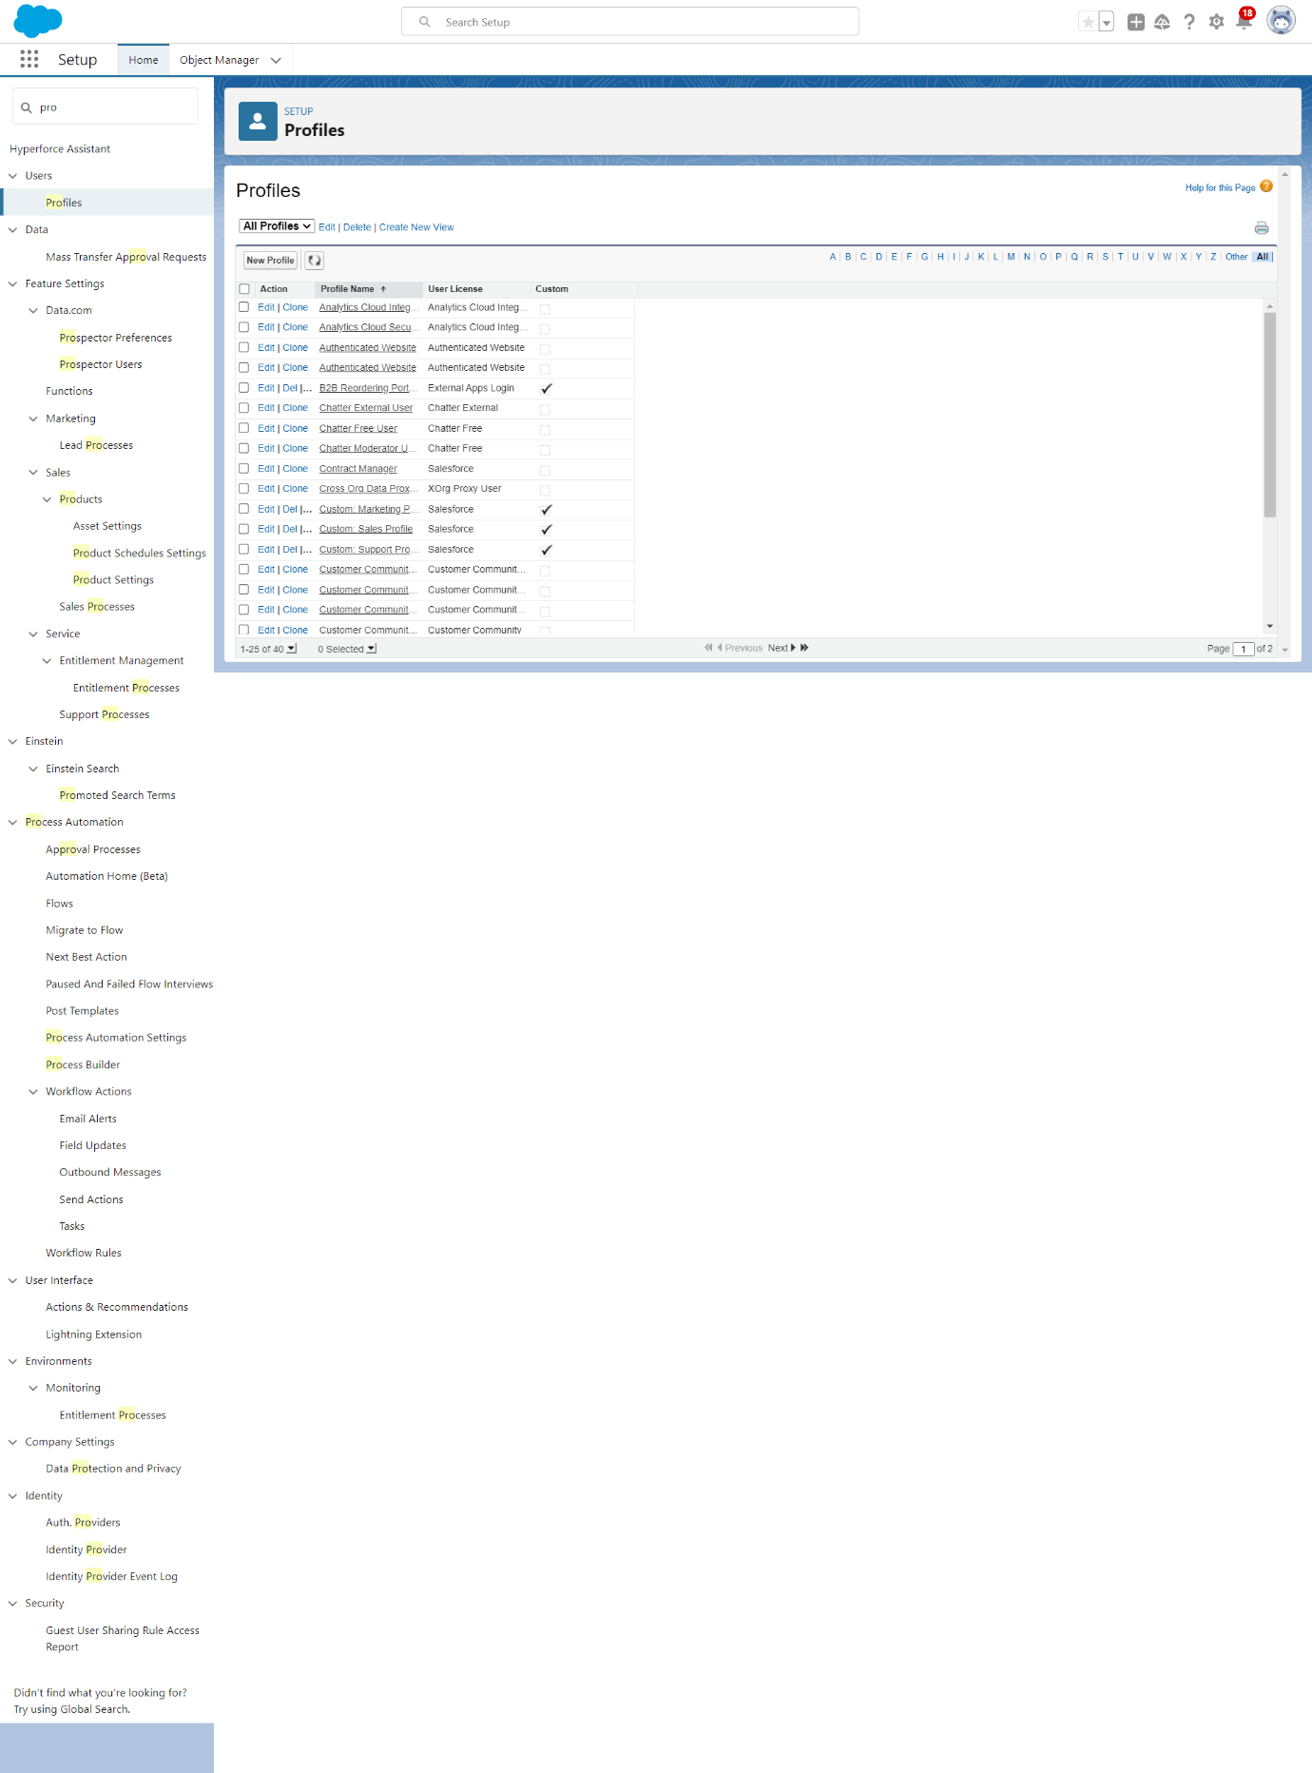

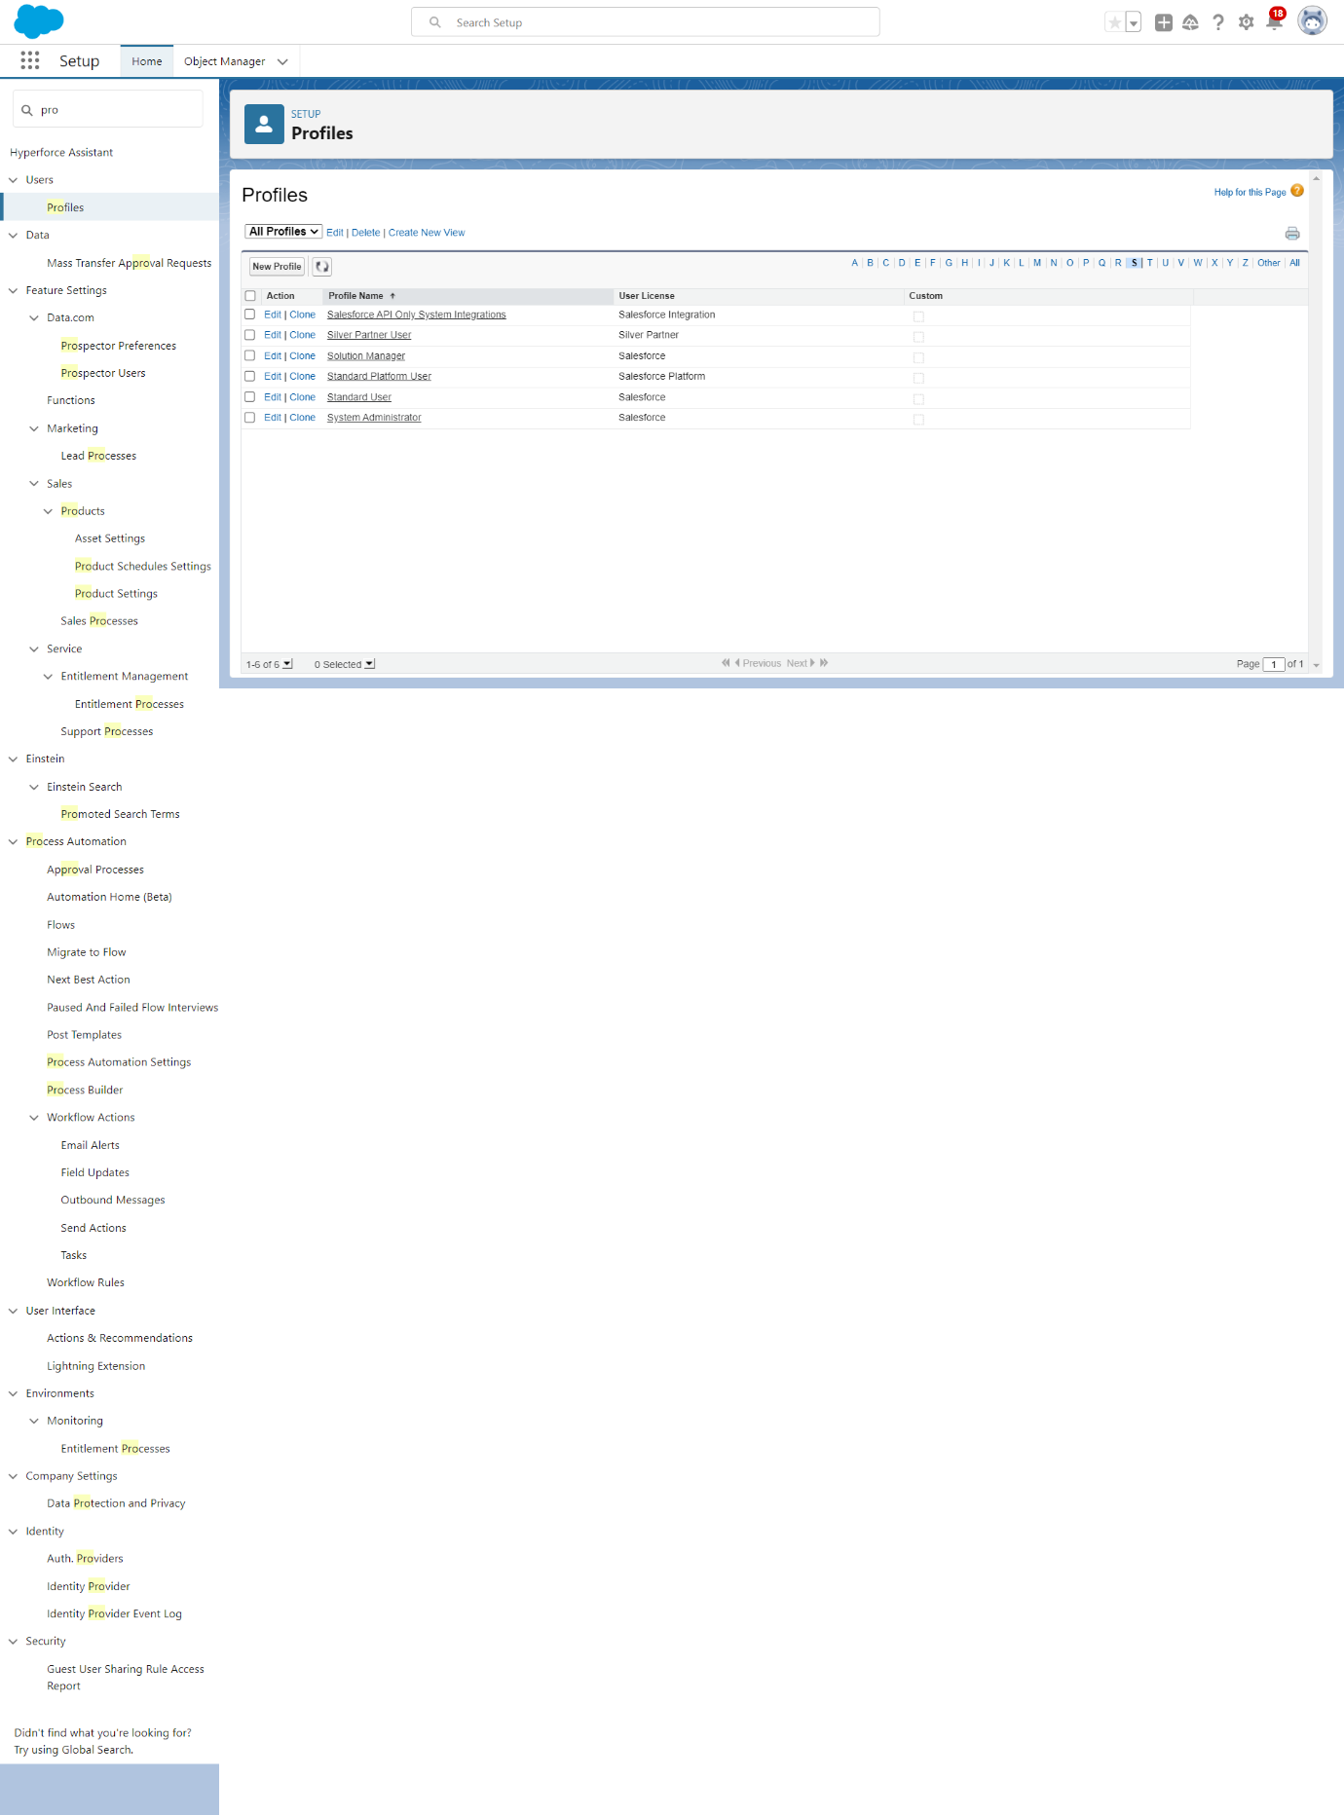

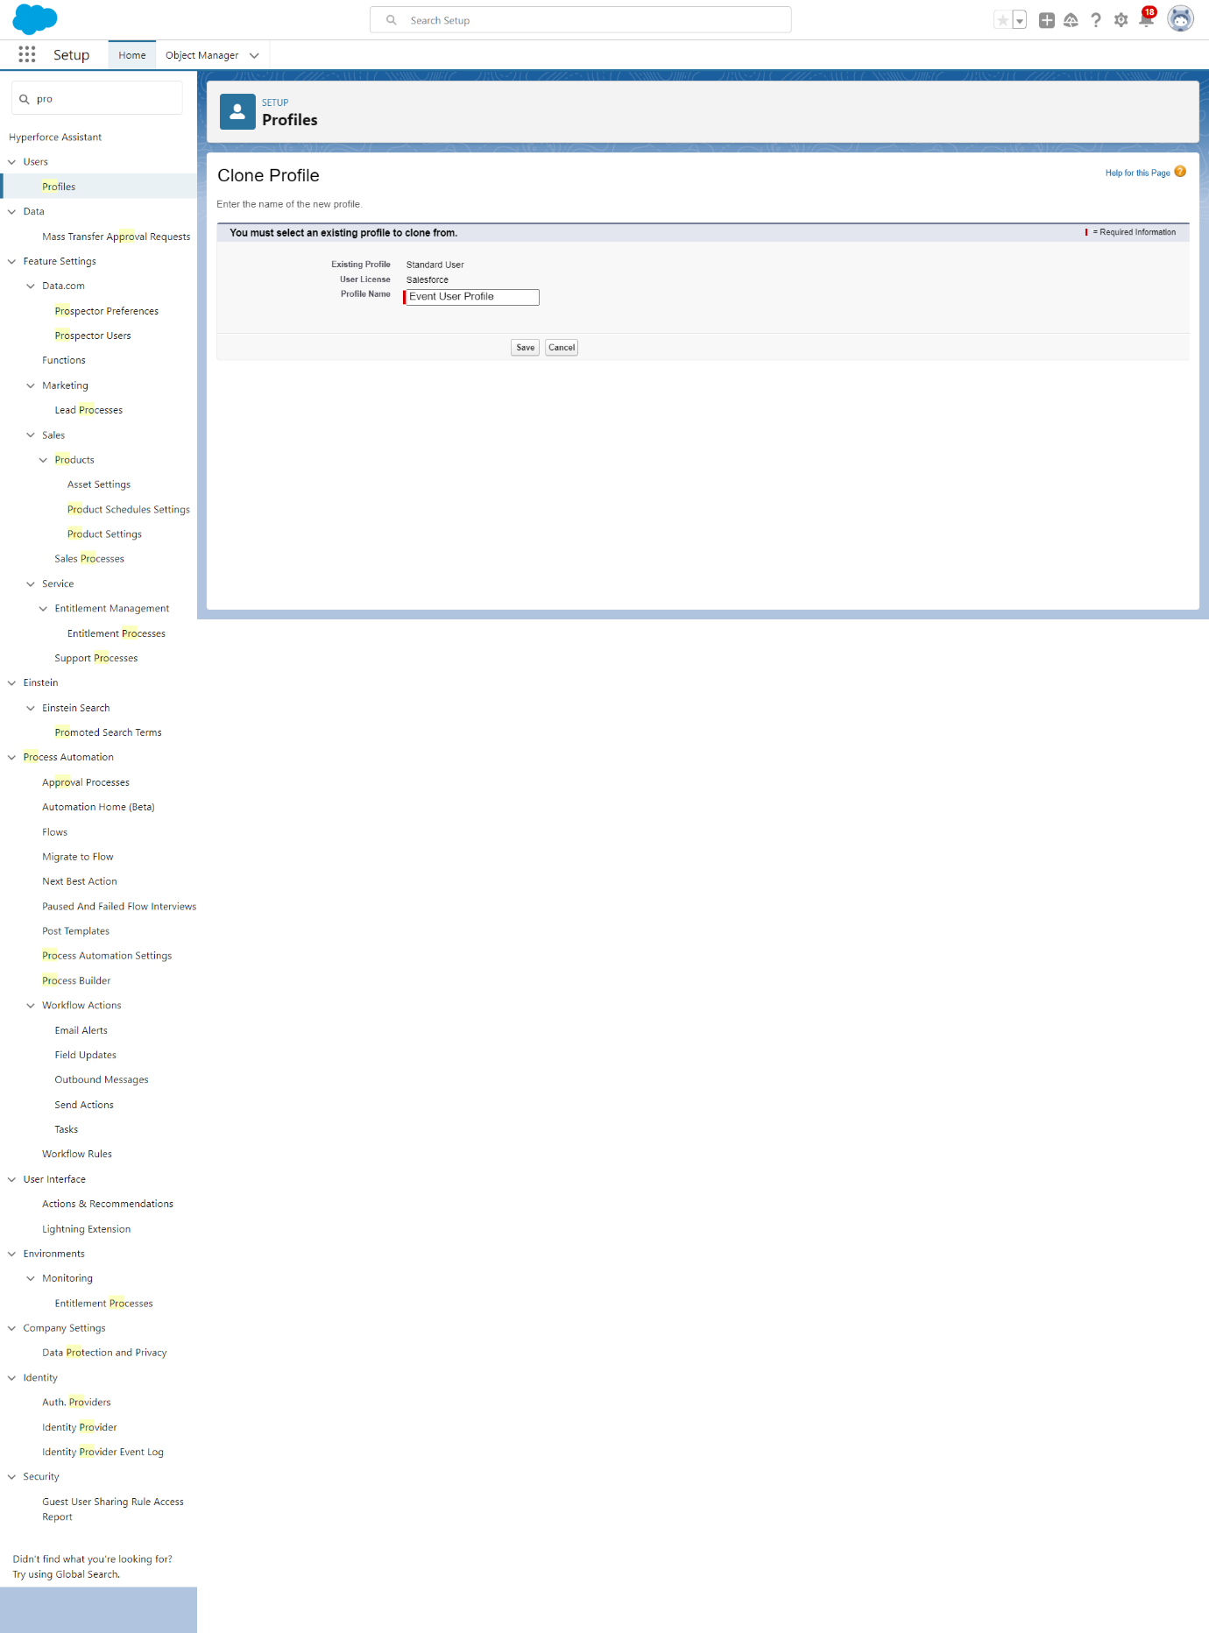

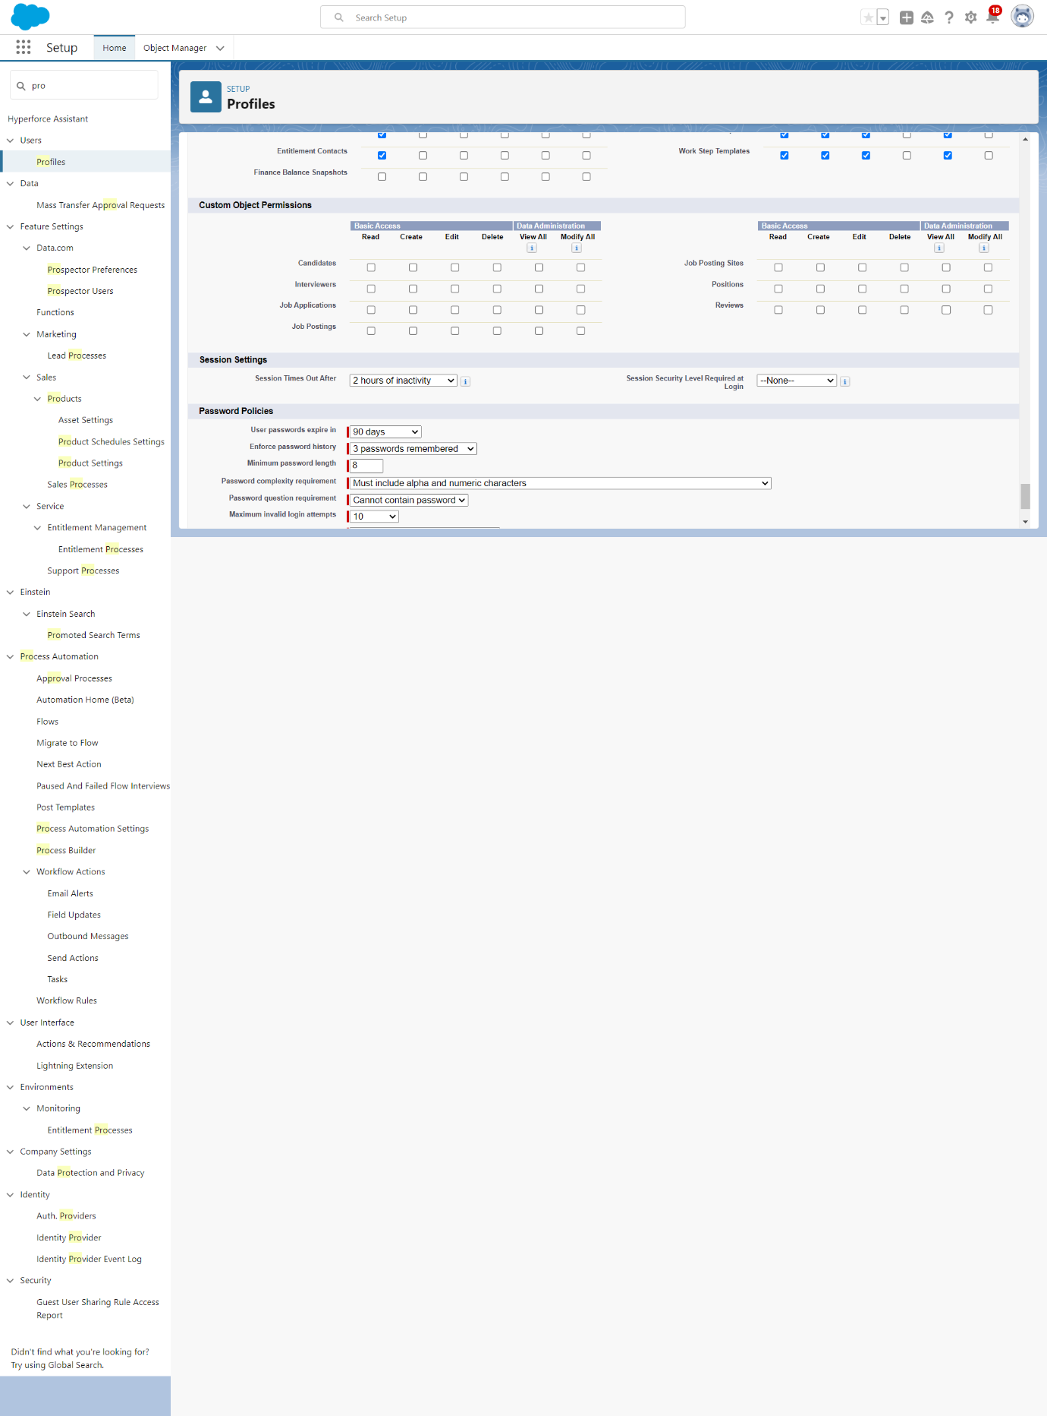 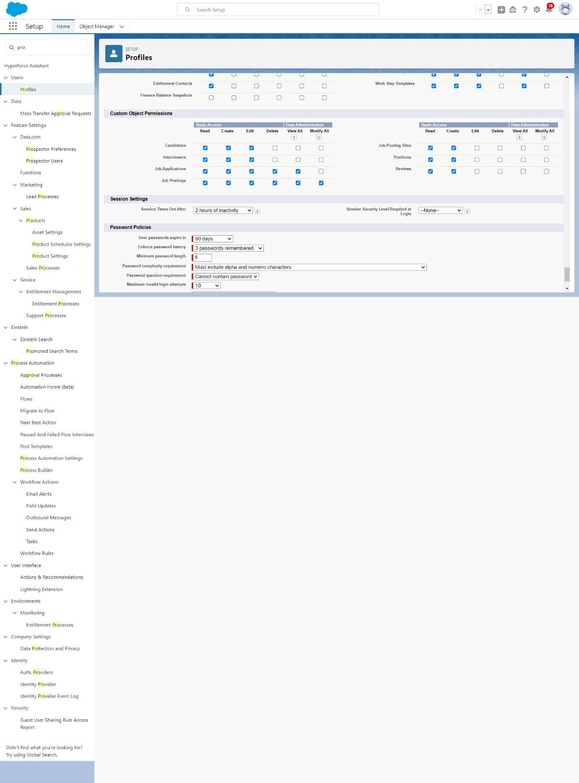

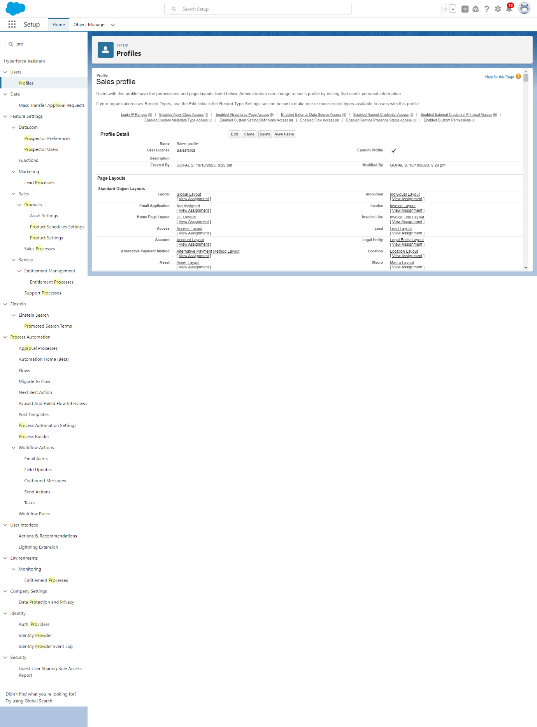

**3.3 Creating A User**

Salesforce allows organizations to create and manage user accounts for their employees, partners, and customers. Users are assigned profiles and roles, which define their access rights and permissions.

From setup type “users” in quick find and select users, then click New User

* First Name: Sanjay
* Last Name: Gupta
* Alias: Sanj
* Email: provide your personal email id for future reference
* Username: sanjaygupta@thesmartbridge.com
* Nickname: Sanju
* Role: leave it as default
* User license salesforce:
* Profile: Event user profile

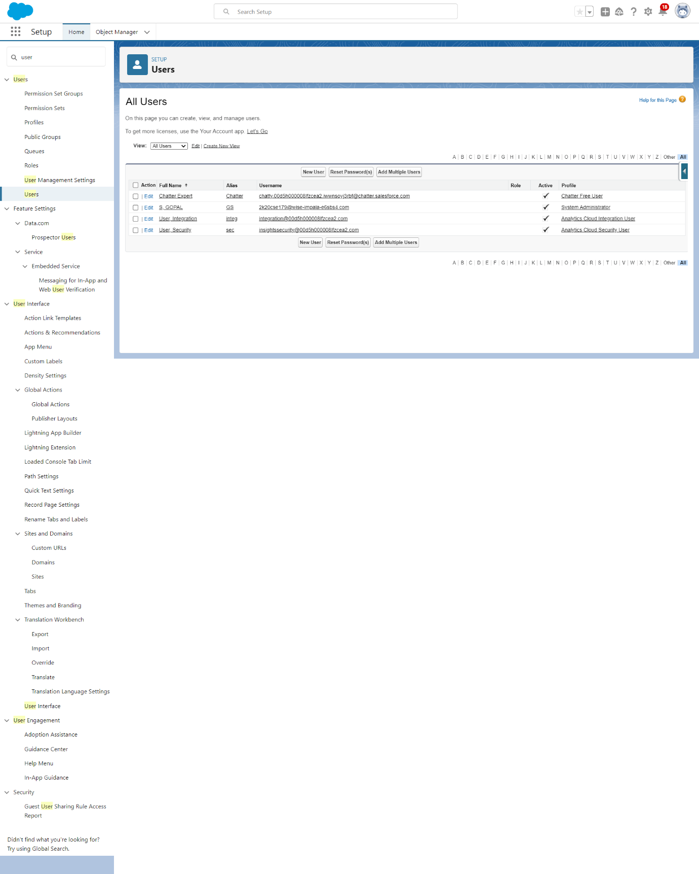

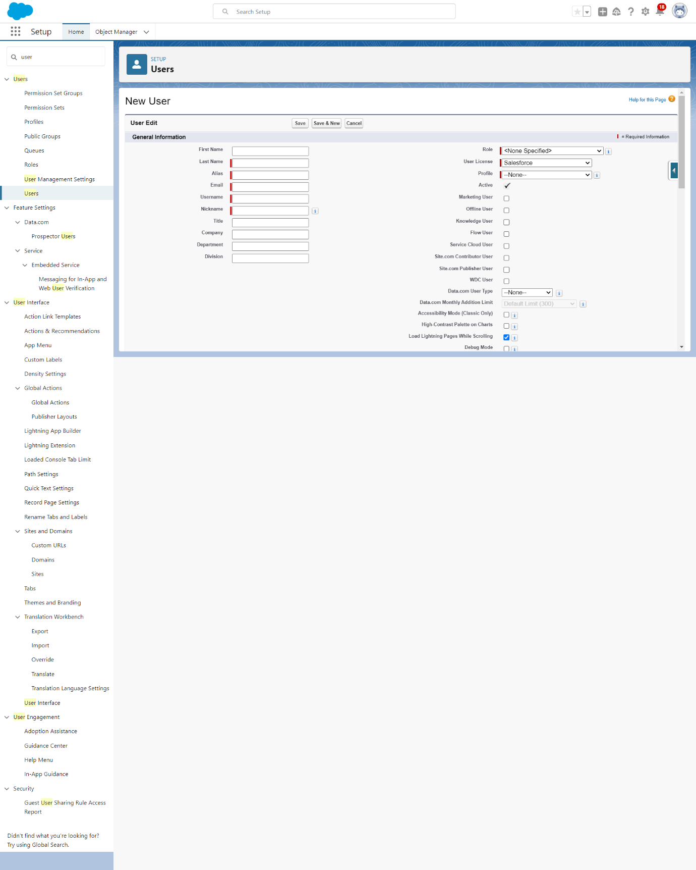

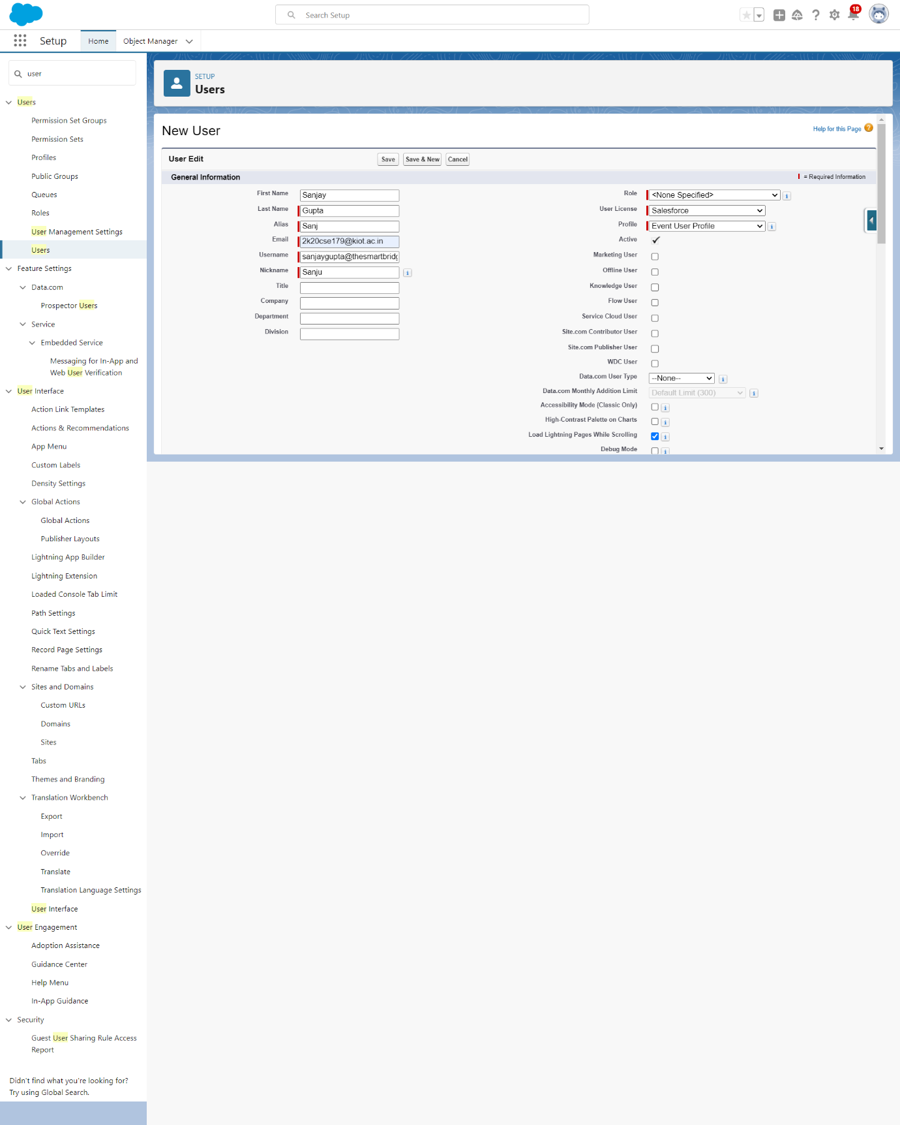

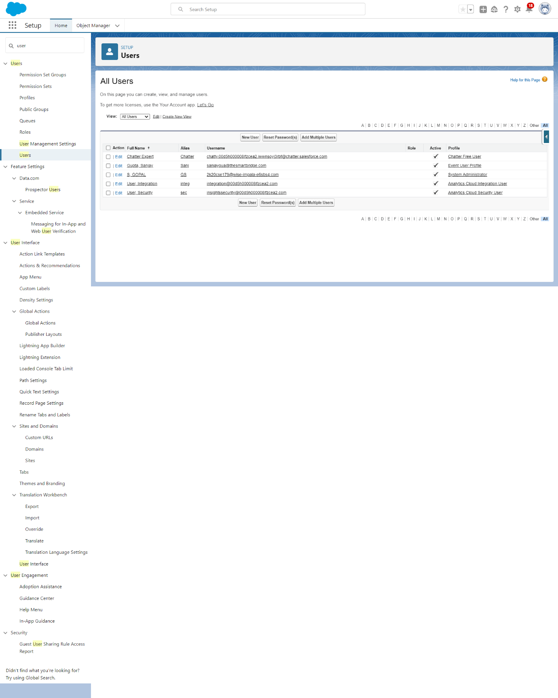

Create a user with a username as “Abhilash Garapati”, and assign him the sales profile.

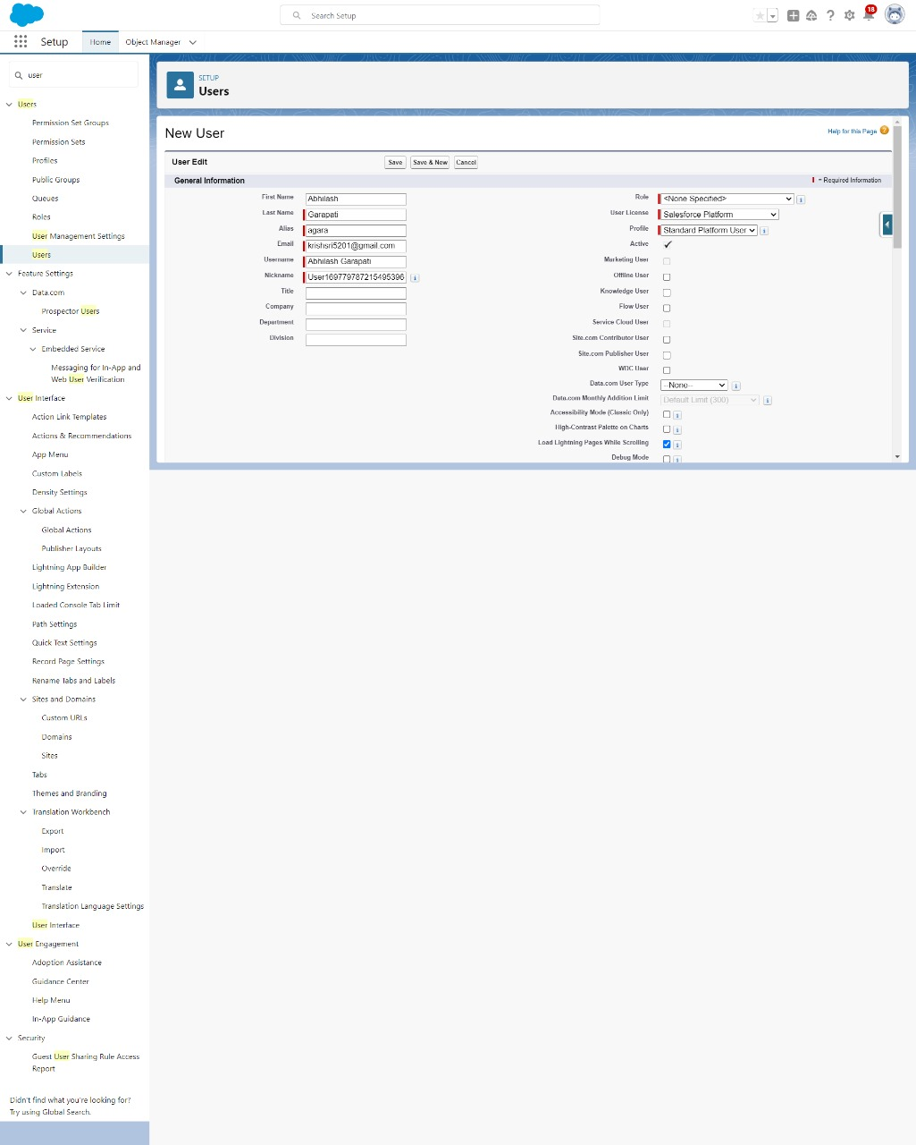

**3.4 Creating A Permission Set:**

Permission sets allow for additional permissions to be granted to individual users or groups of users beyond what their profiles provide. They are useful for granting specific permissions to certain users without changing their profiles.

1.From setup search “permission sets” in quick find and select permission set then click on New.

2.Enter label as: HR Recruiter Supplier Permits and Save.

3.After saving the permission click on the Manage assignment

4.Click on edit and give Object permission (Edit) then save

5. Click on edit,and give object permission (Edit) then save.

6. Now click on the Add Assignment

7. Now select the users and click on sa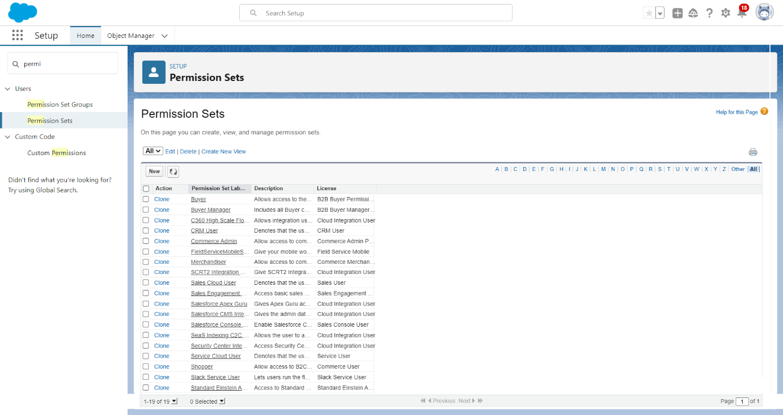ve.

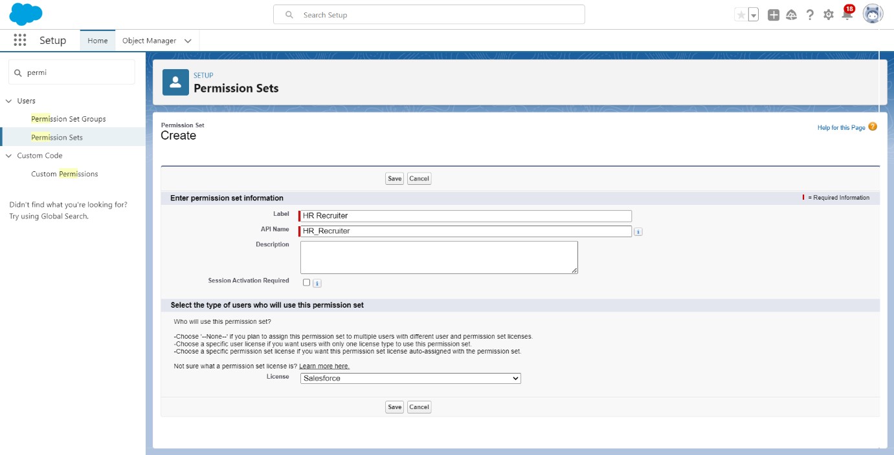 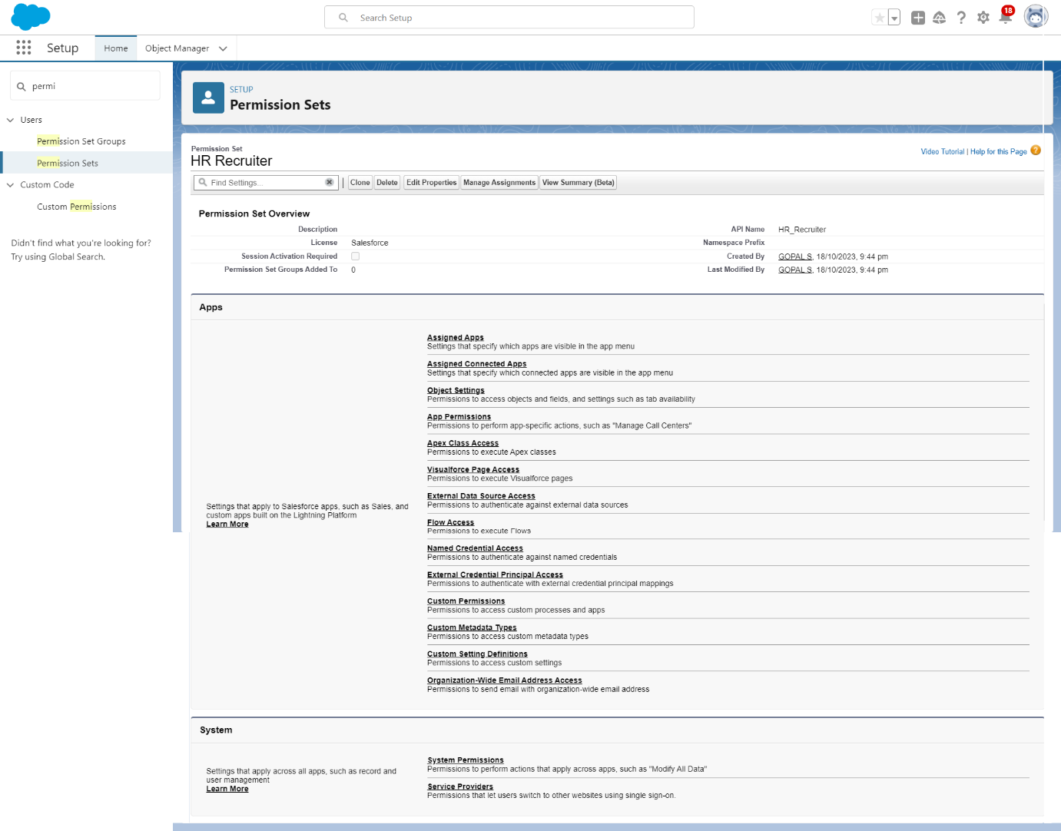 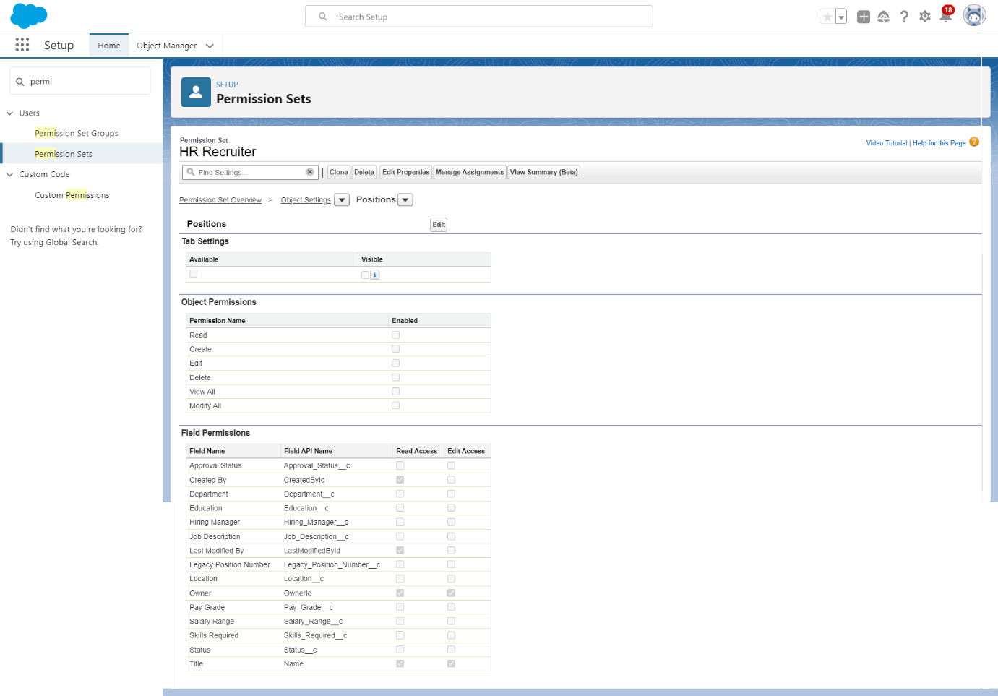 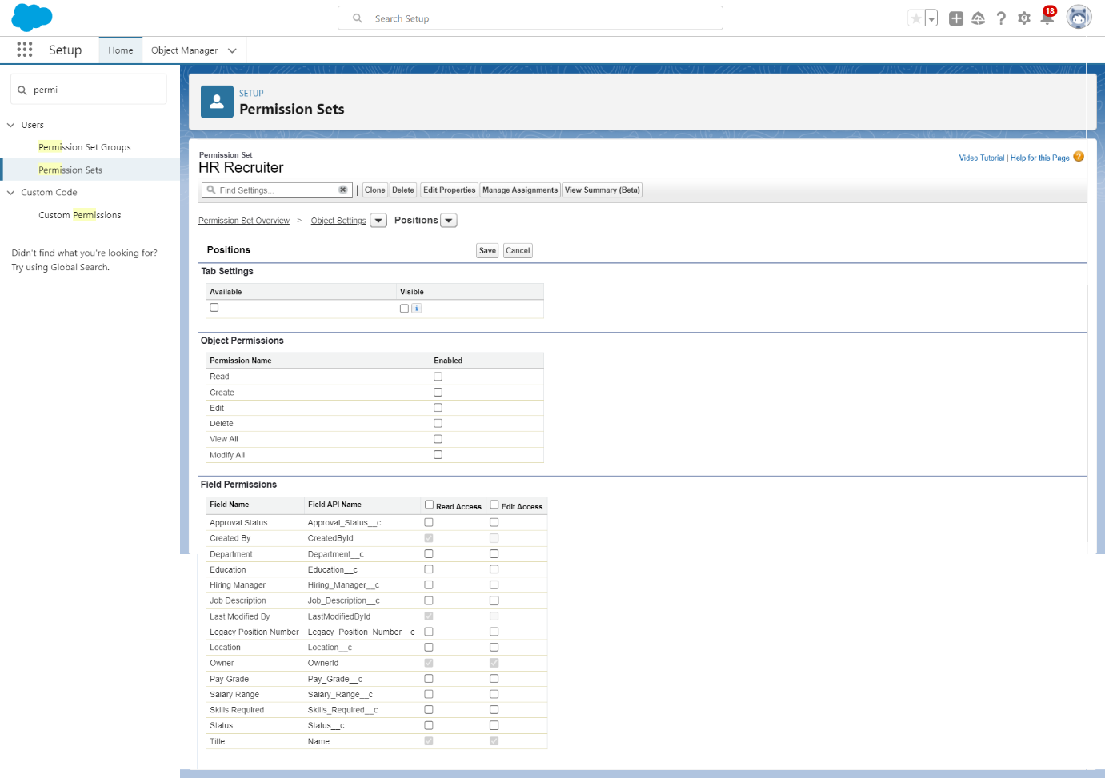 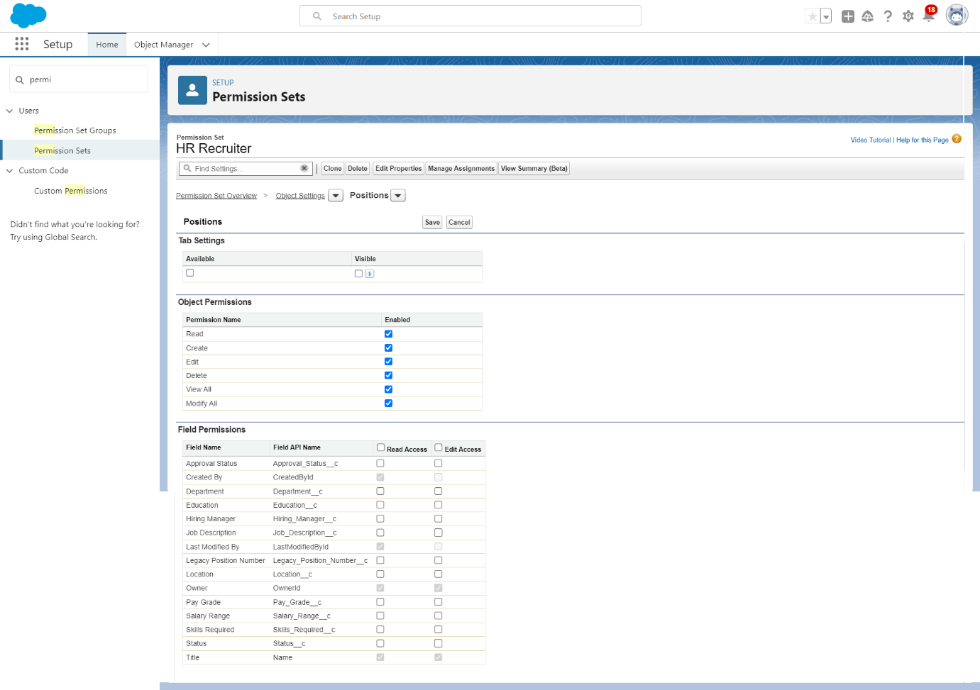 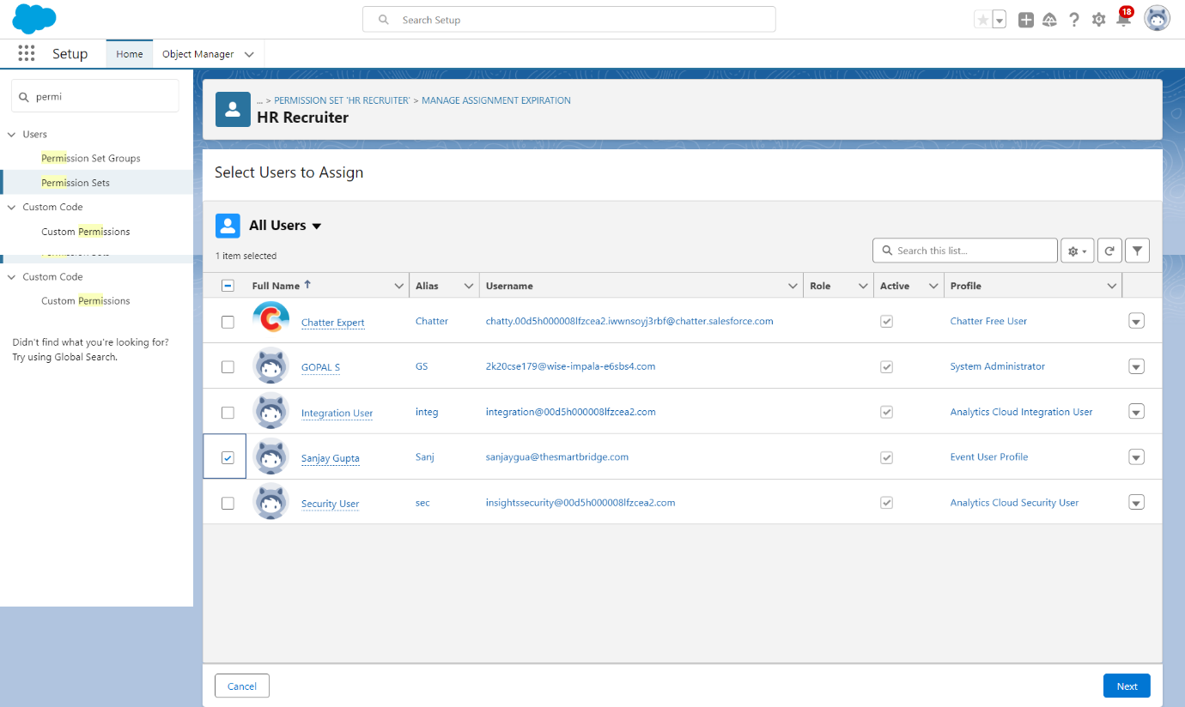 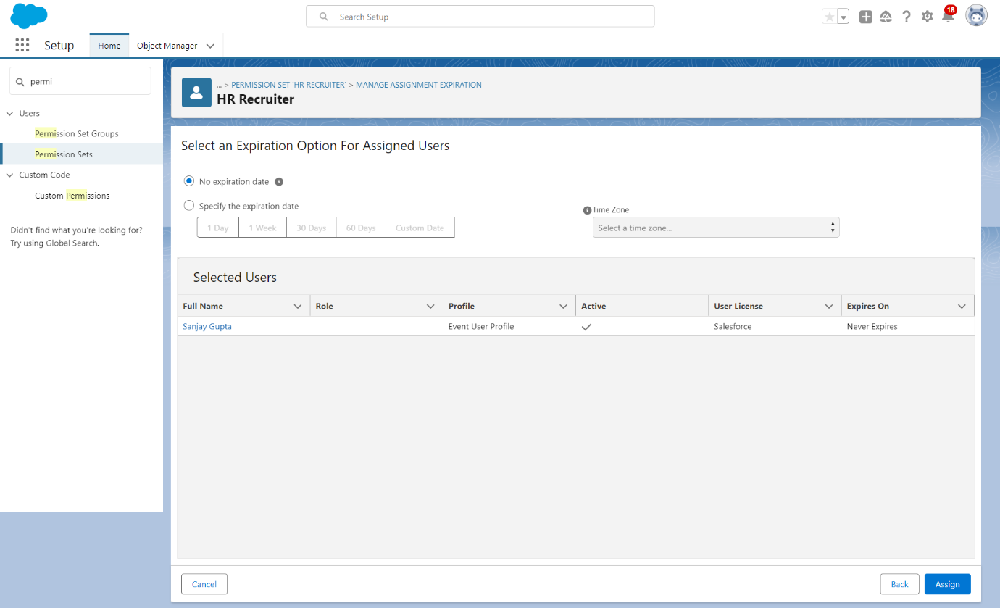

**CHAPTER – 4**

**AUTOMATION**

**4.1 Automation**  
 Working with automation tools such as triggers and flows can significantly enhance the functionality and efficiency of your Salesforce application. Here are some best practices and steps to help you effectively work with triggers and flows:

**Understanding Use Cases:**

Identify specific use cases where triggers and flows can automate processes, improve data quality, and enhance user experience.

Analyze existing manual processes that can be automated to save time and resources.

**Trigger Implementation:**

Define the trigger criteria and events that should activate the trigger.

Write efficient Apex triggers to perform complex actions, calculations, or validations based on the defined criteria.

Test the triggers thoroughly with various scenarios and data inputs to ensure their reliability and accuracy.

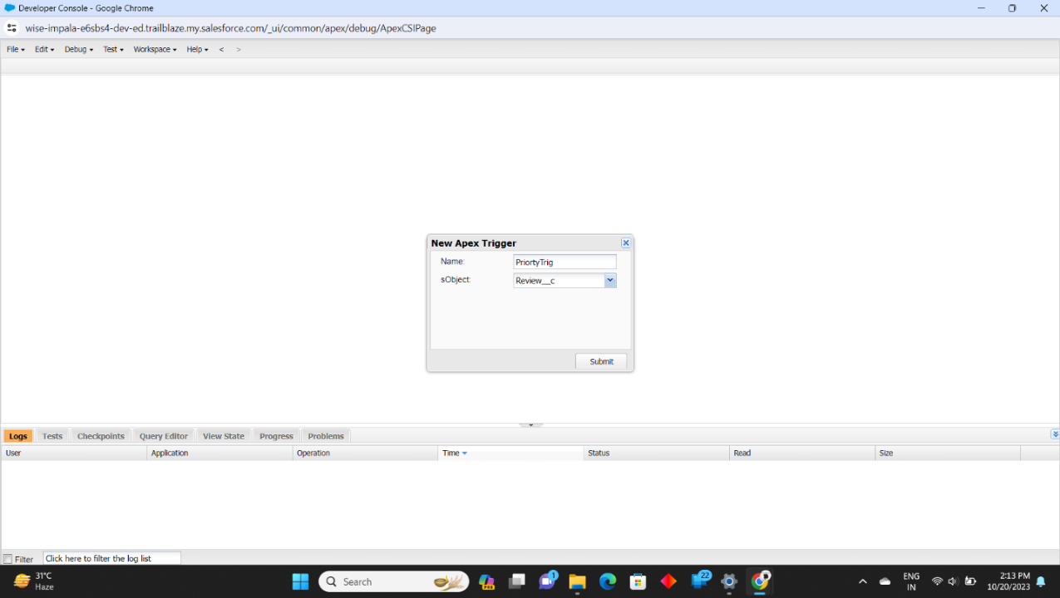

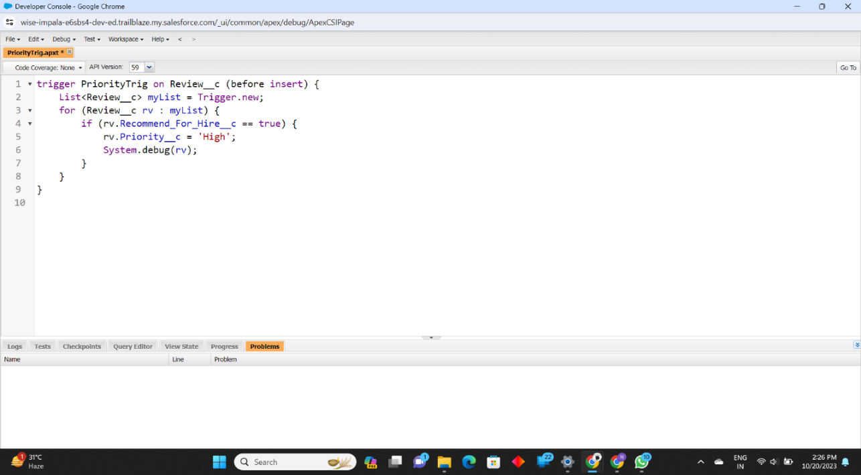

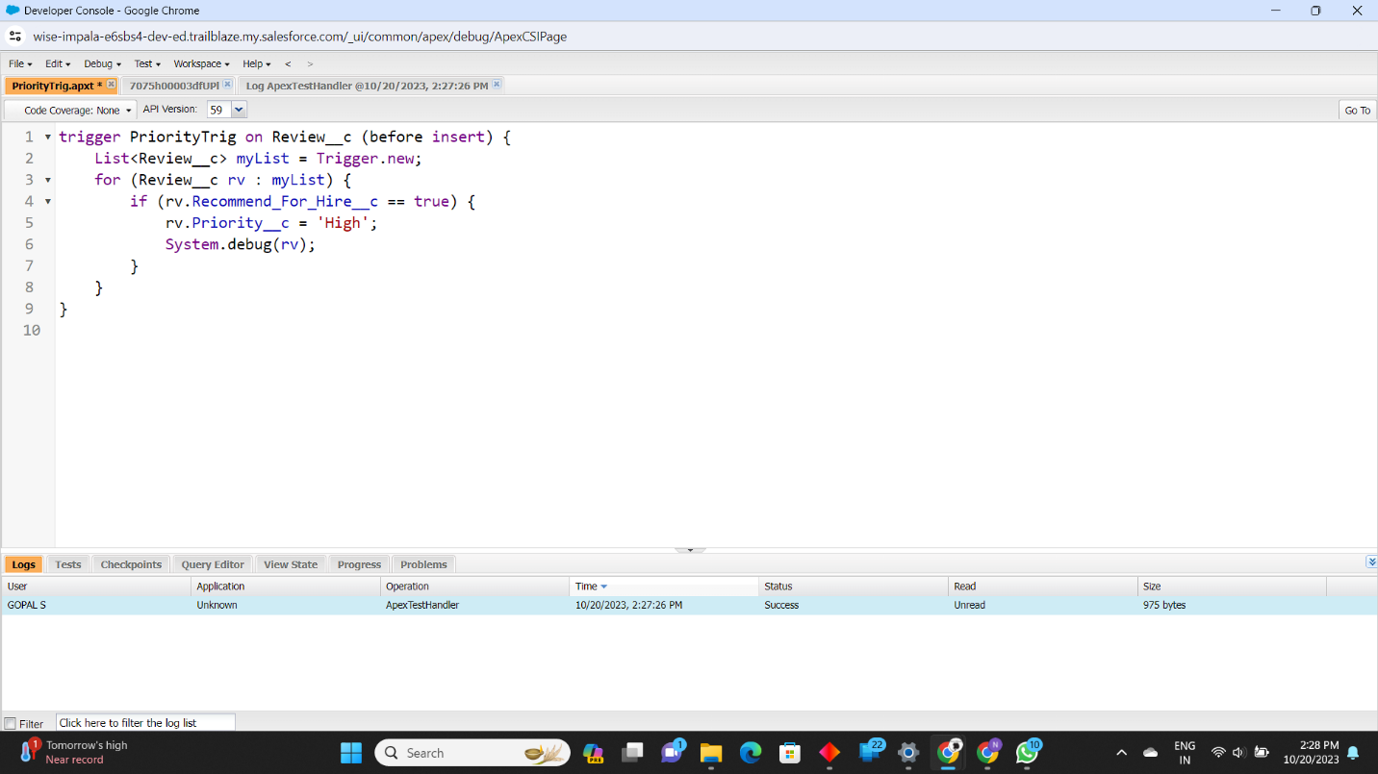 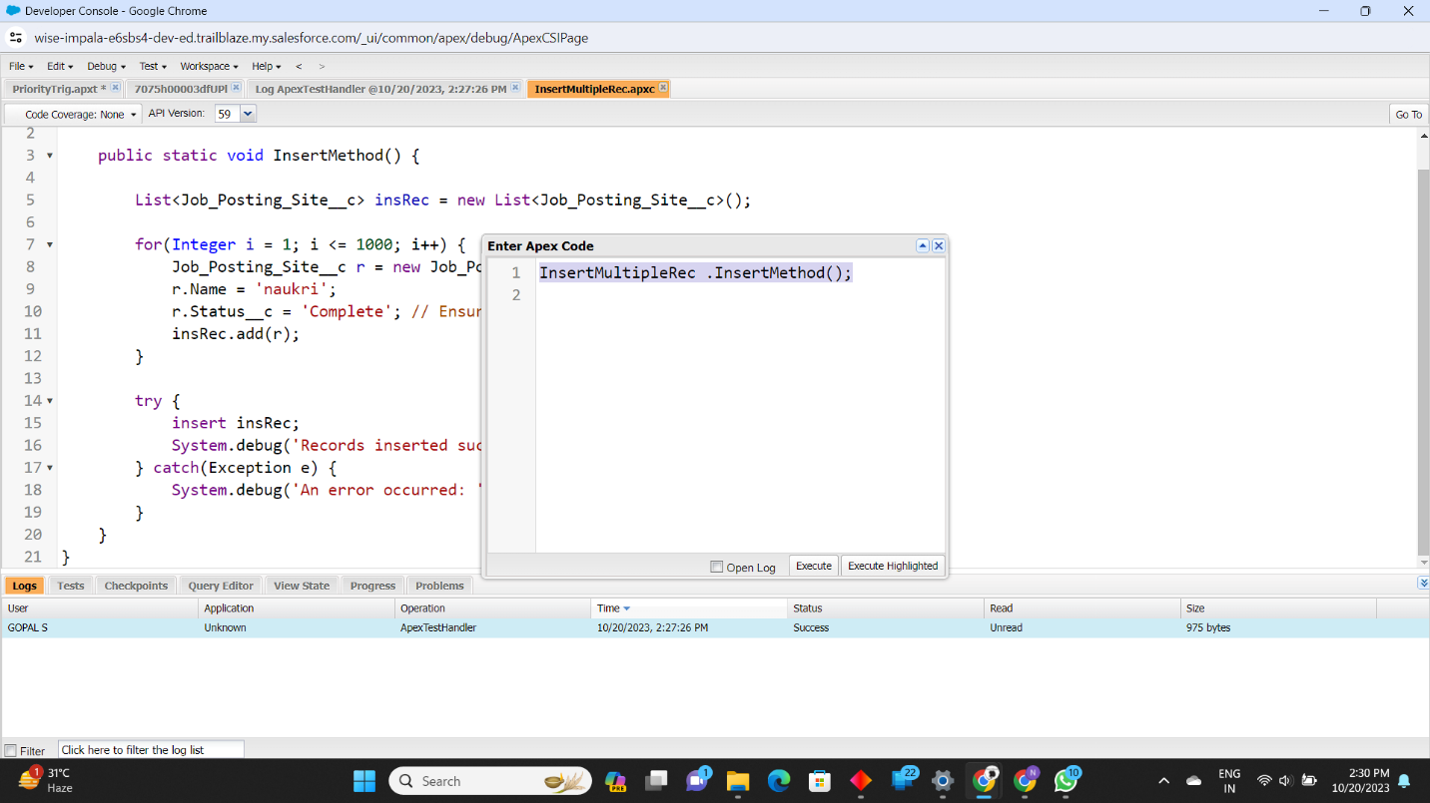 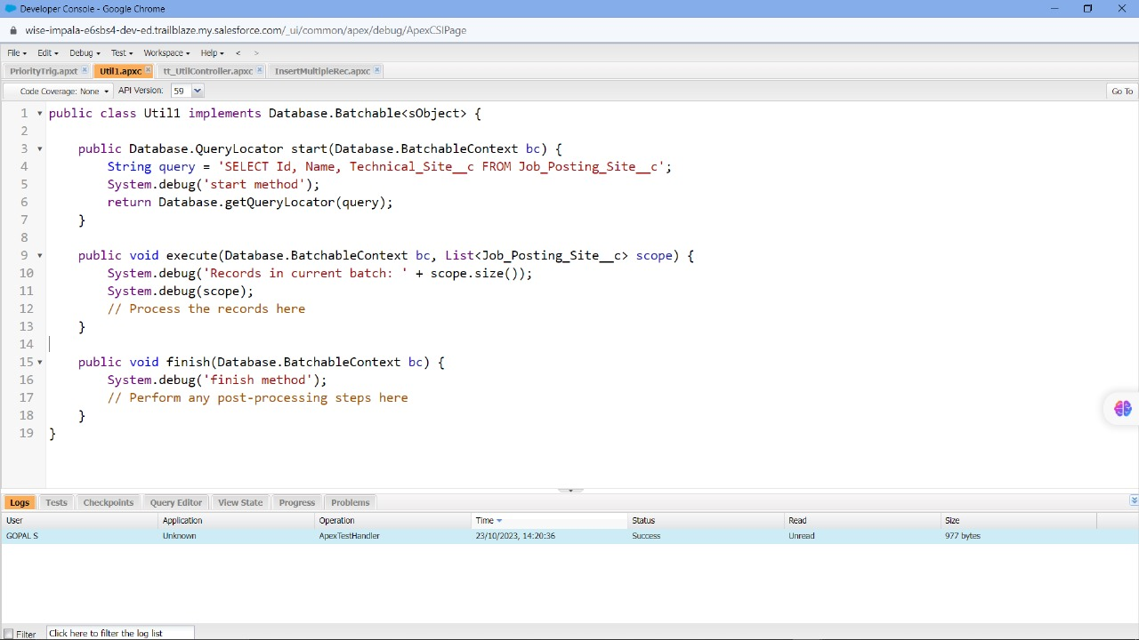

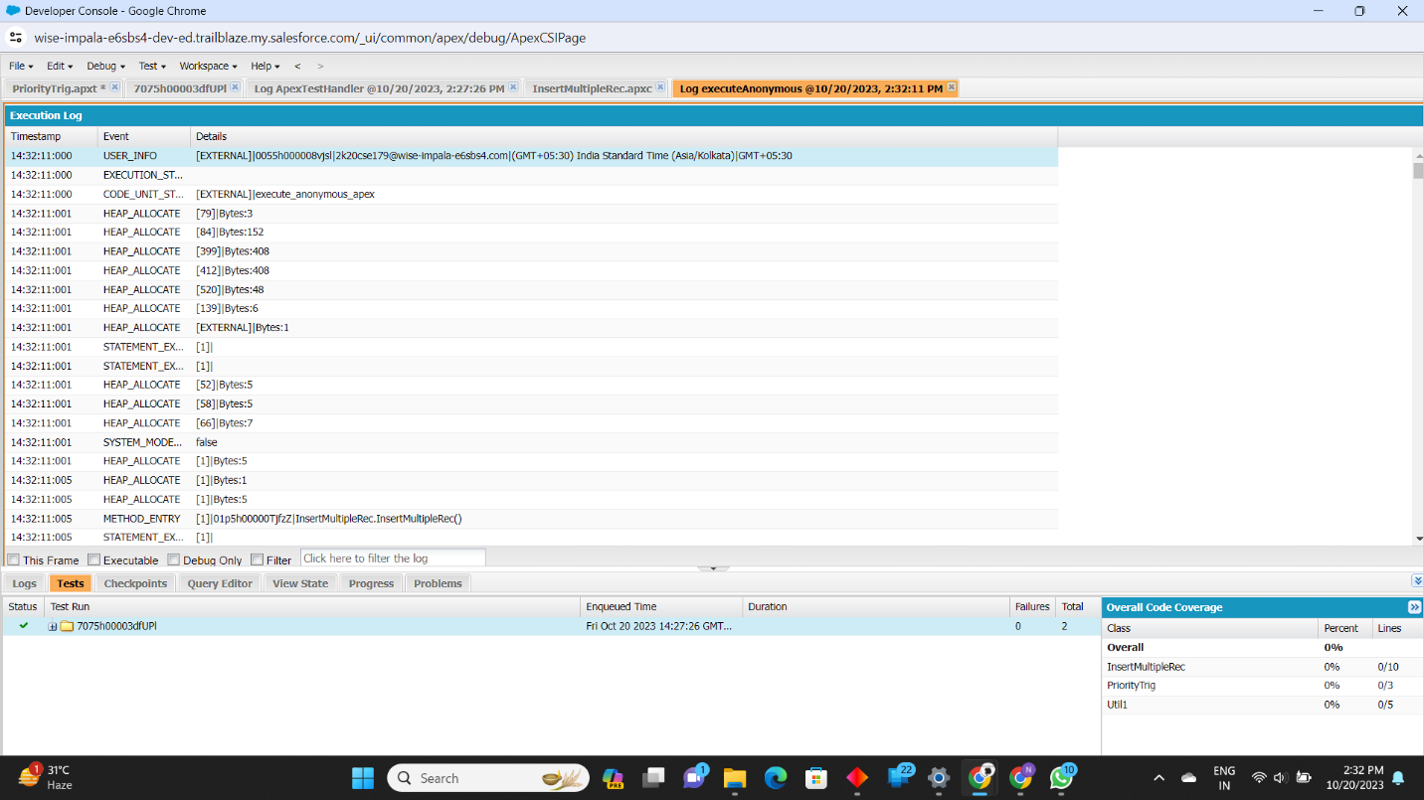

**4.2 Apex Code:**

**Code 1:**

trigger PriorityTrig on Review__c (before insert) {

List<Review__c> myList = Trigger.new;

for (Review__c rv : myList) {

if (rv.Recommend_For_Hire__c == true) {

rv.Priority_c = 'High'; // Assuming Priority_c is a string field, replace with appropriate case

System.debug(rv);

}

}

}

**Code 2:**

public class Util1 implements Database.Batchable<sObject> {

public Database.QueryLocator start(Database.BatchableContext bc) {

String query = 'SELECT Id, Name, Technical_Site_c FROM Job_Posting_Site_c';

System.debug('start method');

return Database.getQueryLocator(query);

}

public void execute(Database.BatchableContext bc, List<Job_Posting_Site__c> scope) {

System.debug('Records in current batch: ' + scope.size());

System.debug(scope);

// Process the records here

}

public void finish(Database.BatchableContext bc) {

System.debug('finish method');

// Perform any post-processing steps here

}

}

**Code 3:**

public class InsertMultipleRec {

public static void InsertMethod(){

// Creating a list to hold the records to be inserted

List<Job_Posting_Site_c> insRec = new List<Job_Posting_Site_c>();

// Using a for loop to create and add records to the list

for(Integer i = 1; i < 1000; i++){

Job_Posting_Site_c r = new Job_Posting_Site_c();

r.Name = 'naukri';

r.status__c = 'Complete';

insRec.add(r);

}

// Inserting the list of records

insert insRec;

// Printing the list of inserted records for debugging purposes

System.debug(insRec);

}

}

**CHAPTER – 5**

**REPORTS & DASHBOARD**

**5.1 Reports & Dashboard**

Develop custom reports within Salesforce that aggregate and analyze the data stored in the custom objects and relationships created for the recruitment app.

Customize the report filters, groupings, and data summaries to provide insightful information aligned with the HR team's requirements and objectives.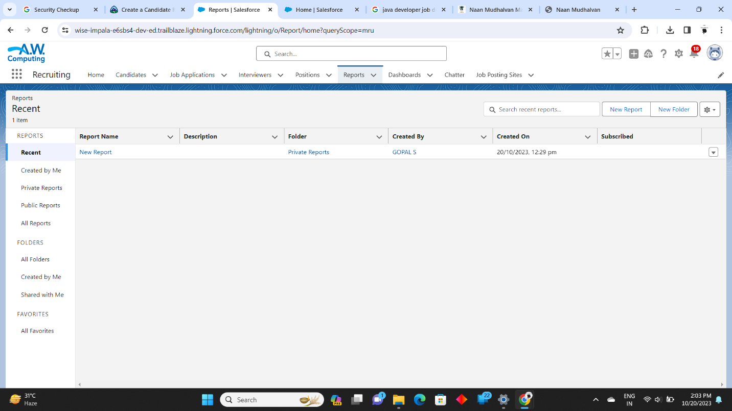 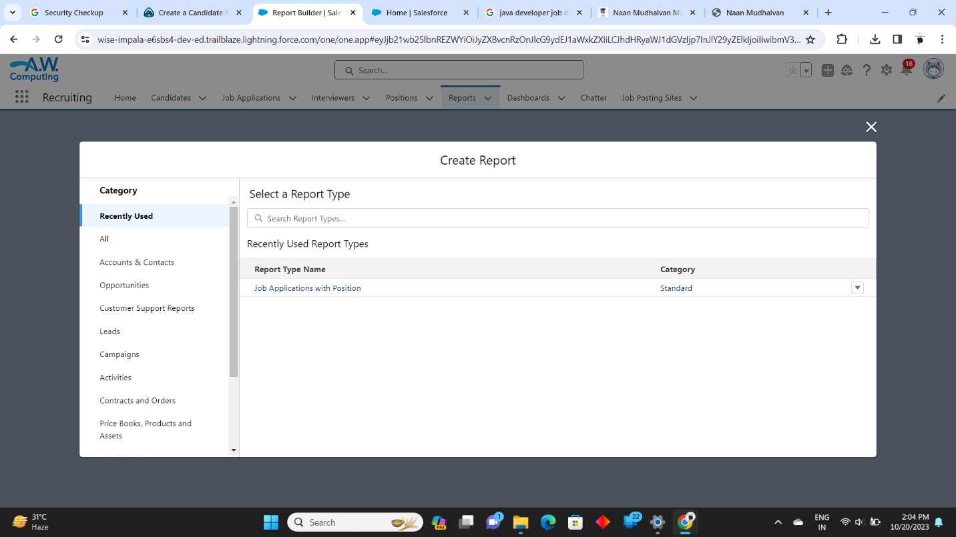 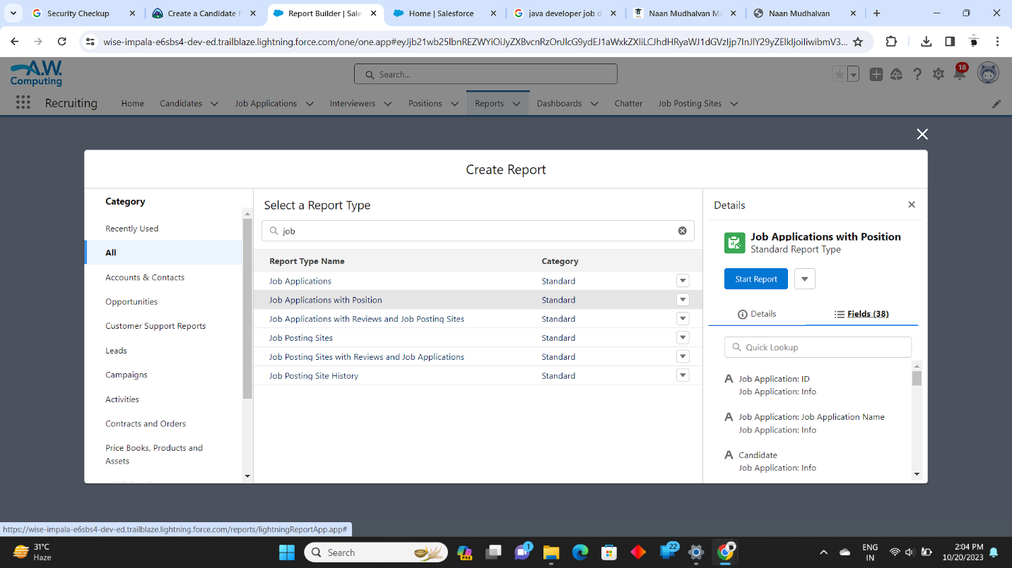 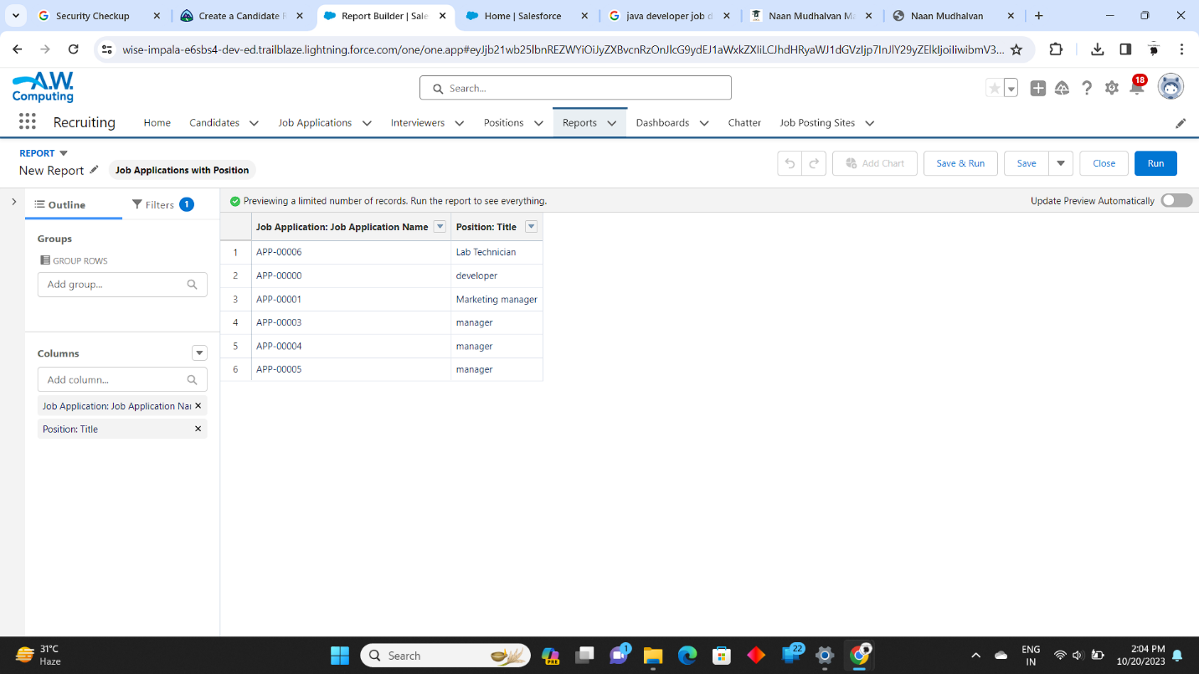 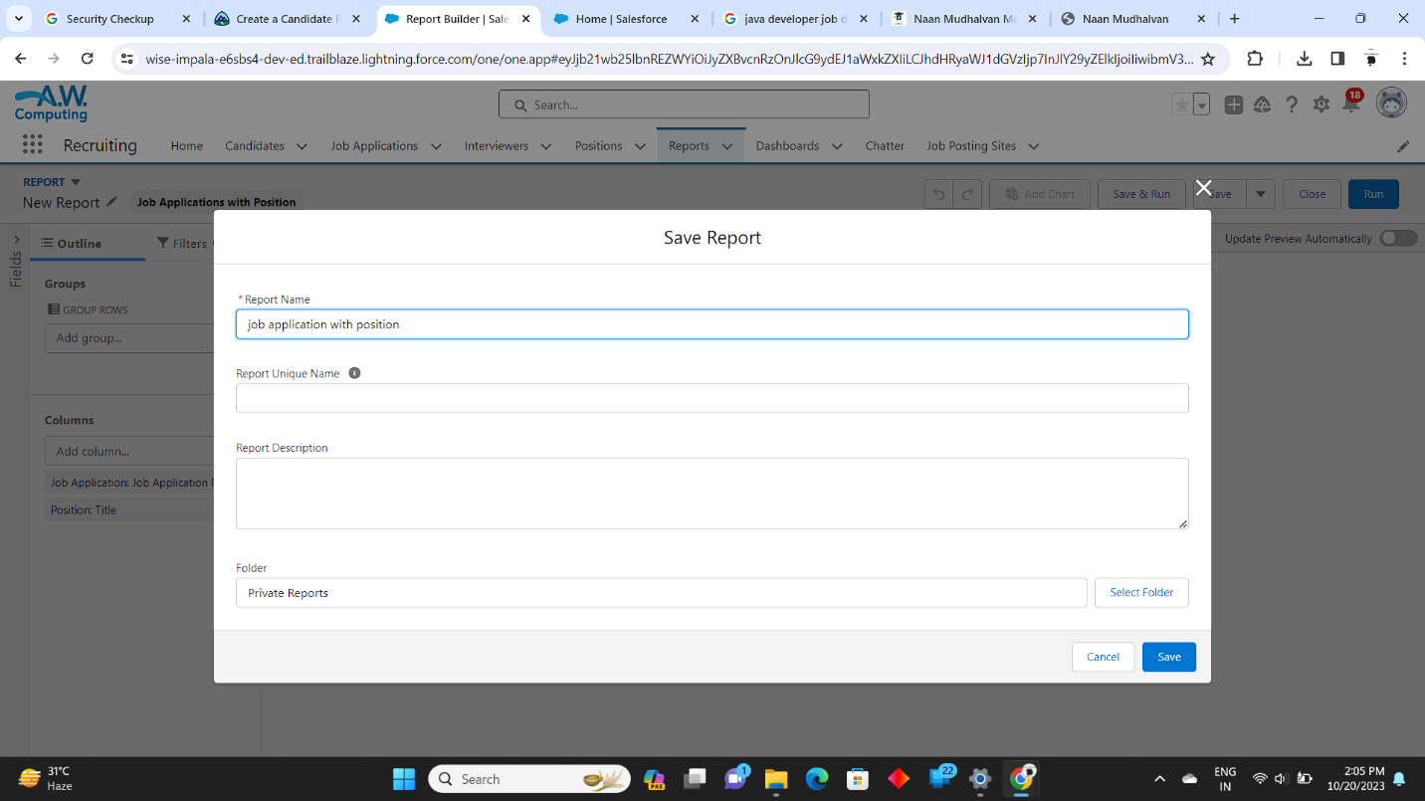 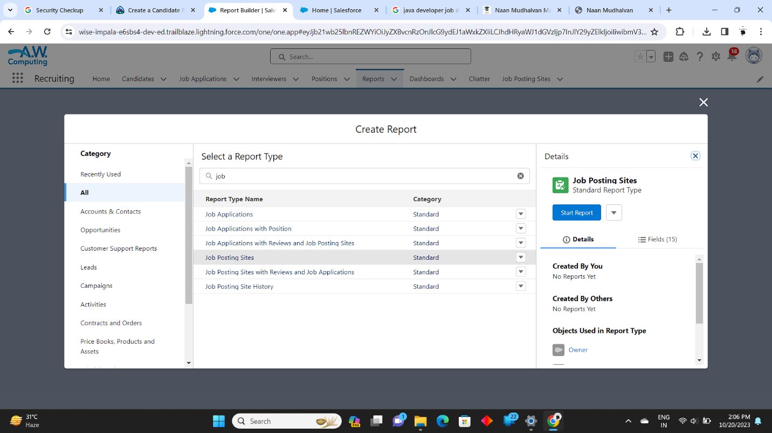 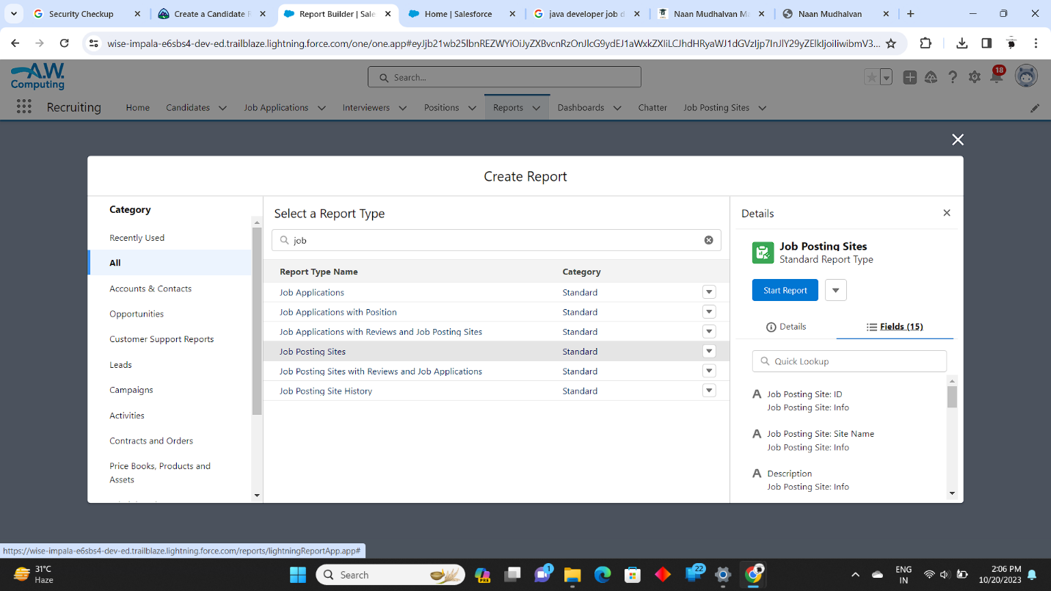 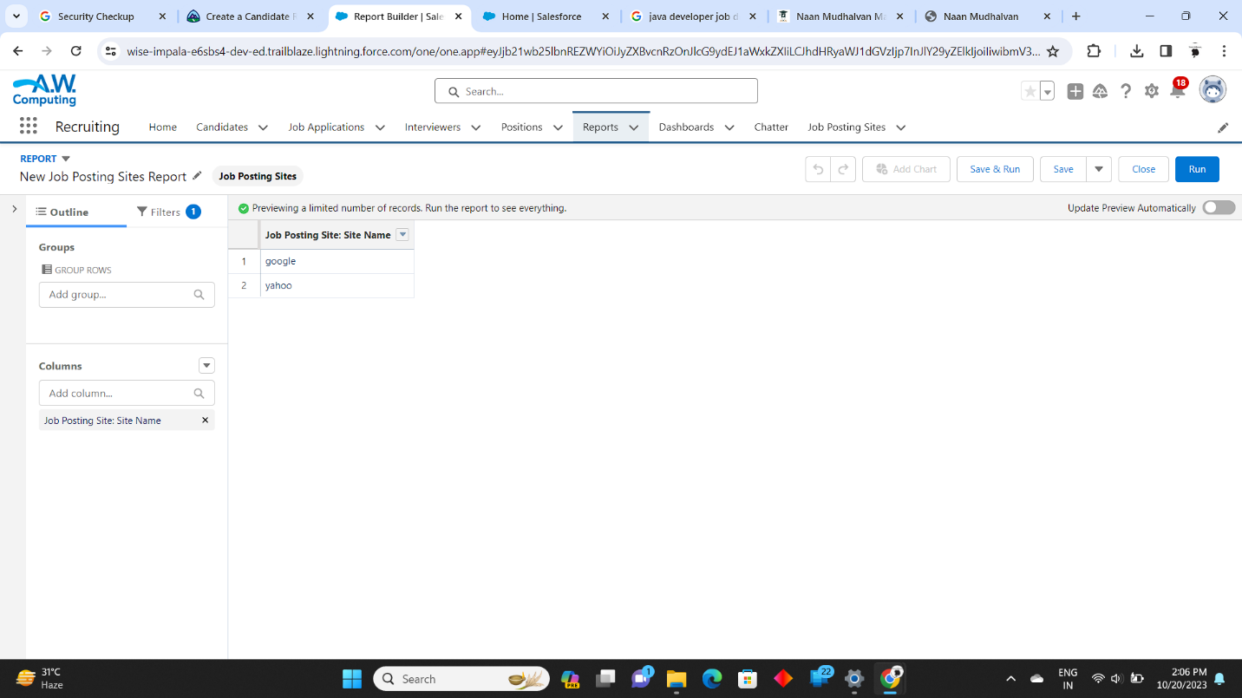 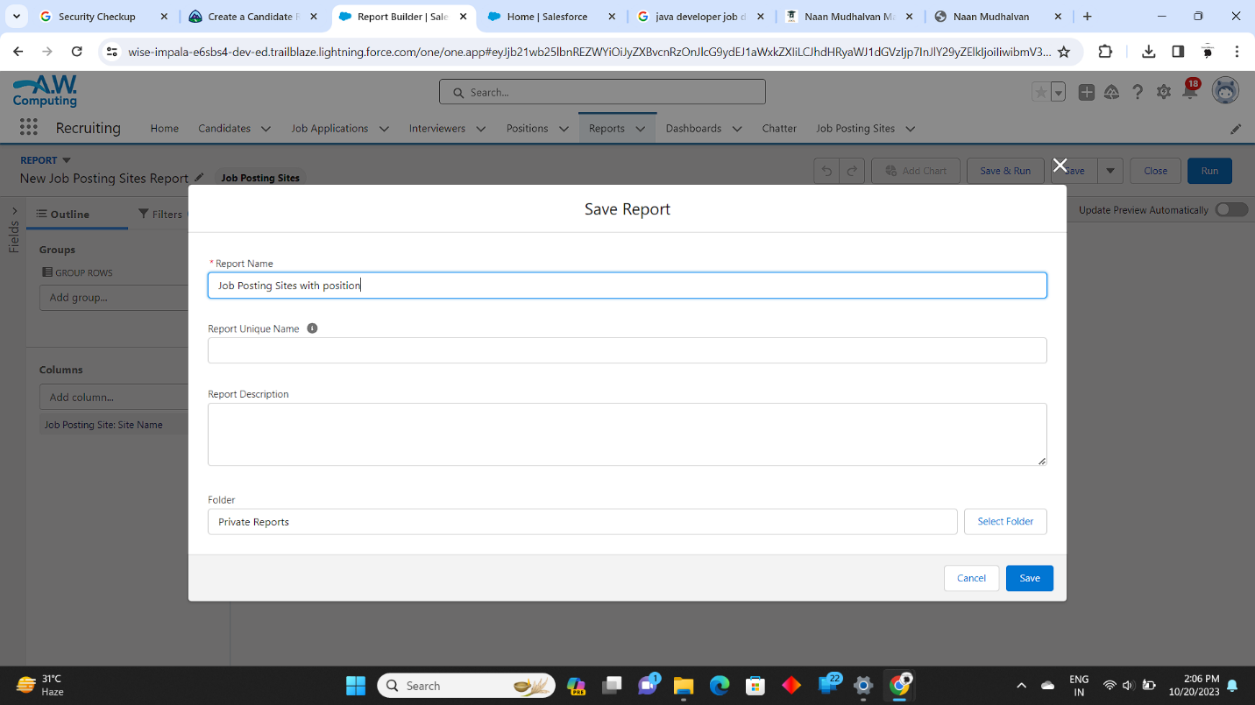 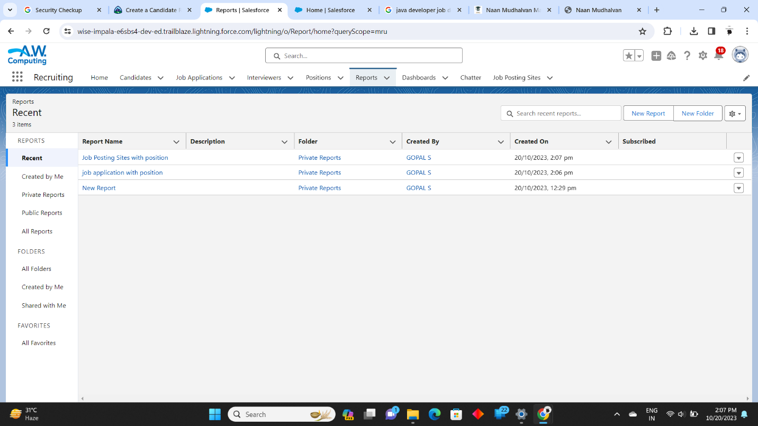

Create interactive dashboards that provide a comprehensive overview of the recruitment performance and key metrics in a visually appealing format.

Configure the dashboard components, such as charts, graphs, and tables, to present real-time data and trends that help in making informed decisions.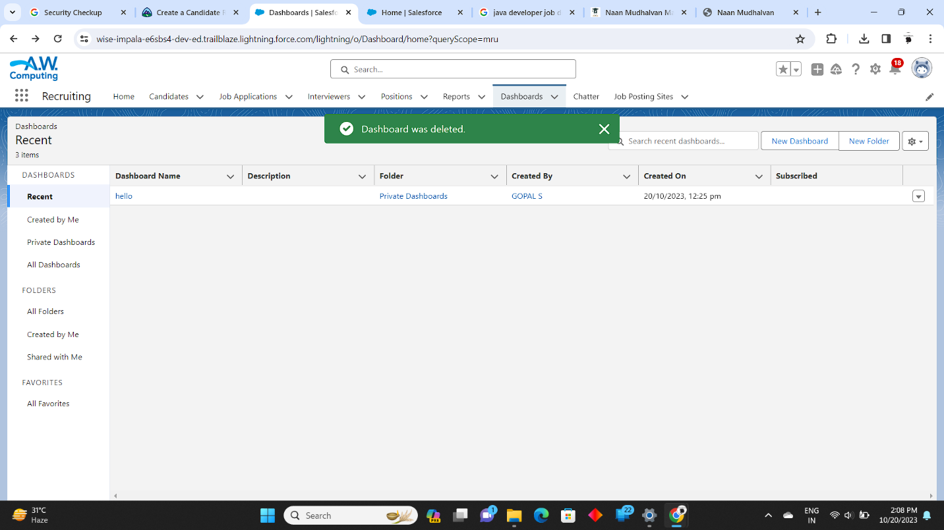

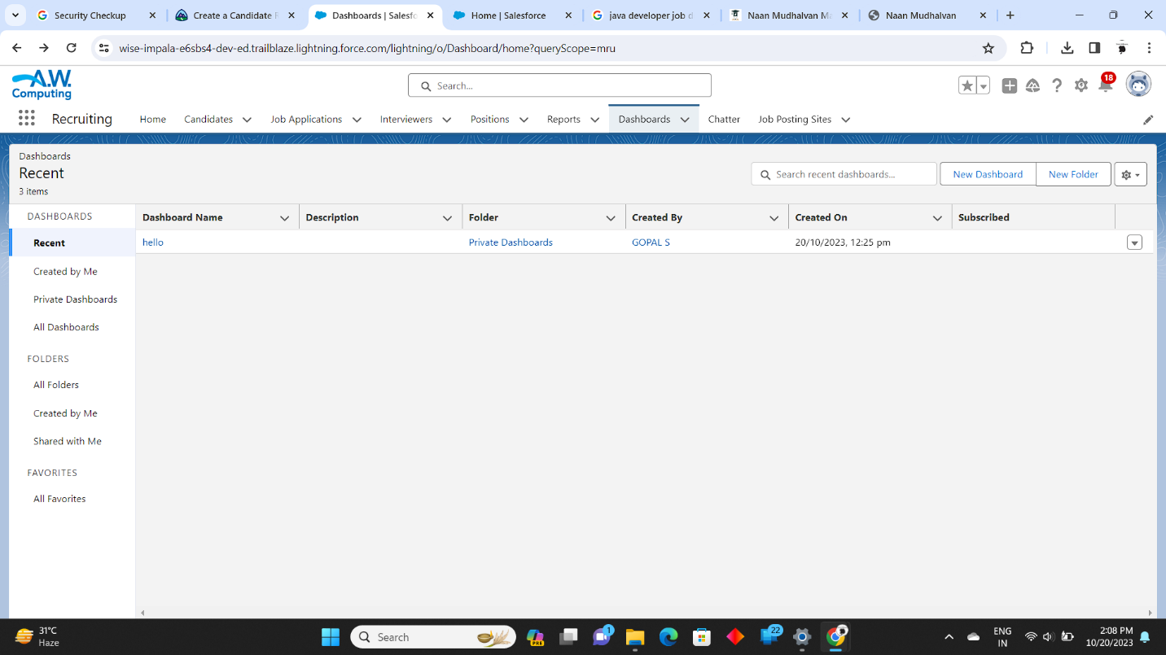 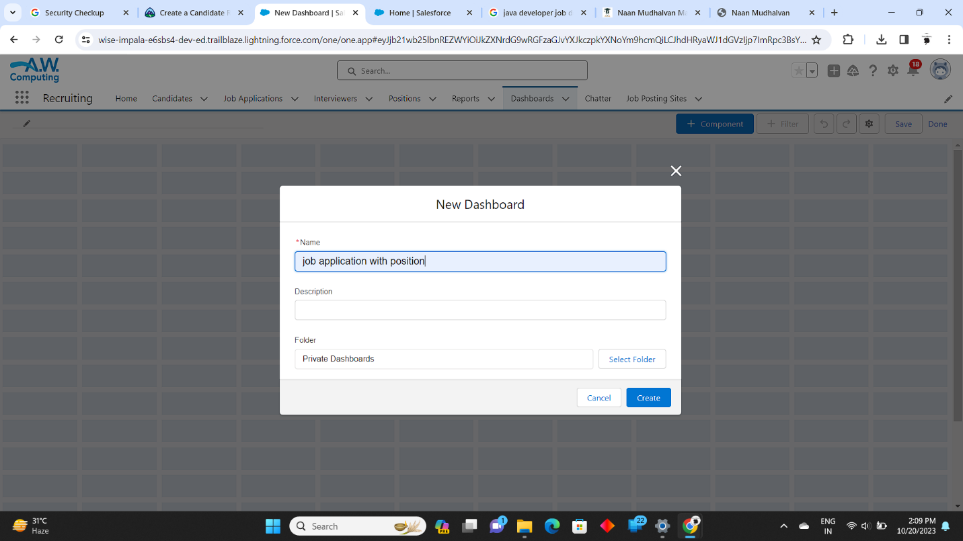 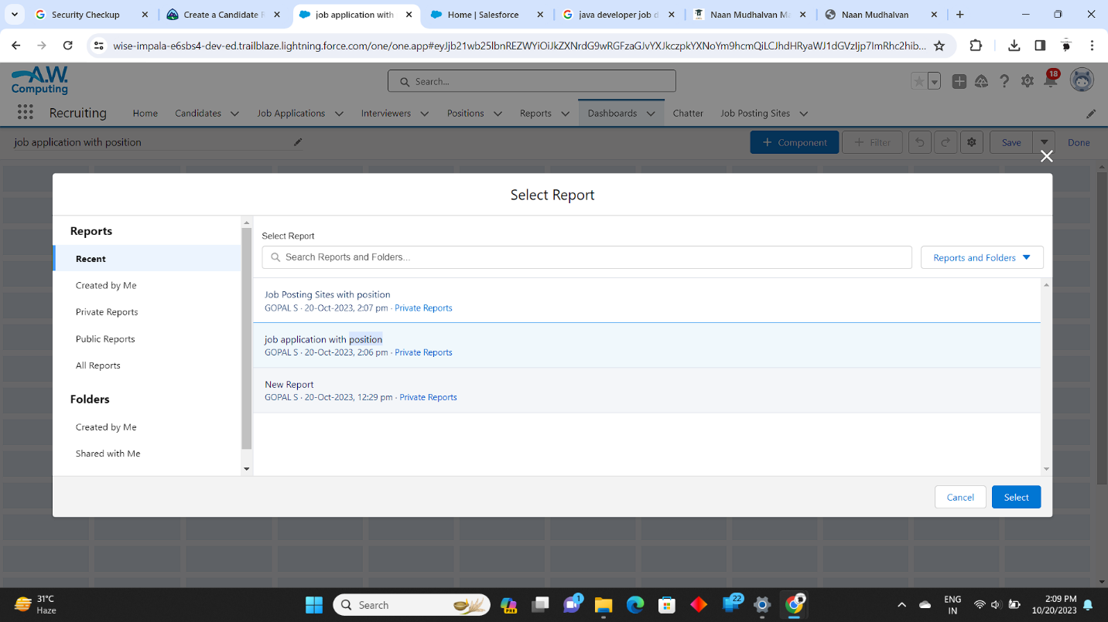 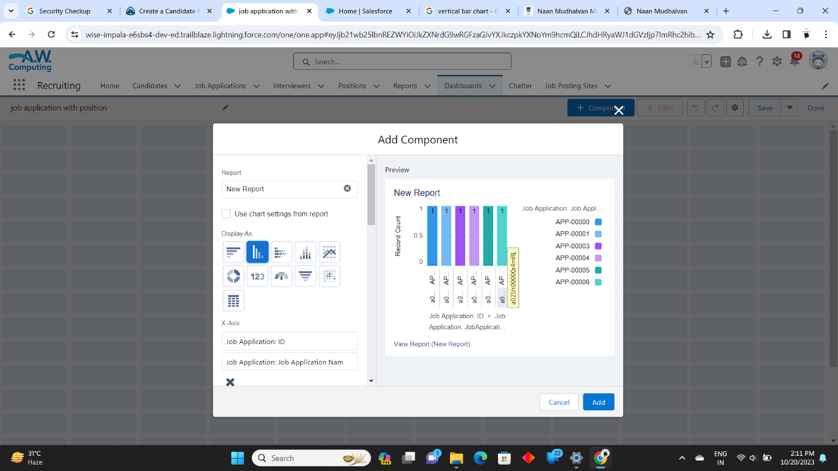 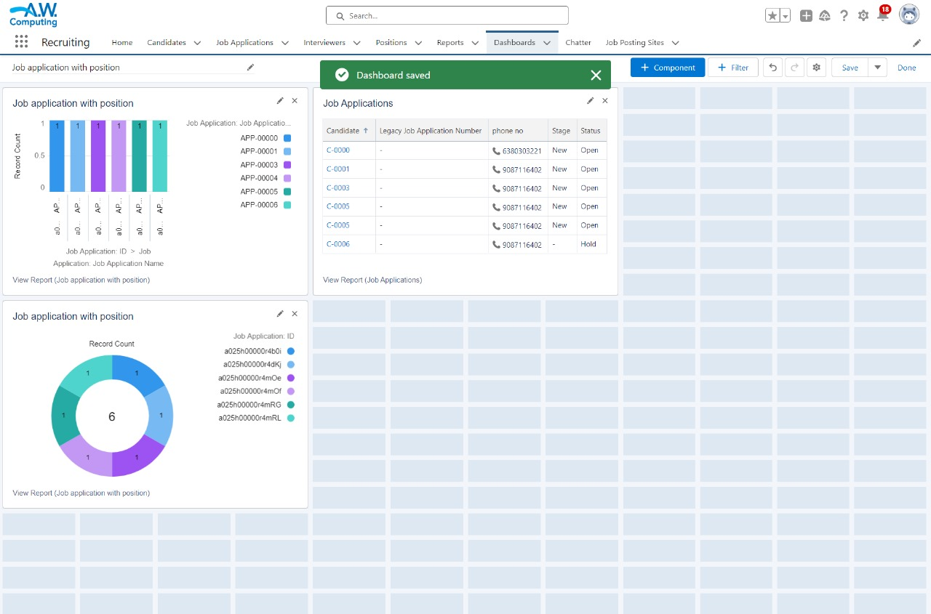

**CHAPTER-6**

**CONCLUSION**

This project proposal highlights the goal of implementing Salesforce to improve the recruitment assistance process. The outlined objectives include streamlining the recruitment process, enhancing candidate tracking and communication, centralizing candidate data, integrating systems, and providing comprehensive training. The project's key deliverables comprise a customized Salesforce platform, automated workflows, a centralized database, system integration, training materials, and user documentation. The scope of work involves requirements gathering, Salesforce customization, workflow automation, data migration, system integration, and ongoing training and support. Key requirements for the project include Salesforce expertise, effective collaboration with the HR team, data security measures, integration capabilities, comprehensive training resources, and detailed documentation.

**CHAPTER-7**

**PROJECT DEMONSTRATION**

**Github:**

[**https://github.com/Navajeevan2002/NM2023TMlD05686.git**](https://github.com/Navajeevan2002/NM2023TMlD05686.git)

**Demo Link:**

[**https://drive.google.com/file/d/1agqsNoVjXcq_GJIYuMwDEYei4hq7Jn3T/view?usp=sharing**](https://drive.google.com/file/d/1agqsNoVjXcq_GJIYuMwDEYei4hq7Jn3T/view?usp=sharing)